STA 3180 – Linear Regression Examples Summary

WNBA – Y = Actual Team Points in Game, X = Predicted Points Based on Betting Lines
Population: All N = 4078 team games during 2010-2019 Regular Seasons
Model: We will use centered X values to reduce correlation between estimated regression coefficients:
Plot of Data, Regression Equation, Line of Equality, and Mean (Y):
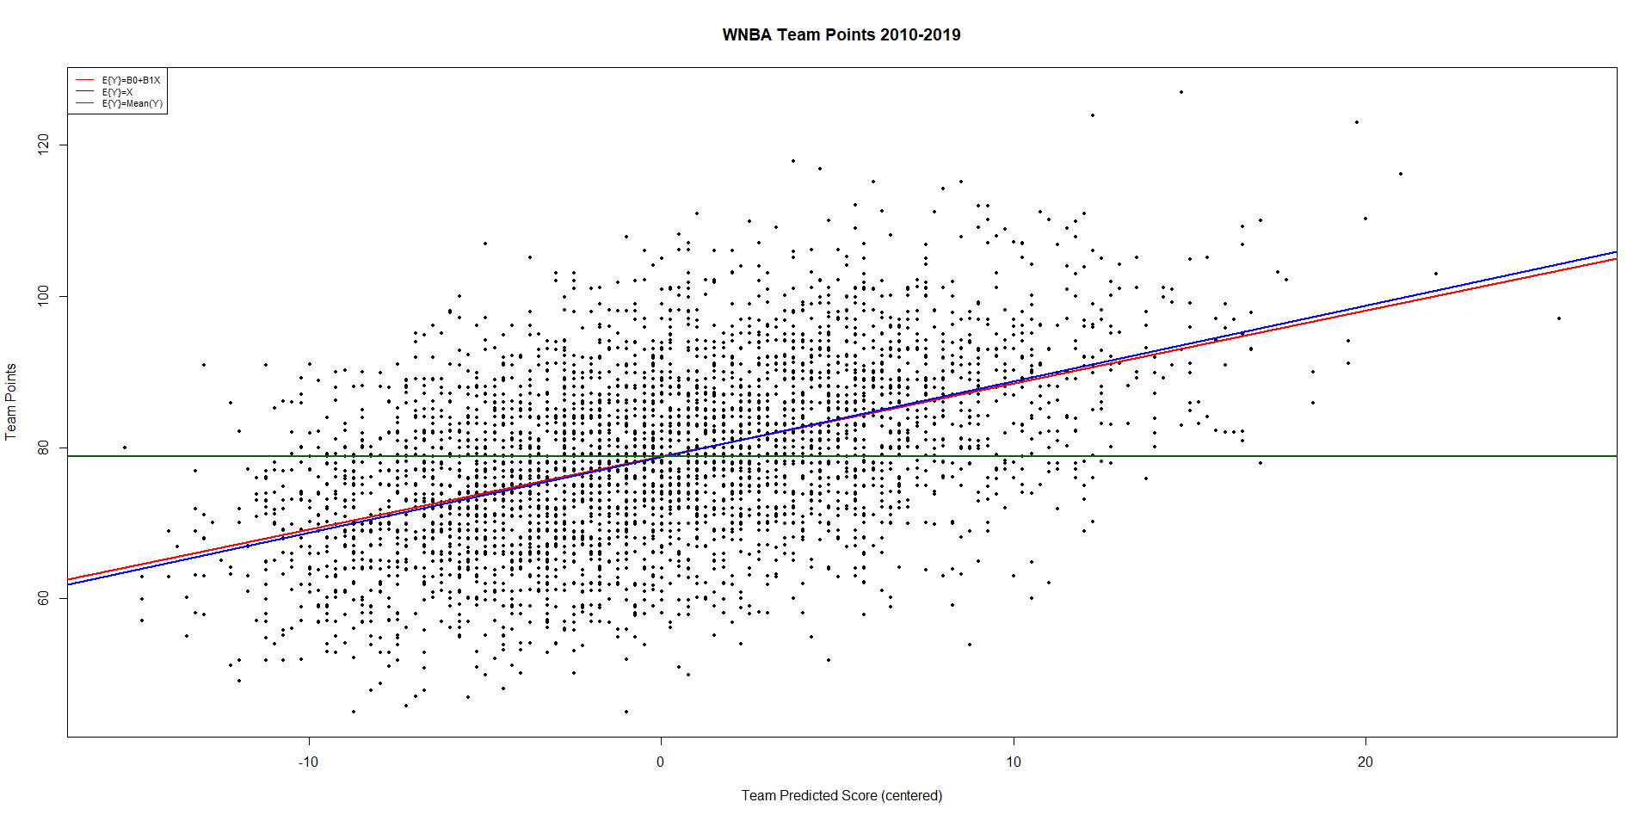
Histogram of Error Terms:
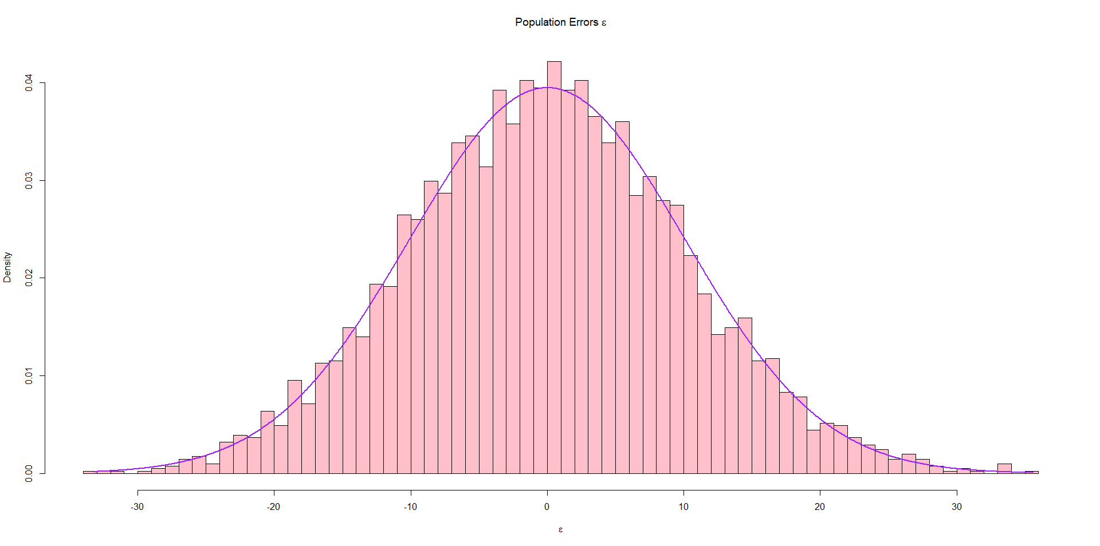

Samples: We will take 100000 samples of size n = 40 team games from the population and fit the simple linear regression for each sample (keep in mind, we are continuing to use the centered X values from the population).
Plot of Population Regression Line and First 10 Sample Regression Lines:
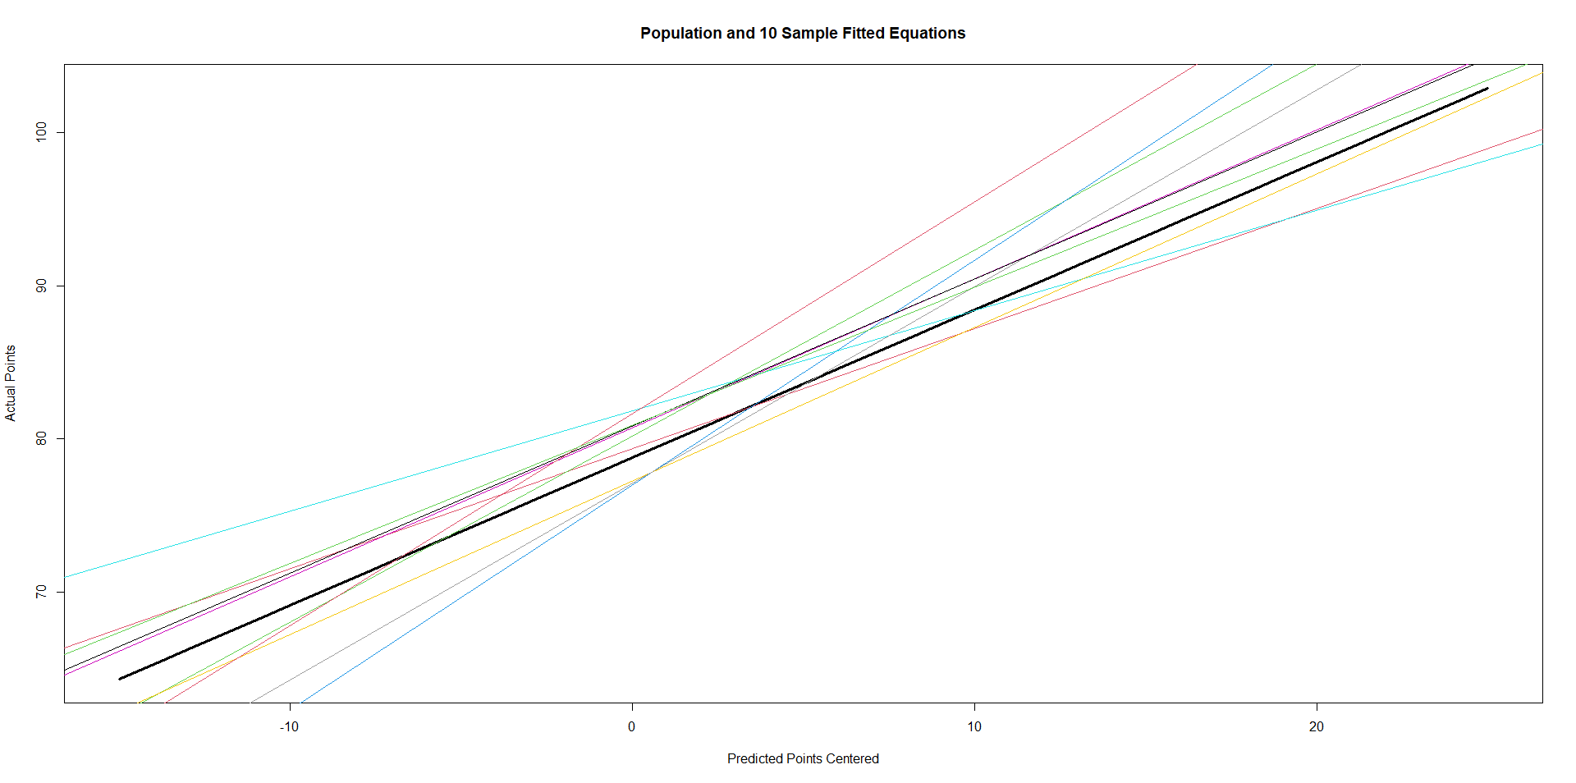
Plot of 100000 Pairs of 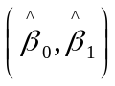:
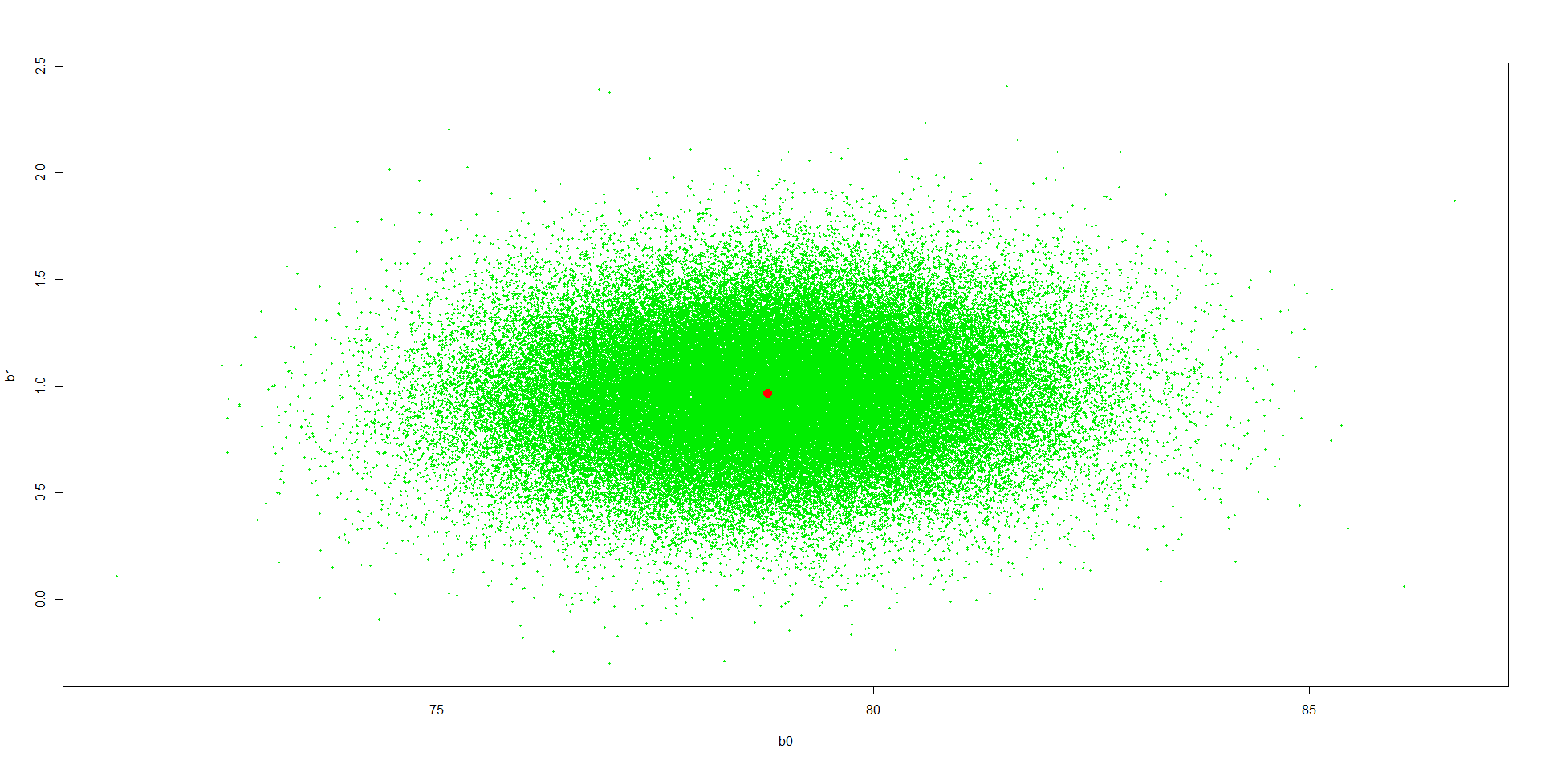
For Each sample, computed 95% Confidence Intervals for β₀ and β₁ :Coverage rates: 95.18% and 95.25%

City Temperature Trends Over Time (1960-2020) – BOS, DFW, LAX, MIA, ORD, SEA
Y = Average Annual Temperature X = Year – 1960
Plots of Data and Least Squares Regression Lines by City:
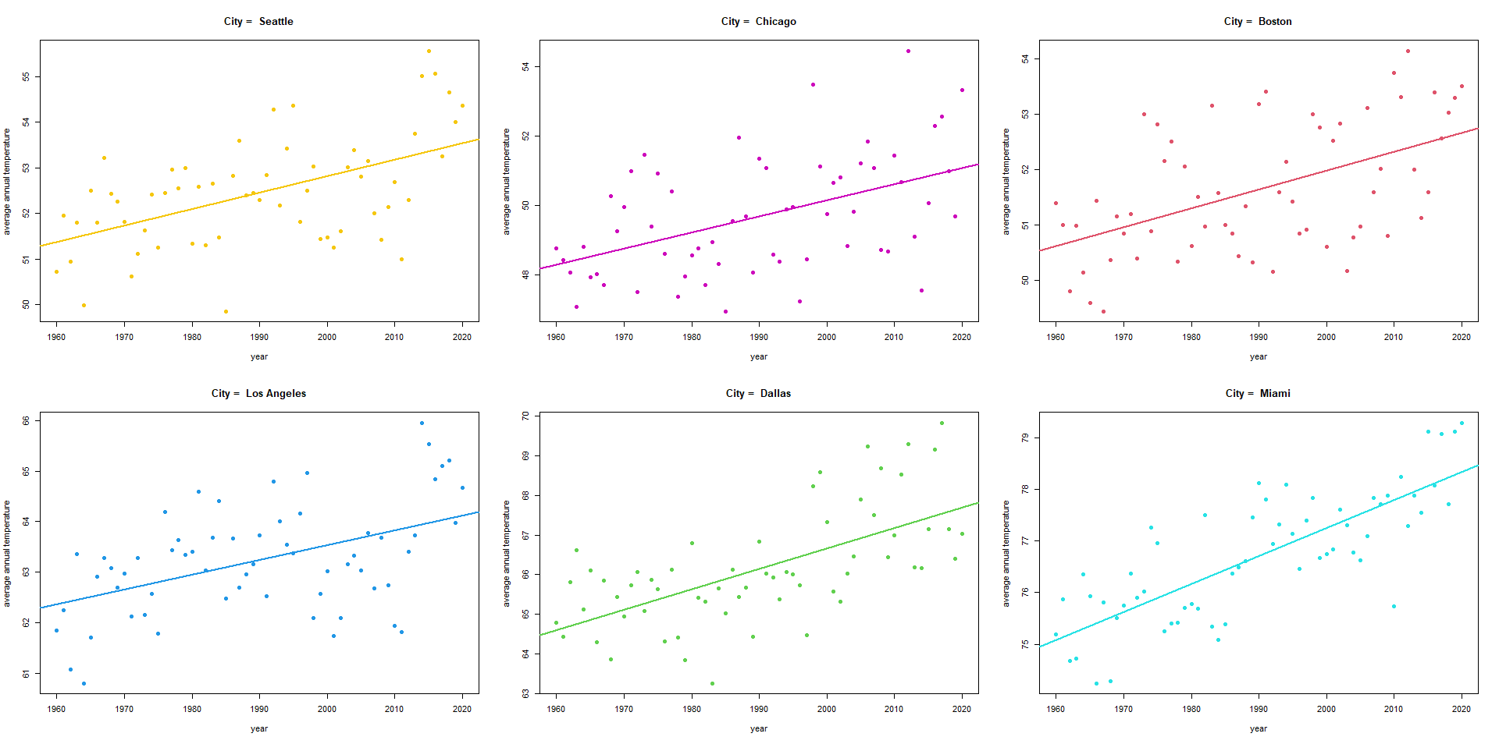
City Summaries for Boston and Dallas/Fort Worth:
> mod.bos <- lm(aveTemp[city_seq==1] ~ year_seq[city_seq==1])
> summary(mod.bos)
Coefficients:
Estimate Std. Error t value Pr(>|t|)
(Intercept) 50.619562 0.256242 197.546 < 2e-16 ***
I(year_seq[city_seq == 1] - 1960) 0.034097 0.007366 4.629 2.07e-05 ***

Residual standard error: 1.013 on 59 degrees of freedom
Multiple R-squared: 0.2664, Adjusted R-squared: 0.254
F-statistic: 21.43 on 1 and 59 DF, p-value: 2.066e-05

>
> mod.dfw <- lm(aveTemp[city_seq==2] ~ year_seq[city_seq==2])
> summary(mod.dfw)

Coefficients:
Estimate Std. Error t value Pr(>|t|)
(Intercept) 64.596294 0.284072 227.394 < 2e-16 ***
I(year_seq[city_seq == 2] - 1960) 0.051745 0.008167 6.336 3.56e-08 ***

Residual standard error: 1.123 on 59 degrees of freedom
Multiple R-squared: 0.4049, Adjusted R-squared: 0.3948
F-statistic: 40.15 on 1 and 59 DF, p-value: 3.555e-08

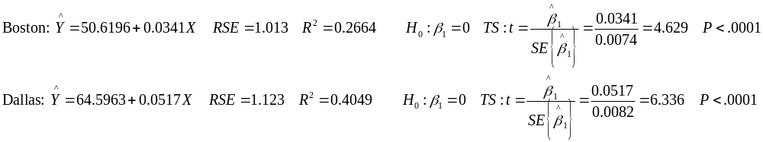
Plots of Residuals versus Year by City. Evidence of Positive Serial Correlation for SEA and LAX:
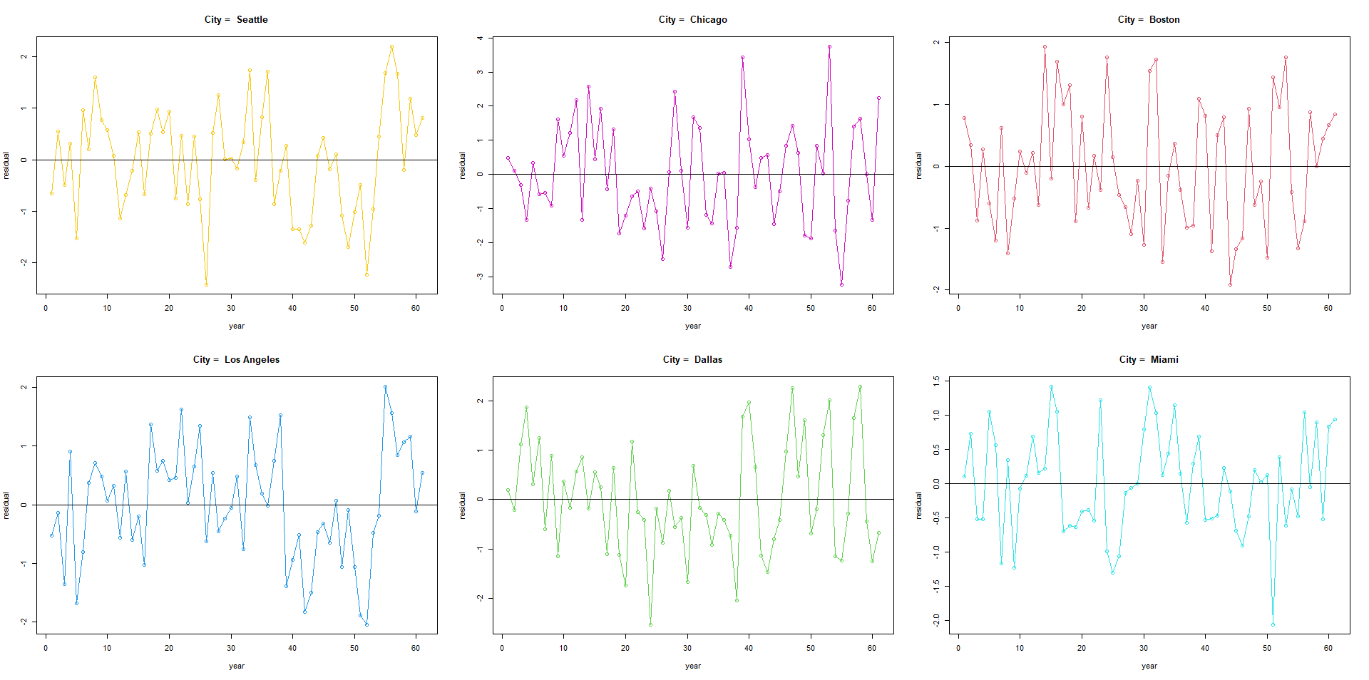

Container Ships Speed (X) and Fuel Usage (Y) – Hong Kong-Singapore Route 3
Plot of Fuel versus Speed:
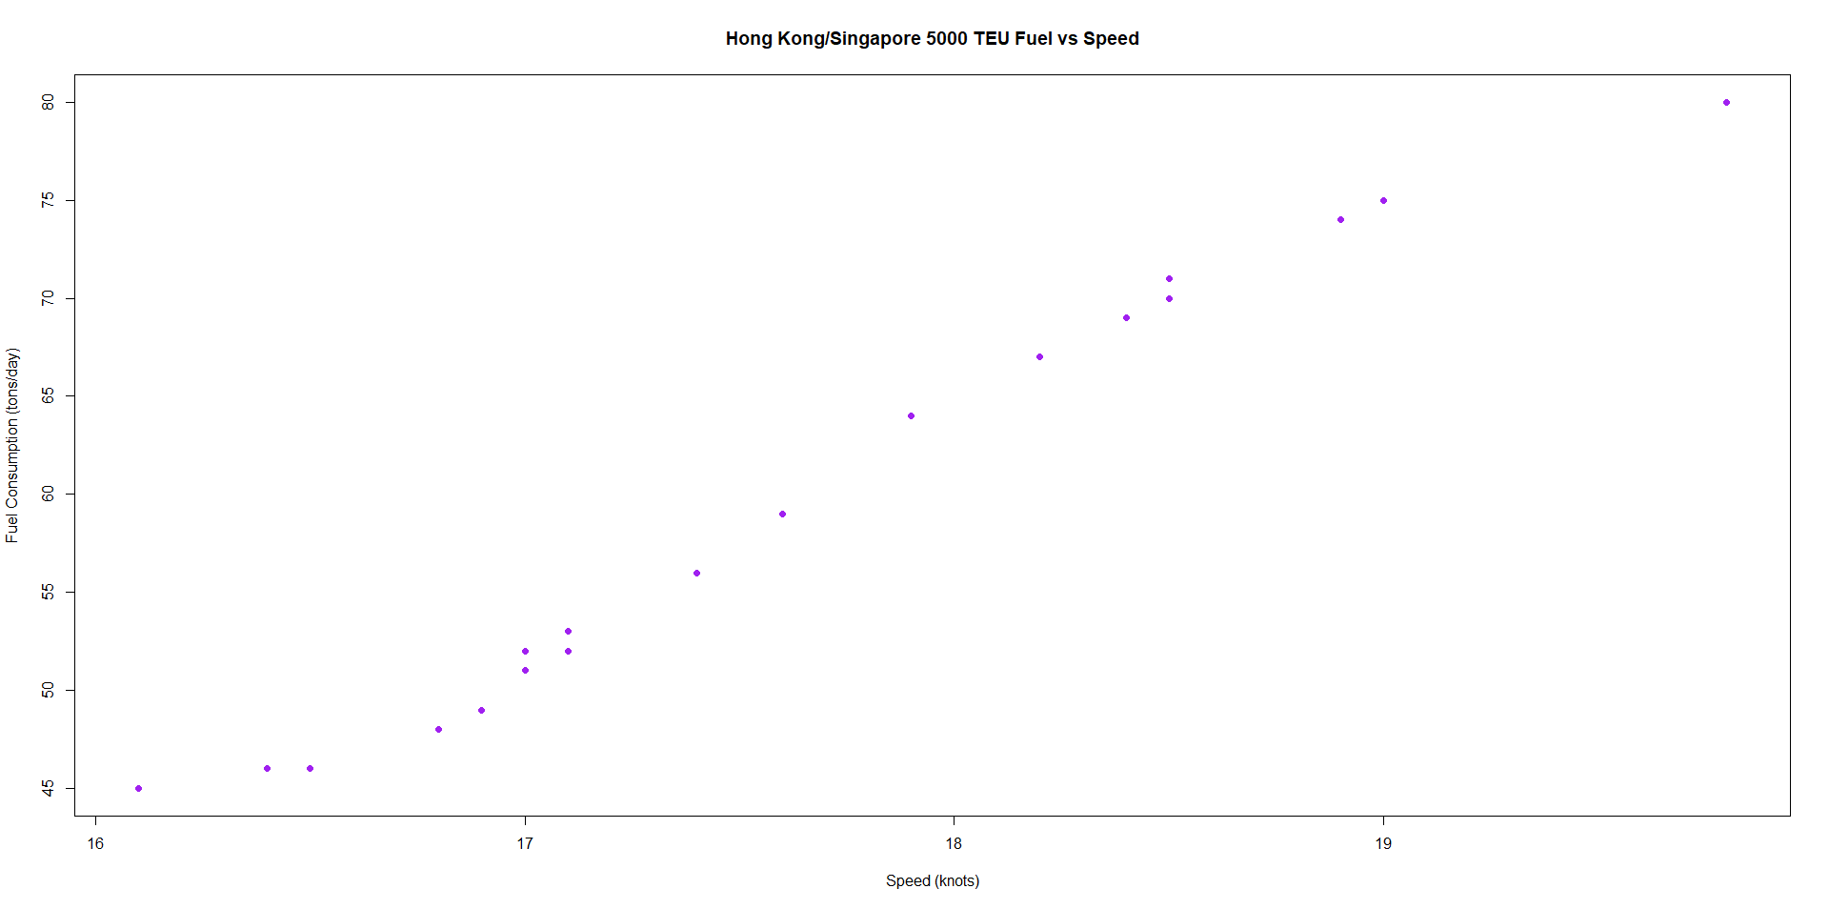
Evidence of a nonlinear relation, fit linear, quadratic, and cubic models with centered speed: 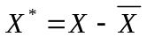
> spdfuel.1 <- lm(fuel_leg3 ~ speed_leg3c)
> summary(spdfuel.1)

Coefficients:
Estimate Std. Error t value Pr(>|t|)
(Intercept) 58.9000 0.3589 164.12 <2e-16 ***
speed_leg3c 11.1785 0.3697 30.24 <2e-16 ***

Residual standard error: 1.605 on 18 degrees of freedom
Multiple R-squared: 0.9807, Adjusted R-squared: 0.9796
F-statistic: 914.4 on 1 and 18 DF, p-value: < 2.2e-16

> spdfuel.2 <- lm(fuel_leg3 ~ speed_leg3c + I(speed_leg3c^2))
> summary(spdfuel.2)

Coefficients:
Estimate Std. Error t value Pr(>|t|)
(Intercept) 59.2579 0.4970 119.229 < 2e-16 ***
speed_leg3c 11.3664 0.4108 27.666 1.41e-15 ***
I(speed_leg3c^2) -0.3797 0.3657 -1.038 0.314

Residual standard error: 1.602 on 17 degrees of freedom
Multiple R-squared: 0.9818, Adjusted R-squared: 0.9797
F-statistic: 459.7 on 2 and 17 DF, p-value: 1.59e-15

> spdfuel.3 <- lm(fuel_leg3 ~ speed_leg3c + I(speed_leg3c^2) + I(speed_leg3c^3))
> summary(spdfuel.3)

Coefficients:
Estimate Std. Error t value Pr(>|t|)
(Intercept) 58.7020 0.2324 252.566 < 2e-16 ***
speed_leg3c 13.3245 0.2993 44.518 < 2e-16 ***
I(speed_leg3c^2) 0.7779 0.2152 3.616 0.00232 **
I(speed_leg3c^3) -1.1479 0.1384 -8.294 3.46e-07 ***

Residual standard error: 0.7171 on 16 degrees of freedom
Multiple R-squared: 0.9966, Adjusted R-squared: 0.9959
F-statistic: 1551 on 3 and 16 DF, p-value: < 2.2e-16

Models 1 and 2 give very similar fits:
For Model 3, the RSE drops to 0.717 and R² increases to .9959 and the t-statistic for β₃ is highly significant.
Re-fitting Model 3 to the original (non-centered) scale, we get the fitted equation:
A plot of the data and fitted equation are given below.
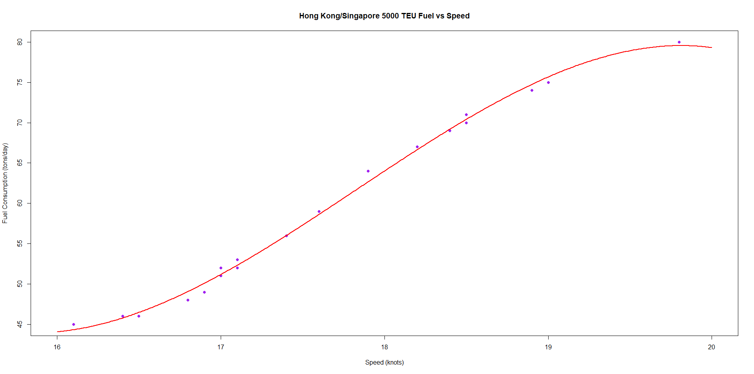
Bollywood Movies Y = Gross Revenues X = Budget
Plots of Gross versus Budgets on Original and Log Scales for Each Variable.
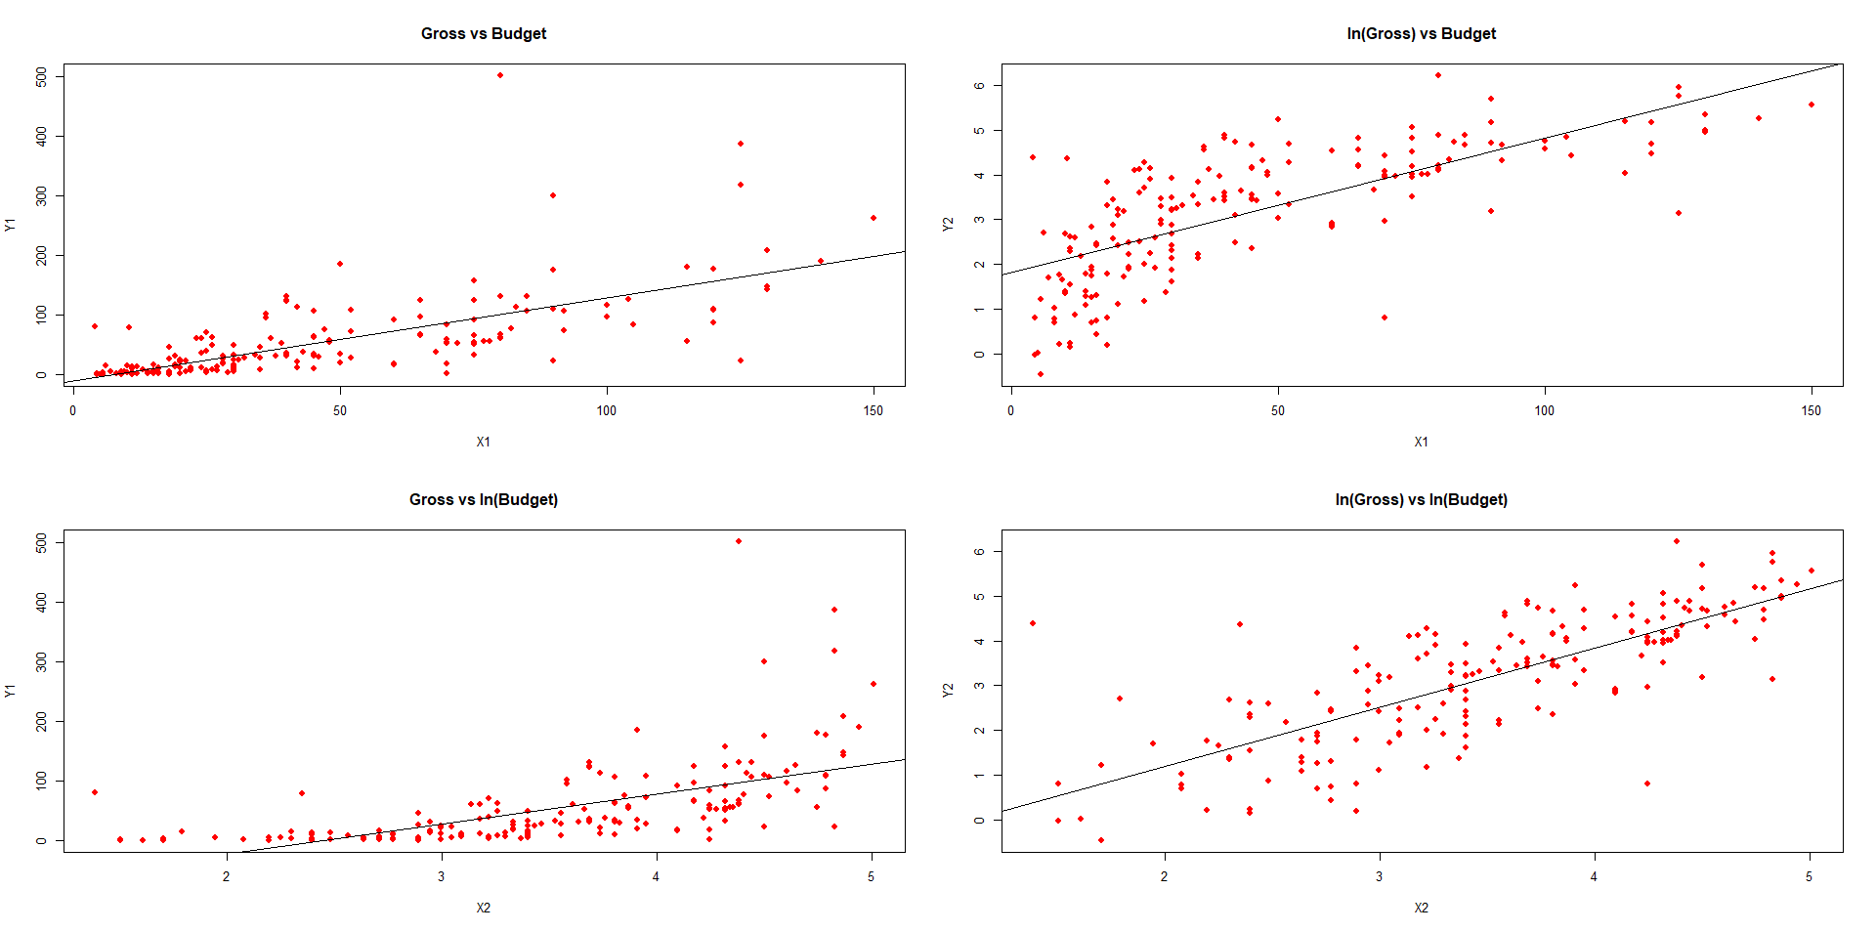
Original Scale: Linear but non-constant variance. Plots 2 and 3 – awful Log/Log looks best (but not perfect)
Model on log/log scale:
> bolly.mod1 <- lm(Y2 ~ X2)
> summary(bolly.mod1)
Coefficients:
Estimate Std. Error t value Pr(>|t|)
(Intercept) -1.44023 0.28410 -5.069 9.51e-07 ***
X2 1.31955 0.07887 16.730 < 2e-16 ***

Residual standard error: 0.9029 on 188 degrees of freedom
Multiple R-squared: 0.5982, Adjusted R-squared: 0.5961
F-statistic: 279.9 on 1 and 188 DF, p-value: < 2.2e-16

> confint(bolly.mod1)
2.5 % 97.5 %
(Intercept) -2.000665 -0.879805
X2 1.163955 1.475138

Residual Plots (Not unreasonable):
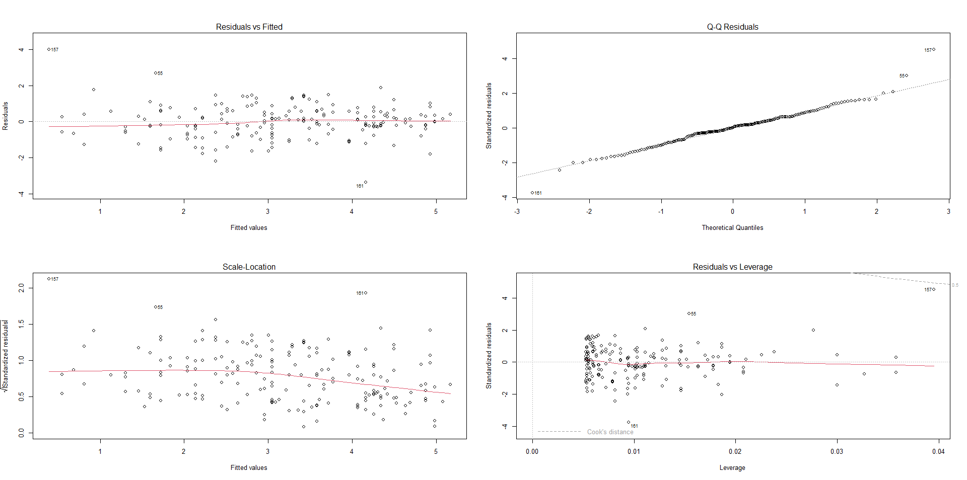

US State Wine Consumption X = Population (millions) Y = Wine (millions of litres)
Stripchart of population (California and Texas are Extreme)
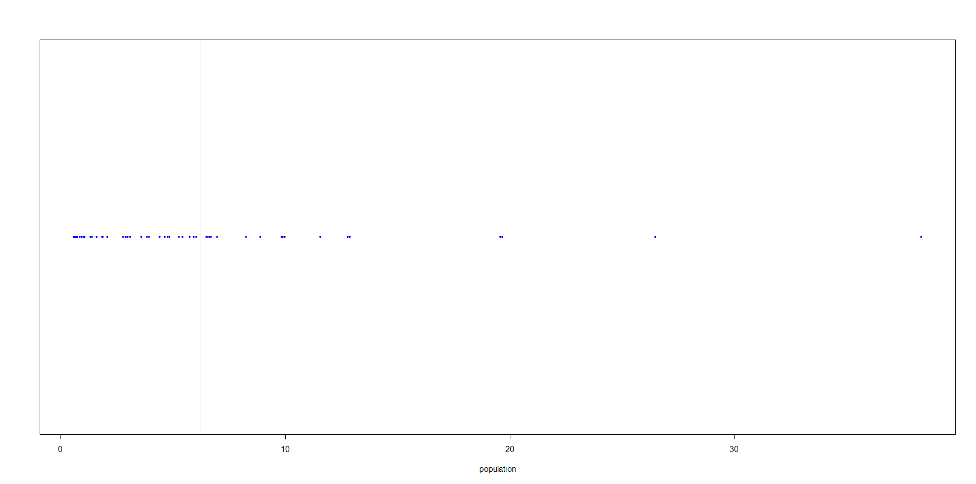

Simple Linear Regression Models fit with and without California:
> wine.mod1 <- lm(totWine ~ pop)
> summary(wine.mod1)

Coefficients:
Estimate Std. Error t value Pr(>|t|)
(Intercept) -12.1211 6.5213 -1.859 0.0691 .
pop 11.2257 0.6991 16.057 <2e-16 ***

Residual standard error: 34.8 on 49 degrees of freedom
Multiple R-squared: 0.8403, Adjusted R-squared: 0.837
F-statistic: 257.8 on 1 and 49 DF, p-value: < 2.2e-16

> wine.mod3 <- lm(totWine[State != "California"] ~ pop[State != "California"])
> summary(wine.mod3)

Coefficients:
Estimate Std. Error t value Pr(>|t|)
(Intercept) 0.6657 5.4676 0.122 0.904
pop[State != "California"] 8.4985 0.7096 11.976 5.02e-16 ***
---
Signif. codes: 0 ‘***’ 0.001 ‘**’ 0.01 ‘*’ 0.05 ‘.’ 0.1 ‘ ’ 1

Residual standard error: 26.78 on 48 degrees of freedom
Multiple R-squared: 0.7492, Adjusted R-squared: 0.744
F-statistic: 143.4 on 1 and 48 DF, p-value: 5.023e-16

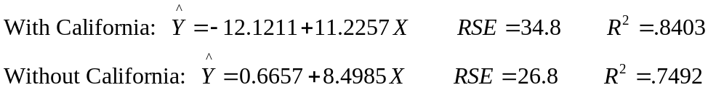
Huge differences among the parameter estimates and fit statistics.
Plot of data and fitted equations:
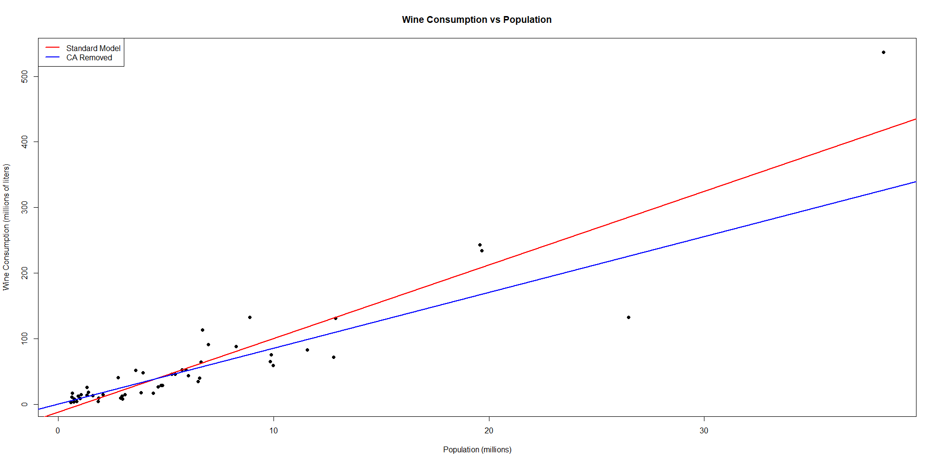

Cotton Yarn Output by Yarn Count and Spindle Type
Plot of Output by Yarn Count for Spindle = Mule (Highly nonlinear)
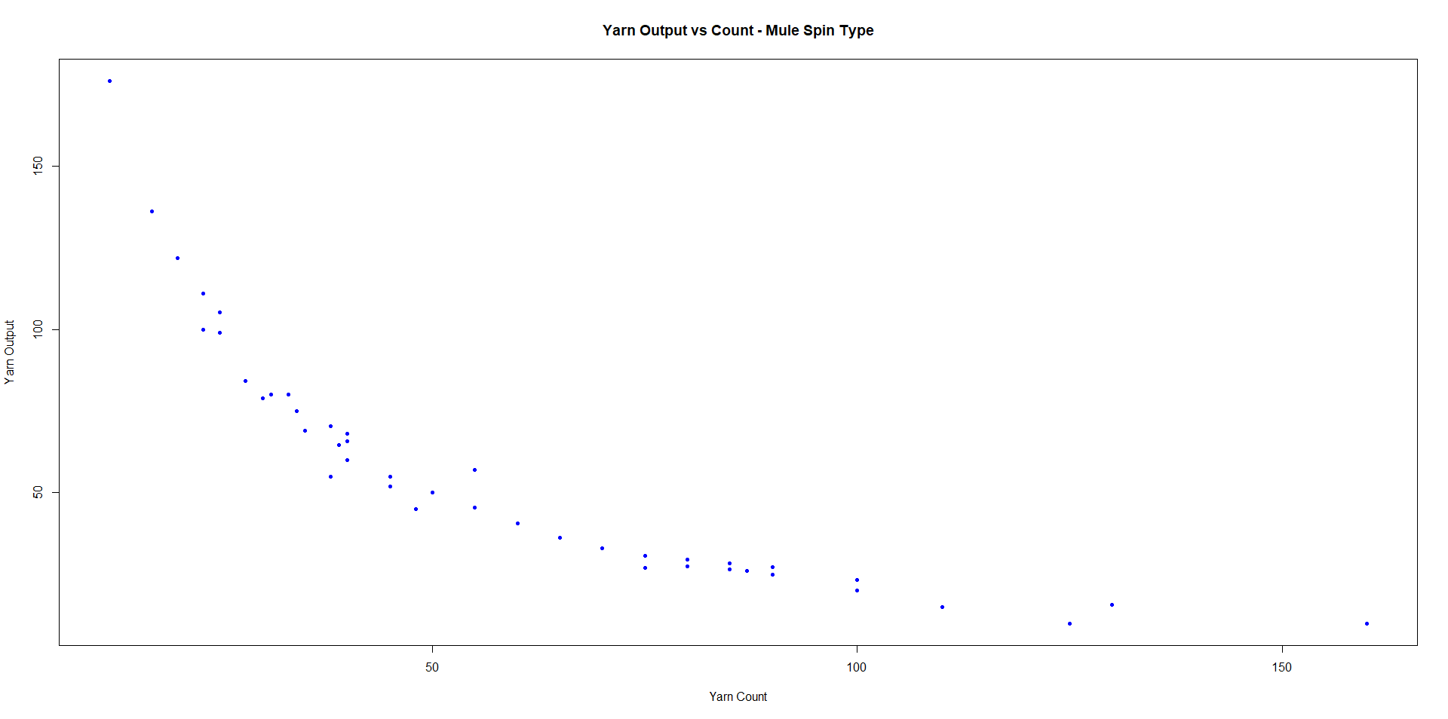
Consider transforming X by working with 1/X:

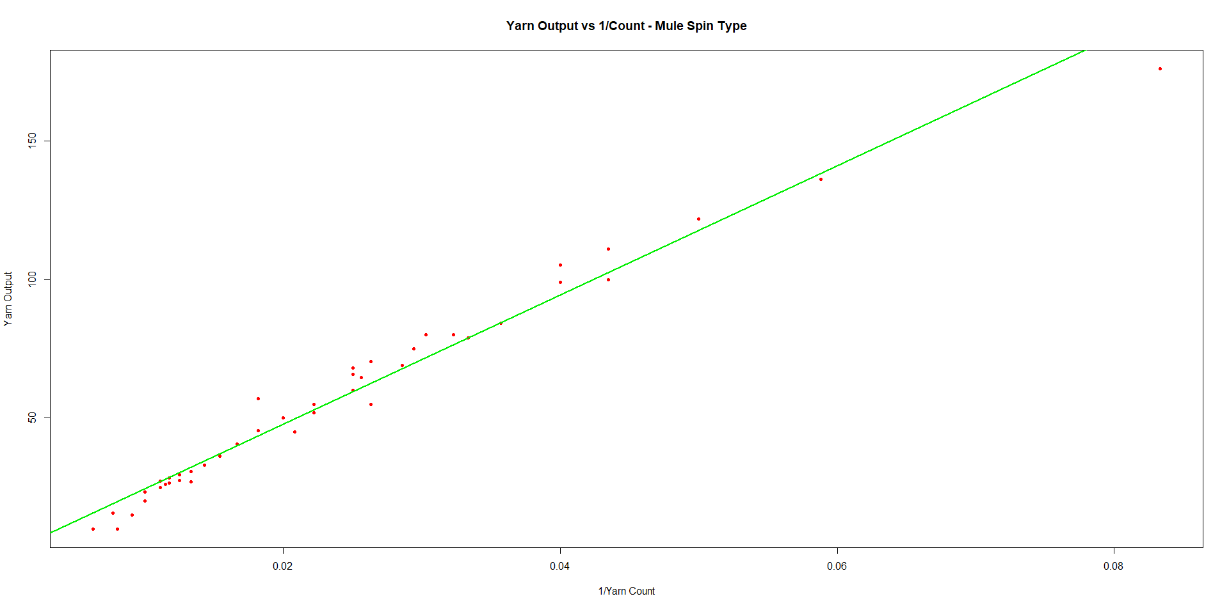
Much more like a linear fit. Fitting the regression model to obtain the regression coefficients
> mod1 <- lm(Y1 ~ I(1/X1))
> summary(mod1)

Coefficients:
Estimate Std. Error t value Pr(>|t|)
(Intercept) 1.298 1.685 0.771 0.445
I(1/X1) 2330.774 59.233 39.349 <2e-16 ***

Residual standard error: 5.962 on 41 degrees of freedom
Multiple R-squared: 0.9742, Adjusted R-squared: 0.9736
F-statistic: 1548 on 1 and 41 DF, p-value: < 2.2e-16

Plug in original X values into equation above to get fitted nonlinear relation:
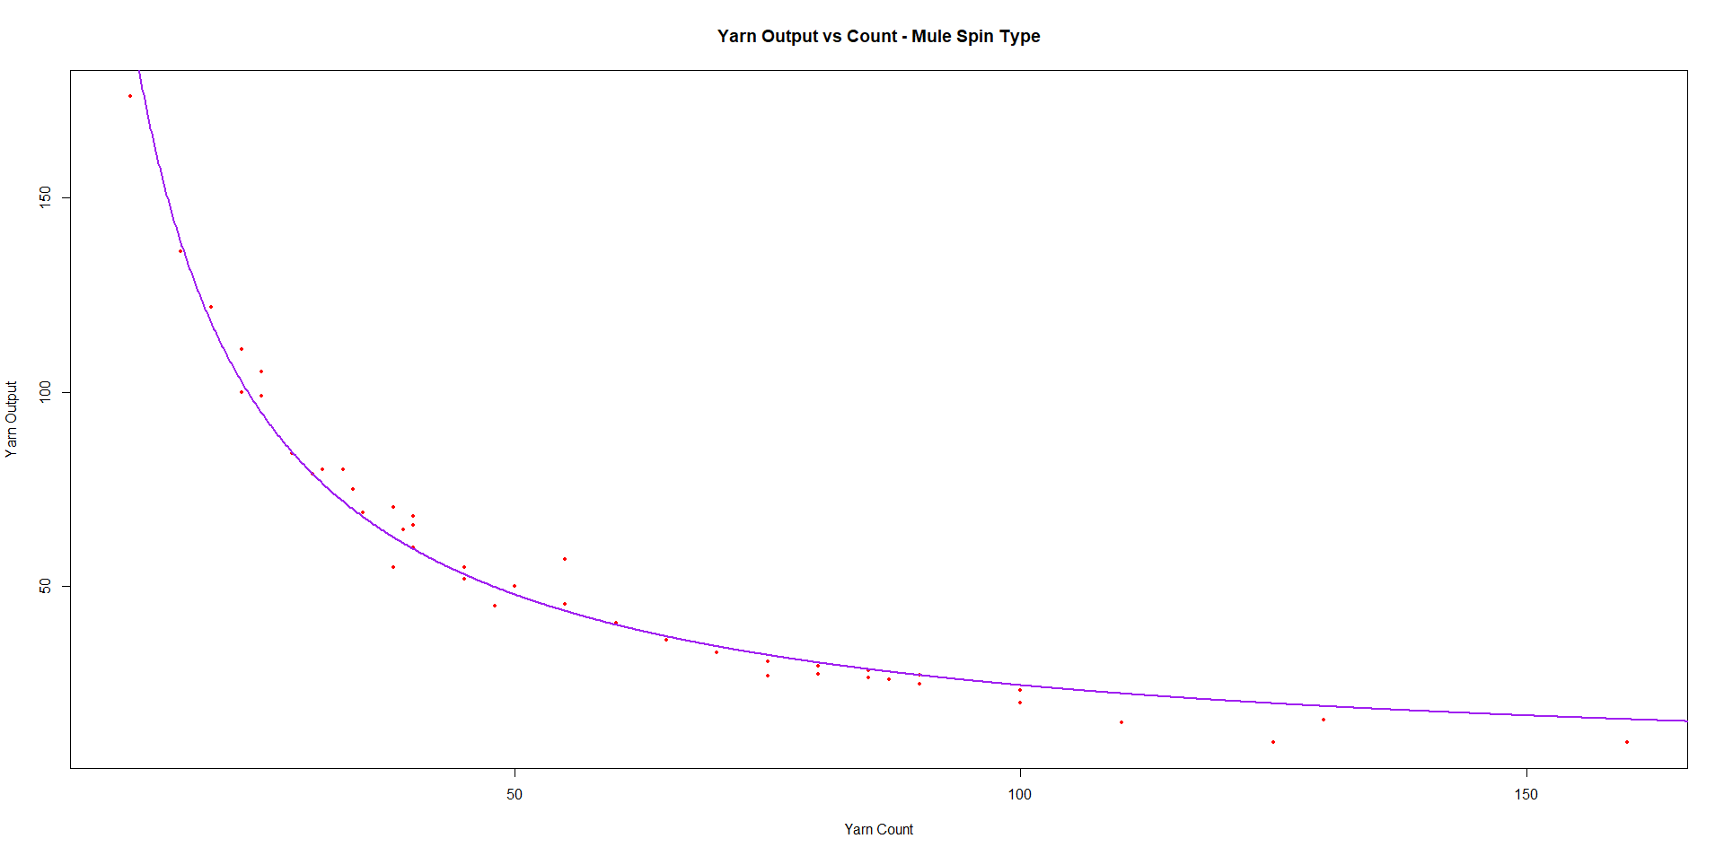
Fit a transformed (1/X) model that allows for separate intercepts and slopes by spindle type (Mule and Ring)
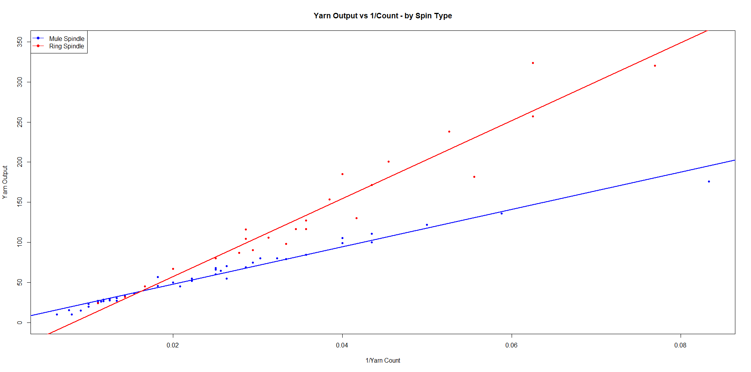
Regression fit for the Interaction Model:
> mod2 <- lm(yarnOut ~ I(1/yarnCnt) * factor(spinType))
> summary(mod2)

Coefficients:
Estimate Std. Error t value Pr(>|t|)
(Intercept) 1.298 3.960 0.328 0.744
I(1/yarnCnt) 2330.774 139.207 16.743 < 2e-16 ***
factor(spinType)2 -41.248 8.304 -4.967 5.48e-06 ***
I(1/yarnCnt):factor(spinType)2 2530.500 228.234 11.087 < 2e-16 ***

Residual standard error: 14.01 on 63 degrees of freedom
Multiple R-squared: 0.9609, Adjusted R-squared: 0.959
F-statistic: 516.2 on 3 and 63 DF, p-value: < 2.2e-16

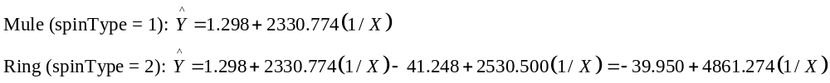
Plot of the 2 Curves on the Original Yarn Count Scale:
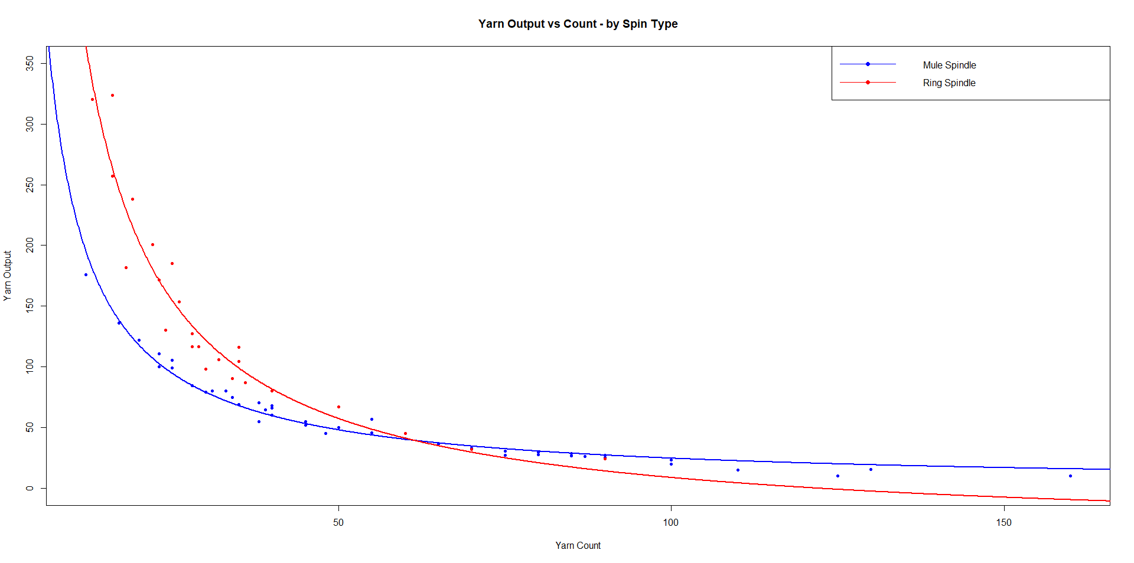

Time to Incapacitation for Animals Exposed to Burning Aircraft Materials
Y = 1000 / (Time to Incapacitation) Predictors: p = 7 Chemicals used in the n = 71 materials
Chemicals: CO, HCN, H2S, HCL, HBr, NO2, SO2
Fit for Full Model with all 7 predictors. Most seem to have effects with the exceptions of HCL and HBR based on the t-tests.

> fit1 <- lm(Y ~ CO+HCN+H2S+HCL+HBr+NO2+SO2)
> summary(fit1)

Coefficients:
Estimate Std. Error t value Pr(>|t|)
(Intercept) 75.44679 15.16710 4.974 5.34e-06 ***
CO 0.64036 0.09717 6.590 1.03e-08 ***
HCN 11.77871 0.90006 13.087 < 2e-16 ***
H2S -10.90998 2.99044 -3.648 0.000537 ***
HCL -0.10200 0.07284 -1.400 0.166337
HBr -0.67569 0.88126 -0.767 0.446105
NO2 44.81628 21.06666 2.127 0.037312 *
SO2 6.61409 2.72454 2.428 0.018069 *

Residual standard error: 55.75 on 63 degrees of freedom
Multiple R-squared: 0.8345, Adjusted R-squared: 0.8161
F-statistic: 45.38 on 7 and 63 DF, p-value: < 2.2e-16

Now fit all possible regressions (2⁷ = 128 possible models) printing out the 2 best for each number of predictors.
(Intercept) CO HCN H2S HCL HBr NO2 SO2 rsq adjr2 cp bic aic
1 1 0 1 0 0 0 0 0 0.573 0.567 95.594 -51.871 -56.396
1 1 0 0 0 0 0 1 0 0.180 0.168 245.189 -5.554 -10.079
2 1 1 1 0 0 0 0 0 0.734 0.727 36.126 -81.325 -88.113
2 1 0 1 0 0 0 1 0 0.665 0.656 62.338 -64.961 -71.749
3 1 1 1 1 0 0 0 0 0.792 0.783 16.069 -94.532 -103.582
3 1 1 1 0 0 0 1 0 0.789 0.780 17.163 -93.556 -102.607
4 1 1 1 1 0 0 1 0 0.817 0.806 8.769 -99.153 -110.466
4 1 1 1 1 0 0 0 1 0.810 0.799 11.164 -96.757 -108.070
5 1 1 1 1 0 0 1 1 0.828 0.815 6.287 -99.605 -113.181
5 1 1 1 1 1 0 0 1 0.820 0.806 9.450 -96.246 -109.822
6 1 1 1 1 1 0 1 1 0.833 0.817 6.588 -97.214 -113.053
6 1 1 1 1 0 1 1 1 0.829 0.813 7.961 -95.698 -111.536
7 1 1 1 1 1 1 1 1 0.834 0.816 8.000 -93.611 -111.712

Best model in terms of minimizing cp, bic, and aic: CO, HCN, H2S, NO2, SO2
Now using forward selection and backward elimination (same predictors are selected).

Forward Selection:

> stepAIC(fit2,direction="both",scope=list(upper=fit1,lower=fit2))
Start: AIC=692.2
Y ~ 1
Df Sum of Sq RSS AIC
+ HCN 1 677833 505408 633.80
+ NO2 1 212831 970410 680.12
+ H2S 1 102071 1081170 687.79
+ CO 1 81119 1102122 689.15
+ HCL 1 51156 1132086 691.06
<none> 1183241 692.20
+ HBr 1 14339 1168902 693.33
+ SO2 1 13344 1169897 693.39

Step: AIC=633.8
Y ~ HCN
Df Sum of Sq RSS AIC
+ CO 1 191068 314340 602.08
+ NO2 1 109591 395817 618.45
+ H2S 1 73868 431541 624.58
+ HCL 1 28118 477291 631.74
+ HBr 1 25890 479518 632.07
<none> 505408 633.80
+ SO2 1 803 504606 635.69

Step: AIC=602.08
Y ~ HCN + CO
Df Sum of Sq RSS AIC
+ H2S 1 68561 245779 586.62
+ NO2 1 65161 249179 587.59
+ SO2 1 14129 300211 600.82
<none> 314340 602.08
+ HCL 1 4387 309953 603.09
+ HBr 1 3701 310639 603.24

Step: AIC=586.62
Y ~ HCN + CO + H2S
Df Sum of Sq RSS AIC
+ NO2 1 28906.7 216872 579.73
+ SO2 1 21462.7 224316 582.13
<none> 245779 586.62
+ HCL 1 5208.0 240571 587.09
+ HBr 1 1509.8 244269 588.18

Step: AIC=579.73
Y ~ HCN + CO + H2S + NO2
Df Sum of Sq RSS AIC
+ SO2 1 13933.9 202938 577.02
<none> 216872 579.73
+ HCL 1 1463.9 215408 581.25
+ HBr 1 901.2 215971 581.44

Step: AIC=577.02
Y ~ HCN + CO + H2S + NO2 + SO2
Df Sum of Sq RSS AIC
<none> 202938 577.02
+ HCL 1 5280.9 197657 577.14
+ HBr 1 1013.4 201925 578.66

Call:
lm(formula = Y ~ HCN + CO + H2S + NO2 + SO2)

Coefficients:
(Intercept) HCN CO H2S NO2 SO2
68.4756 11.7355 0.6211 -10.4239 53.2167 5.5480

Backward Elimination:

> stepAIC(fit1,direction="backward")
Start: AIC=578.48
Y ~ CO + HCN + H2S + HCL + HBr + NO2 + SO2

Df Sum of Sq RSS AIC
- HBr 1 1827 197657 577.14
<none> 195830 578.48
- HCL 1 6095 201925 578.66
- NO2 1 14068 209897 581.41
- SO2 1 18319 214148 582.83
- H2S 1 41373 237203 590.09
- CO 1 135010 330840 613.72
- HCN 1 532345 728174 669.73

Step: AIC=577.14
Y ~ CO + HCN + H2S + HCL + NO2 + SO2

Df Sum of Sq RSS AIC
- HCL 1 5281 202938 577.02
<none> 197657 577.14
- NO2 1 15112 212769 580.38
- SO2 1 17751 215408 581.25
- H2S 1 42033 239690 588.83
- CO 1 154961 352618 616.24
- HCN 1 531912 729569 667.86

Step: AIC=577.02
Y ~ CO + HCN + H2S + NO2 + SO2

Df Sum of Sq RSS AIC
<none> 202938 577.02
- SO2 1 13934 216872 579.73
- NO2 1 21378 224316 582.13
- H2S 1 38630 241568 587.39
- CO 1 166472 369410 617.55
- HCN 1 529032 731971 666.10

Call:
lm(formula = Y ~ CO + HCN + H2S + NO2 + SO2)

Coefficients:
(Intercept) CO HCN H2S NO2 SO2
68.4756 0.6211 11.7355 -10.4239 53.2167 5.5480

>

