STA 3180 – Section 12.4 – Clustering Methods

- Goal: Group individual units into subsets (clusters) of similar units based on observed variables (features).
- Groups are not known in advance (Unsupervised Learning).
- Groupings made in terms of similarities/distances of variables/features between individual units.
- Notation: n = # of units, p = # of variables/features.
Dissimilarity/Distance Measures: There are various measures used in practice, we consider Euclidean here.

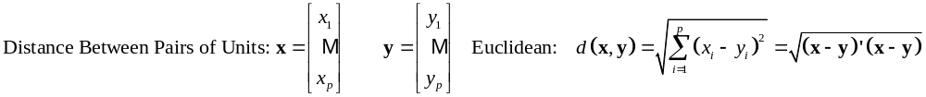
Example 1 – Plot of Drive Distance & Average Putts among LPGA 2022 Golfers (n = 158)
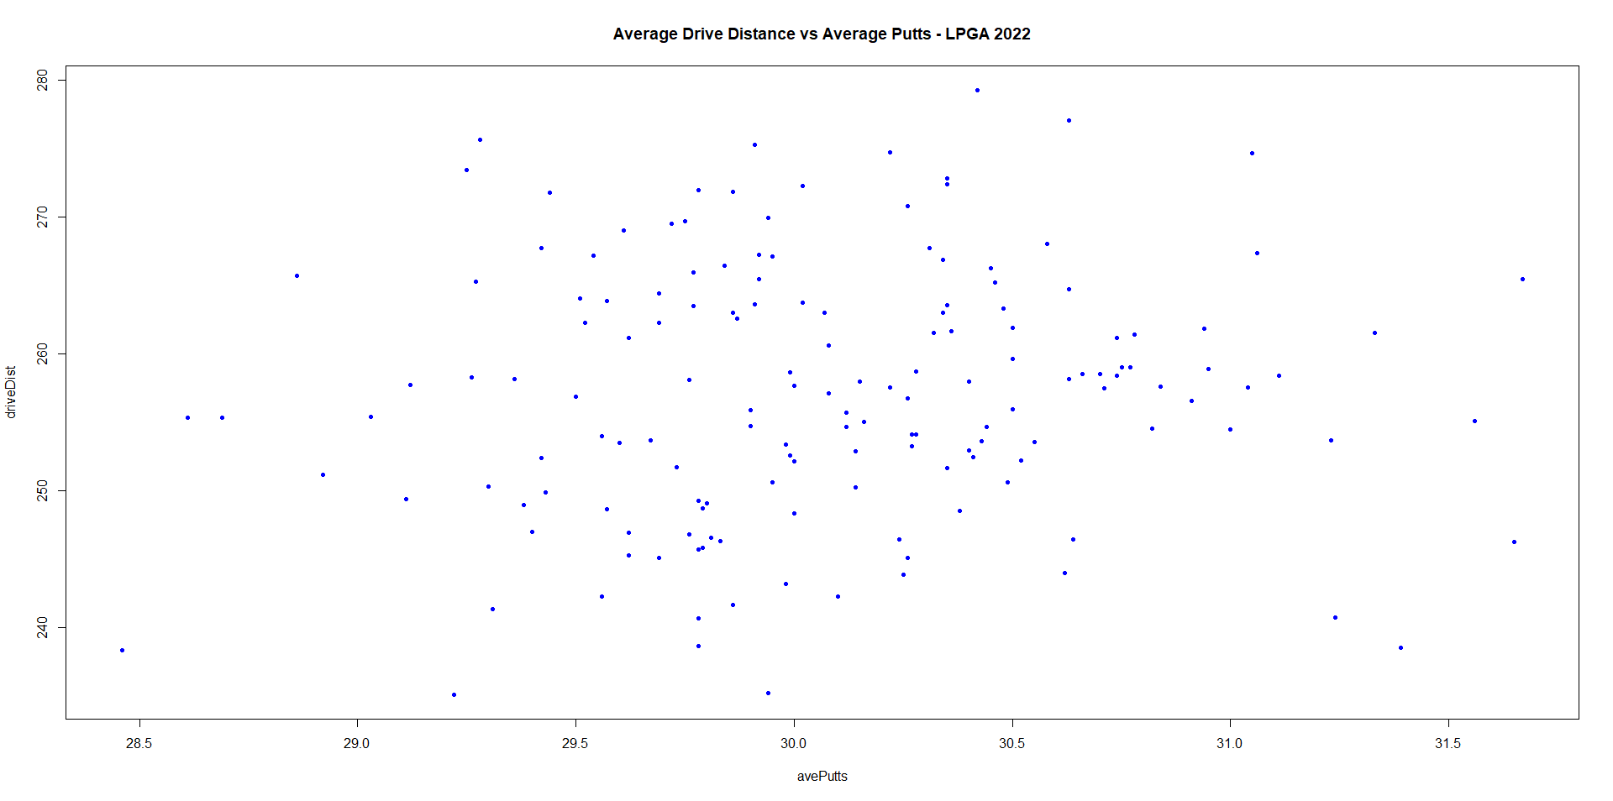

K-means Method (Non-hierarchical Clustering)
- Goal: Assign each of n units to k clusters, based on their p features.
- Randomly partition units into k groups (using random seed) and obtain group centroids (means of each of the p features for each group).
- Go through all units (1-at-a-time), moving to group with nearest centroid, re-calculate centroids for exit/enter groups.
- Continue until no units change groups.
- Due to random assignment in Step 2, this process should be run multiple times (with different starting splits) and choose the split with the smallest final within cluster sum of squares.

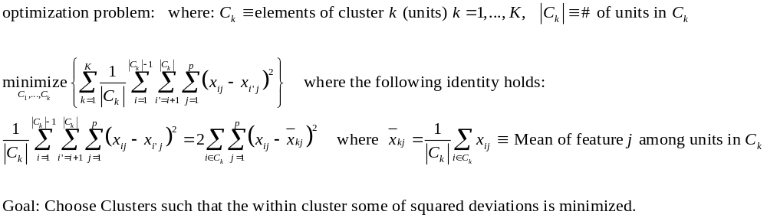

Example2 – n = 12 WNBA Players & K = 2 Clusters & 3 Features (Rebounds, Assists, Points per 36 Minutes)
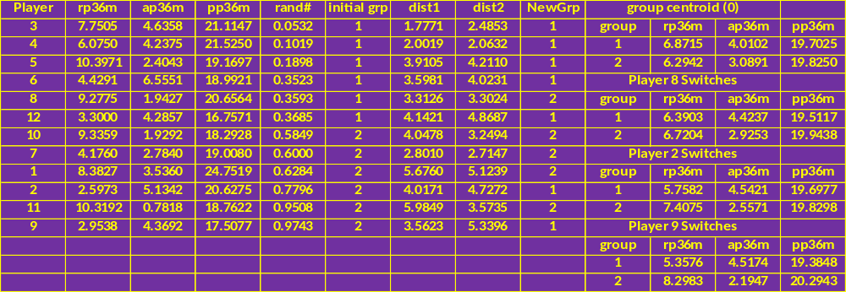
- Give each player a random #, and sort so that 6 are in group 1 and 6 in group 2
- Obtain the mean of the p = 3 variables by group (group centroids)
- Player-by-Player, Obtain the distance from each centroid and move to closest group and re-compute group centroids
- Players 3,4,5,6 remain in group 1
- Player 8 moves to group 2 and centroids re-calculated
- Player 12 distances measured from new centroids (n₁=7, n₂=5) and stays in group 1
- Players 10,7,1 stay in group 2; Player 2 switches to group 1, centroids recalculated
- Player 11 remains in group 2; Player 9 switches to group 1, centroids recalculated
- Process continues until no player switches group
Extension to All Players n = 107 Players (Measures per 48 Minutes) with K = 4 Clusters
### Within Cluster Sum of Squares for K = 1,…,10 Clusters
> wss
[1] 4619.5099 2862.6135 2154.0697 1639.2506 1335.3210 1189.3791 1069.6896
[8] 915.8536 875.8938 710.3843

> wnba.kmean4 <- kmeans(per48m,4, nstart=20)
> wnba.kmean4
K-means clustering with 4 clusters of sizes 35, 33, 27, 12

Cluster means:
rp48m ap48m pp48m
1 6.512356 3.681647 12.44942
2 4.854402 5.445196 20.09424
3 11.857918 2.355189 16.30930
4 11.955291 3.117783 25.47779

Clustering vector:
2 1 9 5 22 24 13 25 14 10 20 36 15 17 18 6 32 3 23 16
2 4 2 4 2 2 4 3 4 4 2 3 2 2 2 2 2 4 4 4
19 30 28 4 29 42 59 37 40 41 11 52 51 8 38 46 21 26 35 31
2 2 3 4 2 3 1 3 3 2 4 1 1 4 2 1 2 2 3 2
70 12 50 43 39 44 83 47 45 27 7 69 49 57 33 68 53 66 34 48
3 2 3 2 3 3 1 2 3 2 2 1 1 1 2 1 2 1 4 2
62 64 65 72 56 75 71 73 61 54 55 60 80 63 74 67 58 94 79 84
3 1 3 1 1 1 1 3 2 2 3 2 1 2 1 3 2 1 1 3
90 91 77 82 85 78 76 100 101 95 81 93 96 89 102 88 87 105 92 97
1 1 3 3 3 1 2 1 1 1 3 1 1 1 1 1 3 1 2 3
86 98 106 99 107 103 104
3 3 1 1 1 3 1

Within cluster sum of squares by cluster:
[1] 518.3470 474.2381 374.5423 197.5021
(between_SS / total_SS = 66.1 %)

### 1 – (518.3470 474.2381 374.5423 197.5021)/ 4619.5099 = 0.661

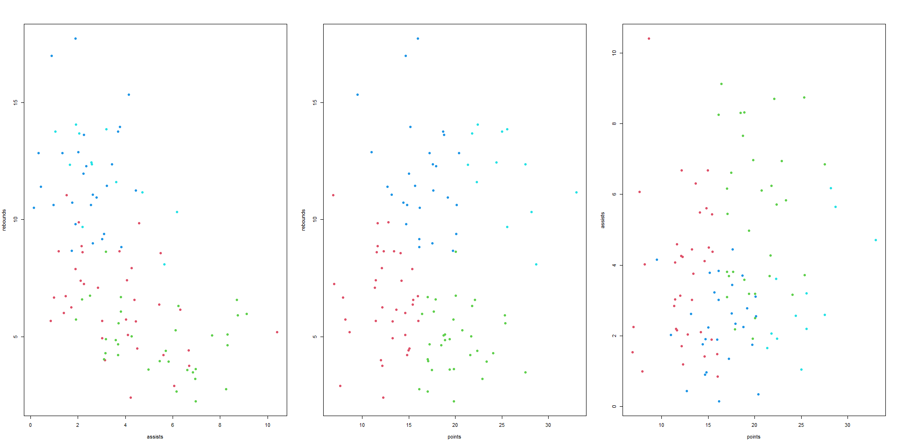

Hierarchical Clustering Methods
- Agglomerative Methods – Begin with individual units or variables and combine until a single cluster
- Linking Strategies for Combining Clusters:
  - Single Linkage – Minimum distance between objects in clusters
  - Complete Linkage – Maximum distance between objects in clusters
  - Average Linkage – Mean distance between objects in clusters
- Dendogram – 2-dimensional diagram of process

Example – Clustering of 5 WNBA Players
n = 5 Players (Angel McCoughtry, Candace Parker, Maya Moore, Skylar Duggins, Tina Charles)
p = 3 Variables (Rebounds, Assists, Points, each per 36 Minutes played)
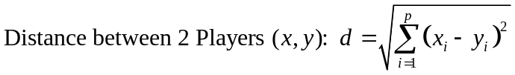
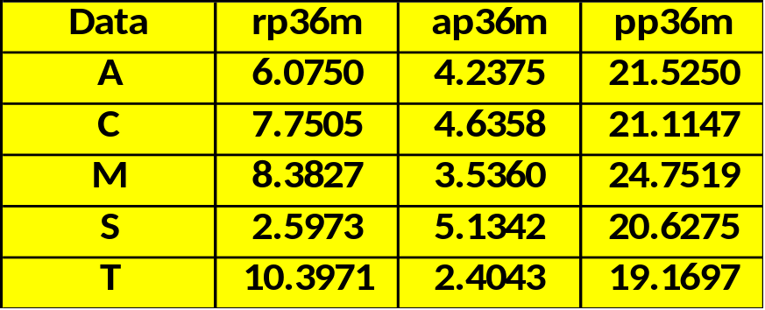
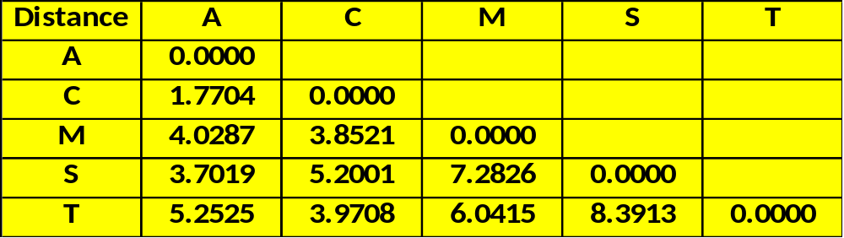

Clustering of 5 WNBA Players – Single Linkage (Minimum Distance Between Clusters)
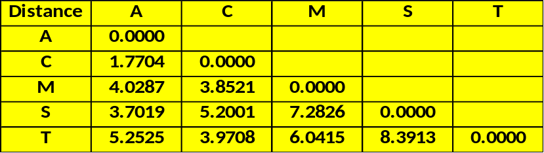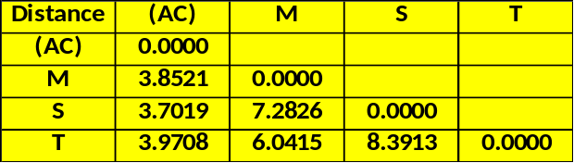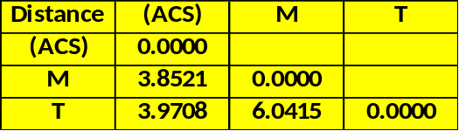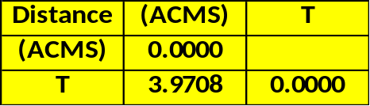
Step 1: Closest 2 are AM, CP
=> Combine AM/CP
Step 2:
d_{M,AC} = min(3.8521 , 4.0287) = 3.8521
d_{S,AC} = min(5.2001 , 3.7019) = 3.7019
d_{T,AC} = min(3.9708 , 5.2525) = 3.9708
- Smallest Distance in Table is 3.7019 (ACS)
Step 3:
d_{M,ACS} = min(7.2826 , 3.8521 , 4.0287) = 3.8521
d_{T,ACS} = min(8.3913 , 3.9708 , 5.2525) = 3.9708
- Smallest Distance in Table is 3.8521 (ACMS)
Step 4: Add T (ACMST)

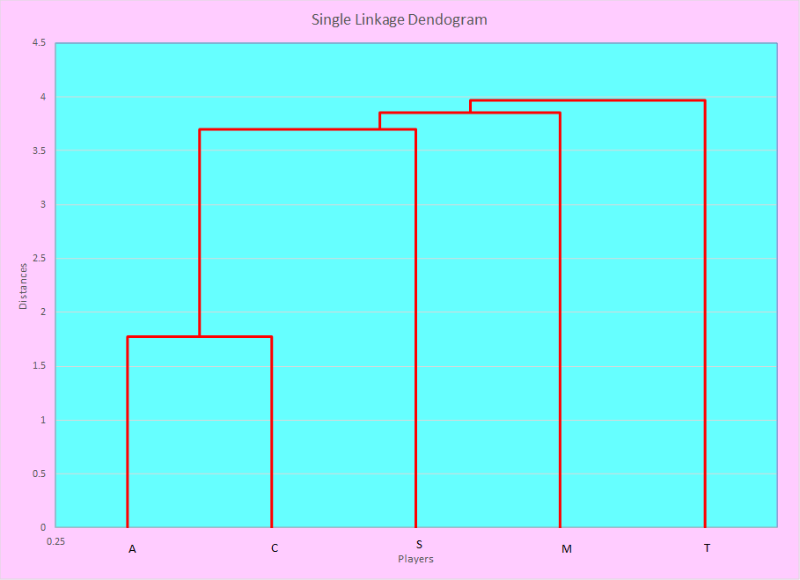
Clustering of 5 WNBA Players – Complete Linkage
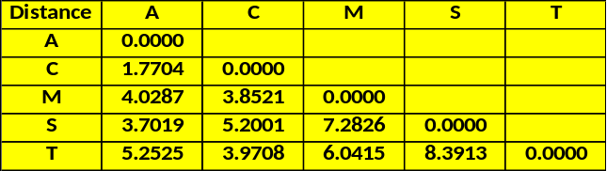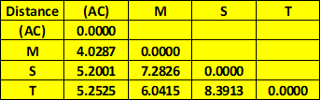
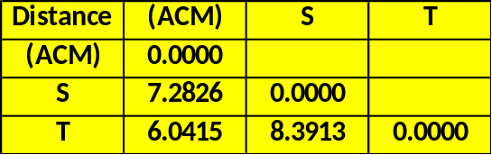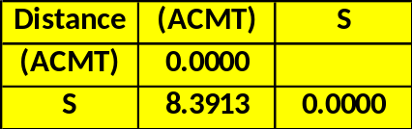
Step 1: Closest 2 are AM, CP
=> Combine AM/CP
Step 2:
d_{M,(AC)} = max(3.8521 , 4.0287) = 4.0287
d_{S,(AC)} = max(5.2001 , 3.7019) = 5.2001
d_{T,(AC)} = max(3.9708 , 5.2525) = 5.2525
- Smallest Distance in Table is 4.0287 (ACM)
Step 3:
d_{S,(ACM)} = max(7.2826 , 5.2001 , 3.7019) = 7.2826
d_{T,(ACM)} = max(6.0415 , 3.9708 , 5.2525) = 6.0415
- Smallest Distance in Table is 6.0415 (ACMT)
Step 4: Add S (ACMST)

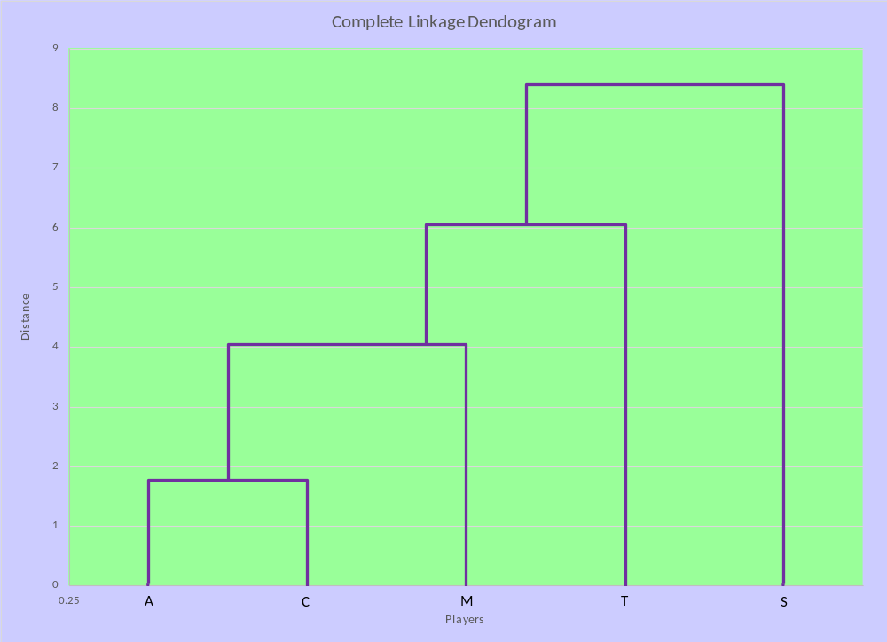

Clustering of 5 WNBA Players – Average Linkage
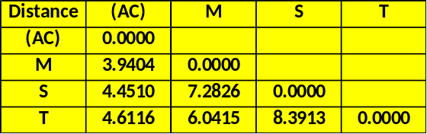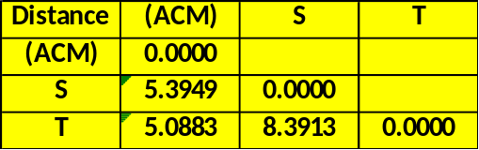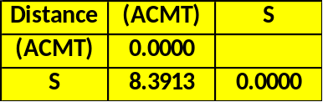
Step 1: Closest 2 are AM, CP
=> Combine AM/CP
Step 2:
d_{M,(AC)} = mean(3.8521 , 4.0287) = 3.9404
d_{S,(AC)} = mean(5.2001 , 3.7019) = 4.4510
d_{T,(AC)} = mean(3.9708 , 5.2525) = 4.6117
- Smallest Distance in Table is 3.9404 (ACM)
Step 3:
d_{S,(ACM)} = mean(7.2826 , 5.2001 , 3.7019) = 5.3949
d_{T,(ACM)} = mean(6.0415 , 3.9708 , 5.2525) = 5.0883
- Smallest Distance in Table is 5.0883 (ACMT)
Step 4: Add S (ACMST)

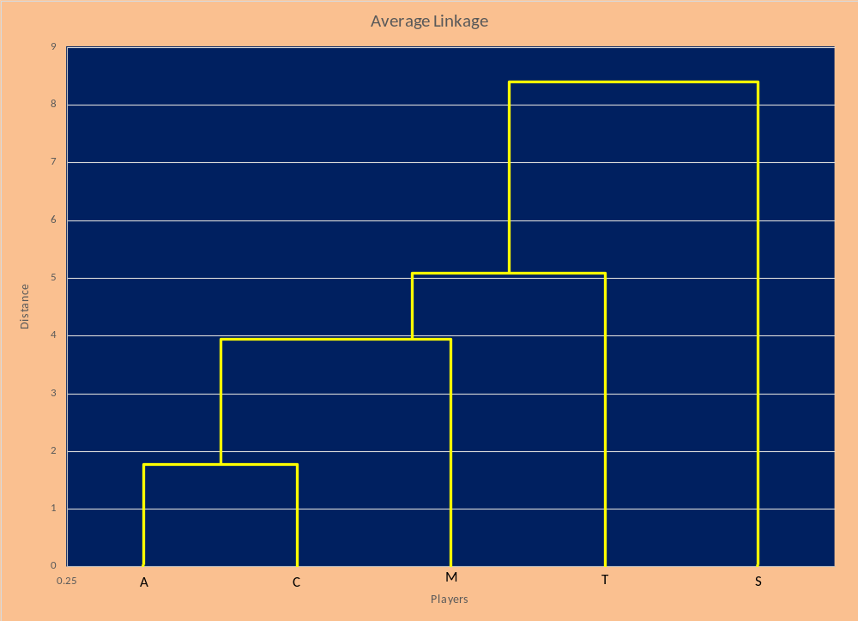
Dendogram with all 107 Players (per 48 minutes) Based on Complete Linkage
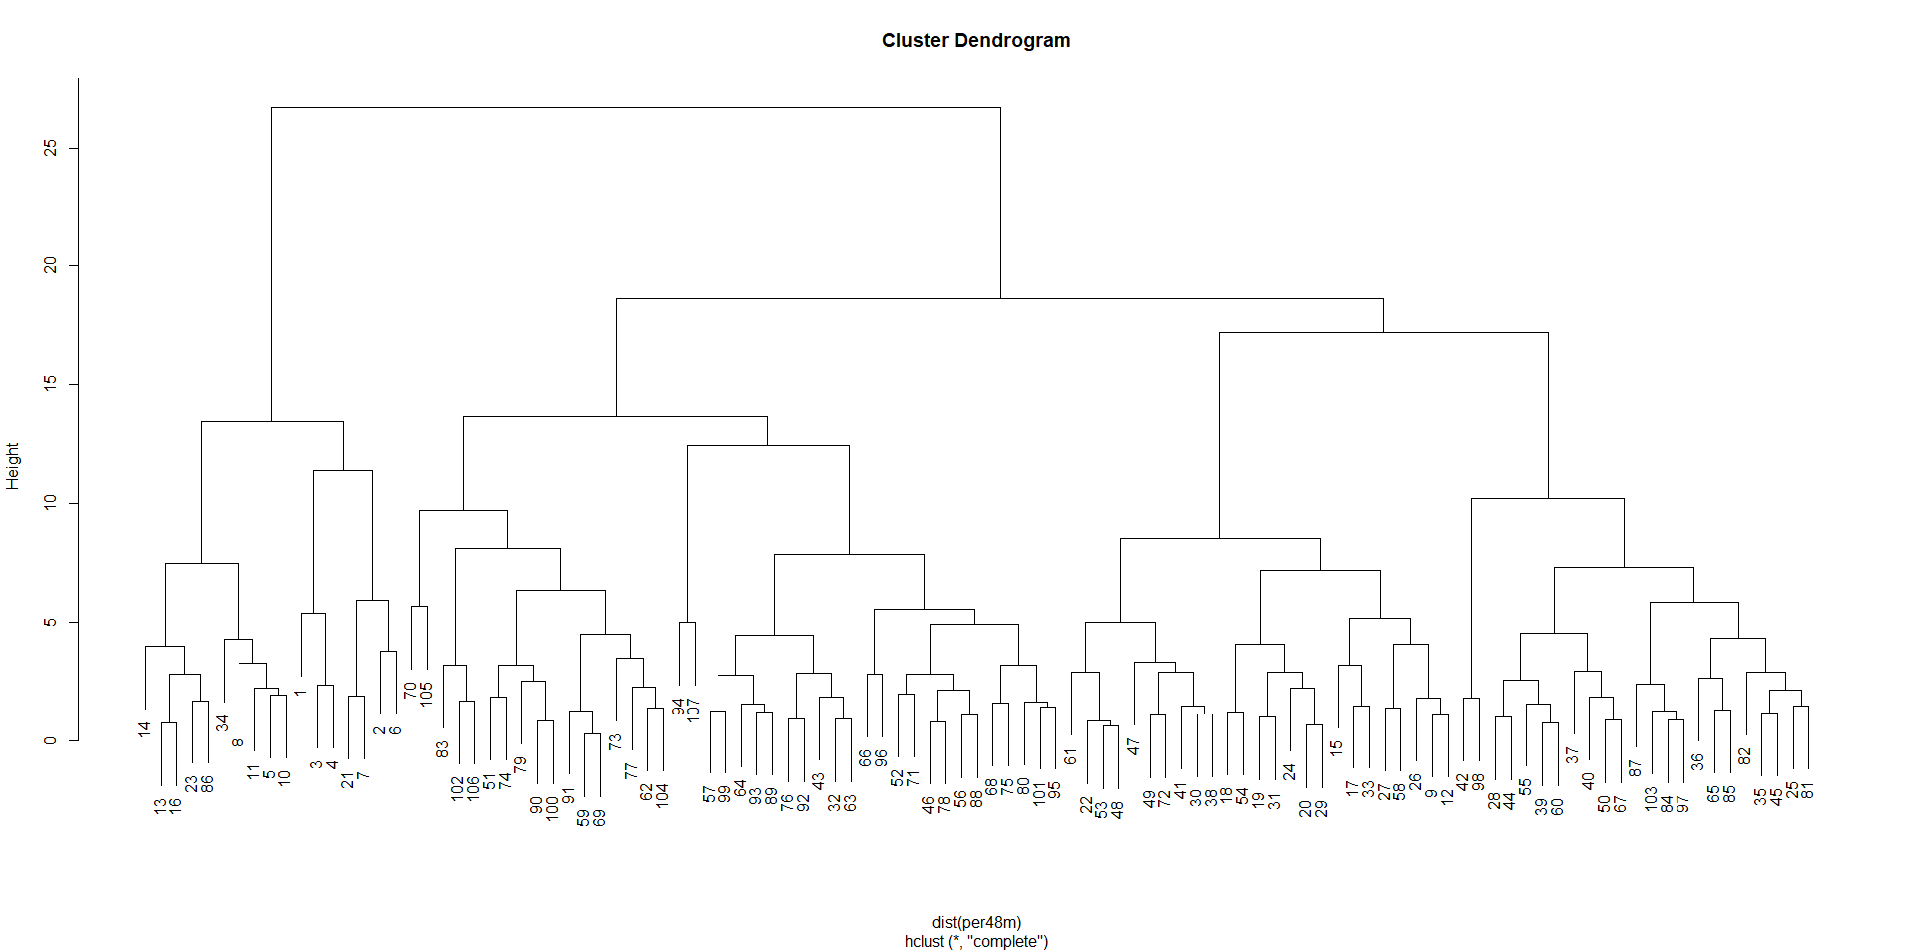
Adding a Cut-point at h = 15 to create 4 Clusters
