STA 3180 – Classification (Chapter 4) – Practice Problems

Part 1: Hammond and Horn Study of Smoking and Death (1954) – Logistic Regression w/ Grouped data
Prospective study: Y = Death over study period: Predictors: Smoking Status (1=Yes, 0=No), Age

sd <- read.table("http://www.stat.ufl.edu/~winner/data/smkdth.dat",
header=F, col.names=c("smoke", "age", "death", "numcases"))
sd

y <- sd$numcases[sd$death==1] ### number of deaths
n_y <- sd$numcases[sd$death==0] ### number of non-deaths
age1 <- rep(c(52.5,57.5,62.5,67.5), times=2) ### mid-age by age group
age2 <- rep(c(52.0,56.9,61.9,66.9), times=2) ### mid-age from 1950 census
smoke <- rep(0:1, each=4) ### smoker dummy variable
sd1 <- data.frame(y,n_y,age1,age2,smoke) ### data frame for analysis
sd1

sd1$death.live <- cbind(sd1$y, sd1$n_y) ### (y, n-y) for grouped glm

> sd1
y n_y age1 age2 smoke
1 204 20132 52.5 52.0 0
2 394 21671 57.5 56.9 0
3 488 19790 62.5 61.9 0
4 766 16499 67.5 66.9 0
5 647 39990 52.5 52.0 1
6 857 32894 57.5 56.9 1
7 855 20739 62.5 61.9 1
8 643 11197 67.5 66.9 1
>
> sd1$death.live <- cbind(sd1$y, sd1$n_y) ### (y, n-y) for grouped glm
>
> mod1 <- glm(death.live ~ smoke, binomial, data=sd1) ### Smoke as predictor
> summary(mod1)

Coefficients:
Estimate Std. Error z value Pr(>|z|)
(Intercept) -3.74162 0.02351 -159.146 < 2e-16 ***
smoke 0.18866 0.02992 6.305 2.89e-10 ***

> mod2 <- glm(death.live ~ smoke + age1, binomial, data=sd1) ### Smoke and age
> summary(mod2)

Coefficients:
Estimate Std. Error z value Pr(>|z|)
(Intercept) -9.233471 0.173405 -53.25 <2e-16 ***
smoke 0.374459 0.030569 12.25 <2e-16 ***
age1 0.090154 0.002765 32.61 <2e-16 ***

> mod3 <- glm(death.live ~ smoke * age1, binomial, data=sd1) ### Interaction
> summary(mod3)

Call:
glm(formula = death.live ~ smoke * age1, family = binomial, data = sd1)

Coefficients:
Estimate Std. Error z value Pr(>|z|)
(Intercept) -9.742695 0.288352 -33.788 < 2e-16 ***
smoke 1.166288 0.356204 3.274 0.00106 **
age1 0.098336 0.004610 21.331 < 2e-16 ***
smoke:age1 -0.012894 0.005774 -2.233 0.02554 *

- Based on mod1, is the probability of death associated with whether the man smoked? Give the test statistic and P-value
- Based on mod1, give the predicted probabilities of death for non-smokers and for smokers
- Based on mod1, give the odds ratio of death for smokers versus non-smokers
- Based on mod2, is the probability of death associated with whether the man smoked, controlling for age? Give the test statistic and P-value
- Based on mod2, is the probability of death associated with age, controlling for whether the man smoked? Give the test statistic and P-value
- Based on mod2, give the following predicted probabilities of death: (smoke=1, age=52.5), (0, 52.5), (1,67.5), (0,67.5)
- Based on mod2, give the odds ratio for smokers versus non-smokers, controlling for age
- Based on mod2, give the odds ratio for increasing age by 1 year, controlling for smoking status
- Based on mod3, test whether the interaction between smoking and age is significant. Give the test statistic and P-value
- Based on mod3, give the following predicted probabilities of death: (smoke=1, age=52.5), (0, 52.5), (1,67.5), (0,67.5)

Part 2: Ions and Ethanol Associated with Original and Fake Perfume Specimens
Y=1 if Original, 0 if Fake: Predictors: Ethnol, Chl, Na, K

> mod1c <- glm(Original.f ~ NaMn, binomial)
> summary(mod1c)

Coefficients:
Estimate Std. Error z value Pr(>|z|)
(Intercept) -2.52117 0.77797 -3.241 0.001192 **
NaMn 0.28300 0.08125 3.483 0.000496 ***

> mod1d <- glm(Original.f ~ KMn, binomial)
> summary(mod1d)

Coefficients:
Estimate Std. Error z value Pr(>|z|)
(Intercept) -1.6422 0.6422 -2.557 0.0106 *
KMn 0.2824 0.1145 2.467 0.0136 *

> mod1cd <- glm(Original.f ~ NaMn + KMn, binomial)
> summary(mod1cd)

Call:
glm(formula = Original.f ~ NaMn + KMn, family = binomial)

Coefficients:
Estimate Std. Error z value Pr(>|z|)
(Intercept) -5.7077 1.6139 -3.537 0.000405 ***
NaMn 0.3692 0.1154 3.201 0.001371 **
KMn 0.4070 0.1707 2.384 0.017148 *

- Based on mod1c, is the probability the perfume is original associated with Na level?
- Based on mod1c, is the predicted probability of perfume being original increasing or decreasing as Na increases
- Based on mod1c, at what Na level is the probability is original equal to 0.5?
- Based on mod1d, is the probability the perfume is original associated with K level?
- Based on mod1d, is the predicted probability of perfume being original increasing or decreasing as K increases
- Based on mod1d, at what K level is the probability is original equal to 0.5?
- Based on mod1cd, is the probability the perform is original associated with Na, controlling for K?
- Based on mod1cd, is the probability the perform is original associated with K, controlling for Na?

> lda.fit3
Call:
lda(Original.f ~ NaMn + KMn)

Prior probabilities of groups:
fake orig
0.5 0.5

Group means:
NaMn KMn
fake 5.2732 4.3148
orig 13.5784 8.8024

Coefficients of linear discriminants:
LD1
NaMn 0.1642687
KMn 0.1606309

> p3 <- predict(lda.fit3, perf1)$class
> tab3 <- table(Predicted=p3, Actual=Original.f)
> tab3
Actual
Predicted fake orig
fake 24 4
orig 1 21

- The coefficients of linear discriminants can be multiplied by the centered NaMn and KMn values for each specimen. If the linear combination is positive, the specimen is classified as Original, and if it is negative it is classified as Fake. The overall mean for NaMn is (5.2732+13.5784) / 2 = 9.4258 (this is only because the number of fakes and originals are the same, and both prior probabilities are 0.5). Similarly, for KMn, the overall mean is (4.3148+8.8024) / 2 = 6.5586. For the first specimen, NaMn = 11.60, KMn = 4.50 (these are uncentered values), compute the LD1 score for this specimen and would it be classified as Original or Fake? Repeat for the 42nd specimen, with NaMn = 0.71, KMn = 2.92. The first specimen was Fake and the 42nd was original, were they correctly classified.
- Based on the confusion matrix (tab3), what is the sensitivity, specificity, positive predictive value (PPV), negative predictive value (NPV), and overall activity of this classification model. Note that the “target” is detecting Original (which is acting as “Disease” in diagnostic testing) in lda.fit3.

Part 3: Classifying NBA and WNBA Players by Body Mass Index (BMI)
Consider the classification of NBA and WNBA players from the class lecture. We have the following means and standard deviations for the two leagues. We will use the pooled variance as the unweighted mean of the two variances throughout for ease of computations. We will use the normal density for x in all cases.
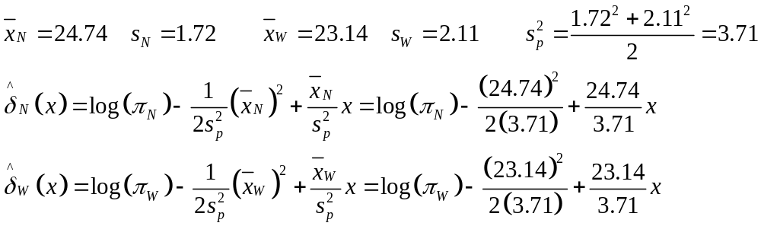
- Give the “cut-off” values for classifying players as NBA vs WNBA when π_{N} = 0.5 and π_{W} = 0.5
- Give the “cut-off” values for classifying players as NBA vs WNBA when π_{N} = 0.8 and π_{W} = 0.2
- For part a) what proportion of NBA players are correctly classified? That is, what’s the probability that X > CU_{a} when X ~ N(μ = 24.74, σ² = 3.71).
- For part a) what proportion of WNBA players are correctly classified? That is, what’s the probability that X < CU_{a} when X ~ N(μ = 23.14, σ² = 3.71)
- Repeat parts c) and d) for part b).
- Suppose there are 1000 players total from parts a), c) and d). Give a table depicting Predicted (rows) and Actual (Columns), and cell counts. Let sensitivity be in terms of NBA players and specificity in terms of WNBA players. Compute sensitivity, specificity, PPV, NPV, and overall accuracy.
- Repeat f) for parts b) and e).

Part 4: Classifying NHL, NBA, and EPL Players by BMI
Plots of histograms and idealized normal distributions from full data set:
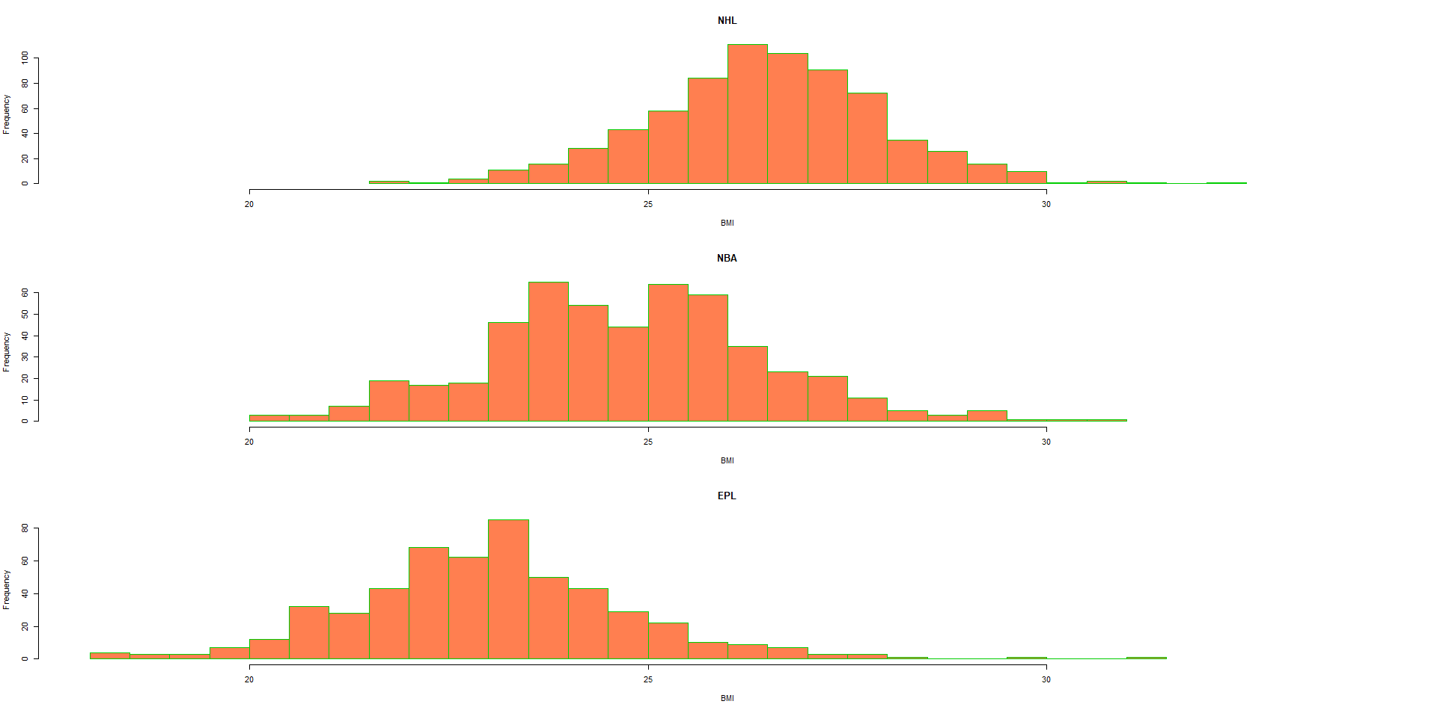

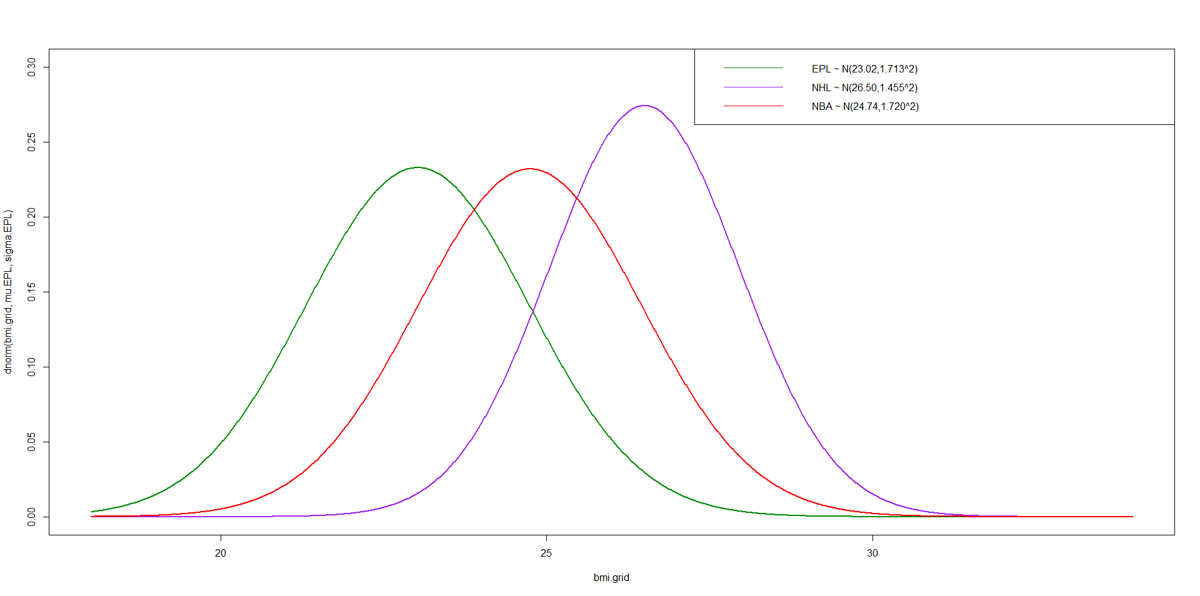
We now 50/50 split the 3 league datasets into training and test samples (with seed = 54321). The results for the training samples are given below, where s_{p}² is the weighted (by prior probabilities) average of the league variances.

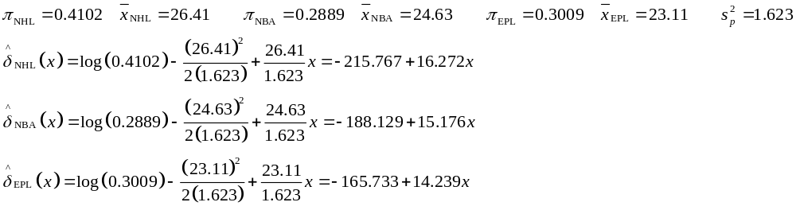
- Compute the values for BMI levels, 22, 23, 24, and 25. Which leagues would players with those BMI levels be assigned to?
- Let 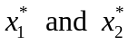represent the cut-off between EPL and NBA players, and the cut-off between NBA and NHL players, respectively. Compute these values by equating the values for the two pairs of leagues.
> (conf.tab.train <-
+ table(Predicted=BMI.train.classify, Actual=BMI.train.actual))
Actual
Predicted EPL NBA NHL
EPL 191 90 18
NBA 44 55 38
NHL 28 107 302
> (conf.tab.test <- table(Predicted=BMI.test.classify,Actual=BMI.test.actual))
Actual
Predicted EPL NBA NHL
EPL 199 80 14
NBA 35 51 35
NHL 29 122 310

- Among the training sample:
  - What proportion of athletes are correctly classified
  - What proportion of NHL players are correctly classified?
  - What proportion of NBA players are mis-classified?
  - What proportion of players that are classified as EPL are actually EPL players?
- Among the test sample:
  - What proportion of athletes are correctly classified
  - What proportion of NHL players are correctly classified?
  - What proportion of NBA players are mis-classified?
  - What proportion of players that are classified as EPL are actually EPL players?

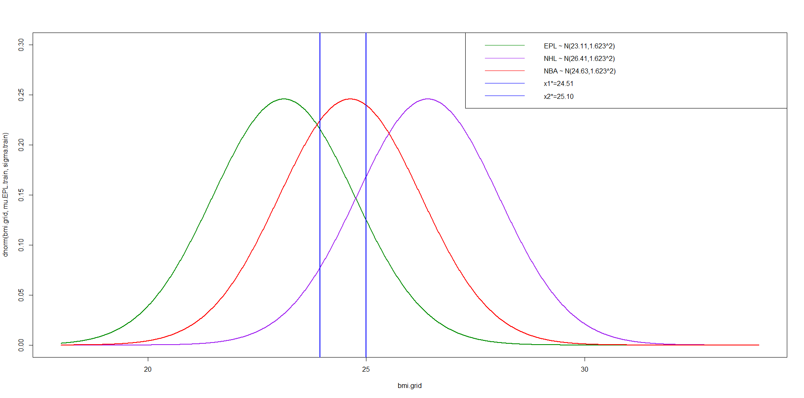
A multinomial logistic regression model was fit, relating the probability that a player played in a particular league, given his BMI. The model and estimated regression coefficients are given below. Note that the levels of league are assigned in alphanumeric level of names (1=EPL, 2=NBA, 3=NHL).
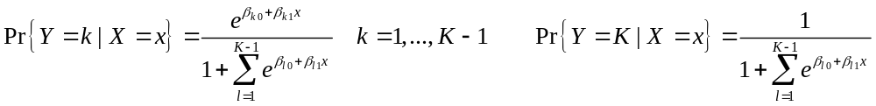
> mlr.fit.train <- vglm(league ~ BMI, data=train.all, family=multinomial)
> summary(mlr.fit.train)
Coefficients:
Estimate Std. Error z value Pr(>|z|)
(Intercept):1 30.63875 1.97988 15.47 <2e-16 ***
(Intercept):2 17.28612 1.61869 10.68 <2e-16 ***
BMI:1 -1.24824 0.08002 -15.60 <2e-16 ***
BMI:2 -0.69070 0.06345 -10.89 <2e-16 ***
Names of linear predictors: log(mu[,1]/mu[,3]), log(mu[,2]/mu[,3])

- Obtain the fitted probabilities for each league for BMI levels 22, 23, 24, and 25. Which leagues would players with those BMI levels be assigned to?
> conf.tab.train2 <- table(Predicted=p.train2, Actual=train.all$league)
> conf.tab.train2
Actual
Predicted EPL NBA NHL
EPL 191 92 18
NBA 44 54 38
NHL 28 106 302

> conf.tab.test2 <- table(Predicted=p.test2, Actual=test.all$league)
> conf.tab.test2
Actual
Predicted EPL NBA NHL
EPL 199 81 14
NBA 35 52 35
NHL 29 120 310

- Among the training sample:
  - What proportion of athletes are correctly classified
  - What proportion of NHL players are correctly classified?
  - What proportion of NBA players are mis-classified?
  - What proportion of players that are classified as EPL are actually EPL players?
- Among the test sample:
  - What proportion of athletes are correctly classified
  - What proportion of NHL players are correctly classified?
  - What proportion of NBA players are mis-classified?
  - What proportion of players that are classified as EPL are actually EPL players?

