**STA 6208 – Spring 2016 – Exam 1 – PRINT Name __________________________**

**Note: Conduct all tests at  = 0.05 significance level and show all your work.**

Q.1. For the balanced completely randomized design with g treatments, and n units per treatment, consider the following (cell means) model:



p.1.a. Derive the least squares estimate of   SHOW ALL WORK

p.1.b. Derive the least squares estimate of k  SHOW ALL WORK

p.1.c. Derive:  SHOW ALL WORK

p.1.d. If you had point estimates for all parameters in the model, how would you set up a 95% Confidence Interval for k - k’ (as a function of n and g)

Q.2. An experiment is conducted with 3 diets, and 4 replicates per diet. Weight loss (Y) is observed from pre-diet at 6 months. Positive values of Y imply the subject has lost weight since the trial began. You are given the following data. Compute the Analysis of Variance, including testing H0:     





Q.3. In an experiment to compare g = 4 cold medications, brands 1 and 2 make use of one chemical, and brands 3 and 4 make use of a second chemical. A researcher is interested in whether there are differences among the effects of the 4 cold medications. In particular, she would like to compare medications within each chemical type, as well as compare the 2 chemical types. The response is a measure of the brand’s ability to keep a cold virus from occurring in the subject.

p.3.a. Give 3 orthogonal contrasts (sets of weights) that will answer her research questions. Show that they are orthogonal.



p.3.b. The sample means and standard deviations for each treatment are given below, based on samples of n = 8 subjects per treatment. Compute SSTRT and MSErr



SSTrt = ____________________________________ MSErr = ______________________________

p.3.c. Compute each of the 3 estimated contrasts, their sums of squares and their corresponding F-statistics and critical F-values



p.3.d. Show that the orthogonal sums of squares add to the Treatment sum of squares.

Q.4. An experiment was conducted on the phenobarbital sleep time of rats when they had been exposed to various fragrances in a Completely Randomized Design. There were 5 fragrances, including a control condition, and there were 10 rats per treatment. MSErr = 16.0. The means are given below.



p.4.a. Compute Tukey’s Honest Significant difference. Draw lines below the treatment labels, joining pairs of treatments that are not significantly different.

Lemon Jasmine Control Sandalwood Rose

p.4.b. Compute Bonferroni’s minimum Significant difference. Draw lines below the treatment labels, joining pairs of treatments that are not significantly different.

Lemon Jasmine Control Sandalwood Rose

p.4.c. Compute Scheffe’s minimum Significant difference. Draw lines below the treatment labels, joining pairs of treatments that are not significantly different.

Lemon Jasmine Control Sandalwood Rose

Q.5. A one-way ANOVA is run as cell means model in matrix form **Y** = **X** + ****    You are given the following matrix and vector:



p.5.a. Complete the following parts:

g = _____________ ns = _______________________________ 

 

Q.6. You would like to obtain the uncorrected sum of squares (USS) for a sample, based on published summary statistics: mean, standard deviation, and sample size. Given their published summary, how would you compute it?



Q.7. A researcher wants to run a 1-Way ANOVA with 3 treatments with  = 0.05 level test of H0: 1 = 2 = 3

An important difference in treatment means he would like to detect is:

p.7.a. He considers balanced designs with n = 5, 10, 15. For each n, give the critical value for the F-test and the non-centrality parameter (2 in the notes from Wednesday’s lecture).



p.7.b. This plot represents the central and non-central F distributions when n = 10. Sketch the area that represents the power of the test for this set of treatment effects.

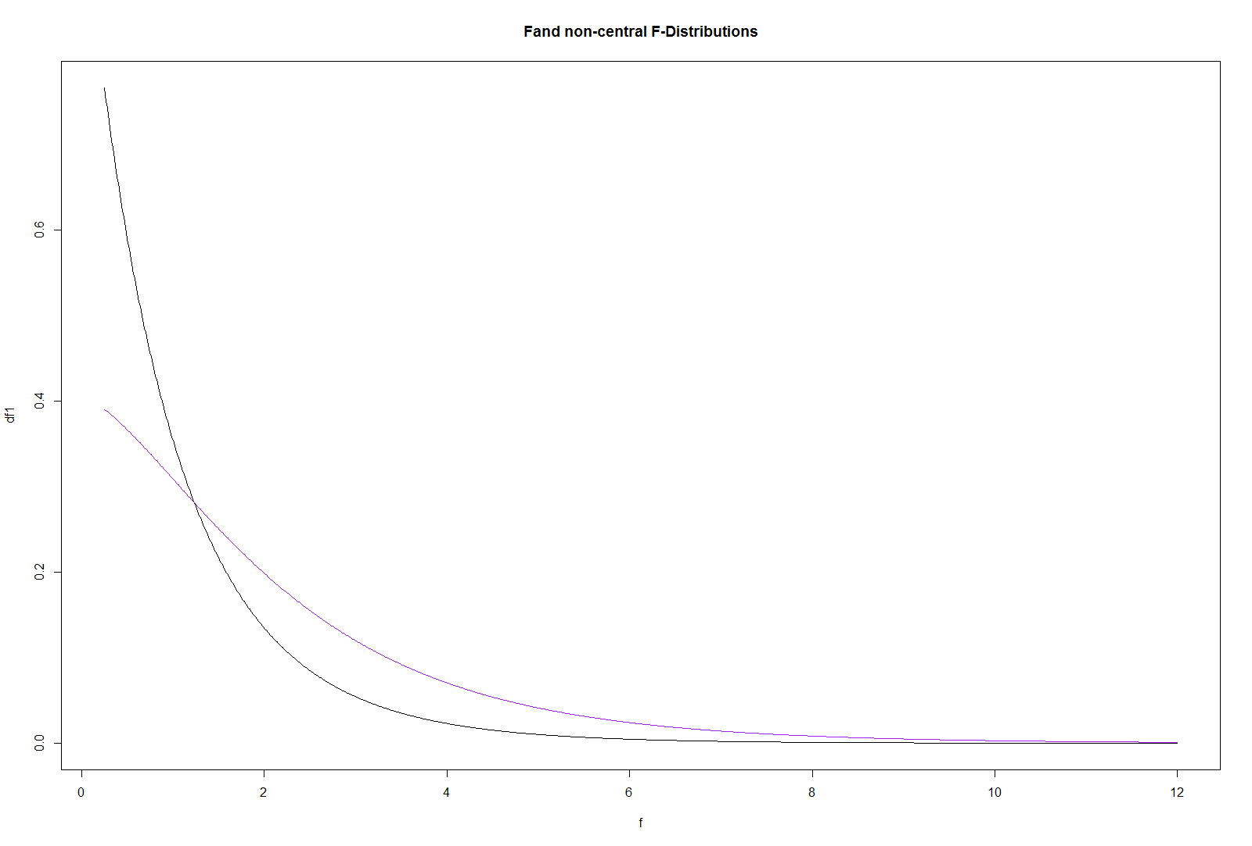

Non-Central F

Central F