Shampoo Comparison Worksheet

Experimental Structure/Elements
- Primary Goal: Compare 2 formulations of shampoo (A vs B) on hair combability
- Experimental Units: 16 hair swatches created from human hair clippings
- Observational Units: Each swatch measured on 5 occasions (runs) both before and after shampoo
- Randomization: Swatches randomized so that 8 receive shampoo A, 8 receive B
Questions:
- How many total measurements obtained? ___________________________________

- How many “true” replications per shampoo? _______________________________

- How many ways to assign the 16 swatches to 8 for A, 8 for B? __________________

Results (Data Averaged over Swatch’s 5 runs):
swatch | shampoo | period0 | period1 |  | Period1 | Sh1 | Sh2 | PooledSD
1 | 1 | 180.8 | 166.4 |  | Mean | 116.775 | 124.500
2 | 1 | 249.4 | 161.8 |  | SD | 43.377 | 48.651 | 46.090
3 | 1 | 73.2 | 70.2
4 | 1 | 136.8 | 126.6 |  | ybar1-2
5 | 1 | 125.8 | 126.8 |  | se(yb1-2)
6 | 1 | 130.2 | 97.2 |  | t-stat
7 | 1 | 158.2 | 141.4
8 | 1 | 50.0 | 43.8
9 | 2 | 144.4 | 173.2
10 | 2 | 153.8 | 145.2 |  | Period0 | Sh1 | Sh2 | PooledSD
11 | 2 | 201.6 | 180.6 |  | Mean | 138.050 | 123.225
12 | 2 | 132.0 | 136.0 |  | SD | 61.880 | 42.623 | 53.131
13 | 2 | 90.0 | 84.0
14 | 2 | 76.0 | 66.0 |  | ybar1-2 | 14.825
15 | 2 | 100.0 | 154.0 |  | se(yb1-2) | 26.566
16 | 2 | 88.0 | 57.0 |  | t-stat | 0.558

- Conduct the 2-sample t-test to determine whether the (Period 1) mean combabilities differ for the 2 shampoos: H₀: μ_{A} − μ_{B} = 0 H_{A}: μ_{A} − μ_{B} ≠ 0
Point Estimate: 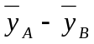= __________________________________________

Std. Error: 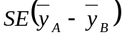 = ____________________________________________
t- Statistic __________________________________________________________
Rejection Region (α=0.05): _________________________________________

- Conduct the Analysis of Covariance (Multiple regression) to determine whether the (Period 1) mean combabilities differ for the 2 shampoos, controlling for pre-shampoo levels: H₀: β_{A} = 0 H_{A}: β_{A} ≠ 0 for the model: 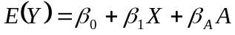
(X = pre-shampoo score, A=1 if Shampoo A, 0 if shampoo B)
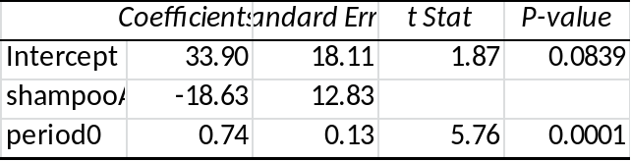
Point Estimate: 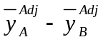= __________________________________________
Std. Error: 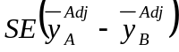 = ____________________________________________
t- Statistic __________________________________________________________
Rejection Region (α=0.05): _________________________________________
- Conduct a “simulated” randomization test to determine whether the (Period 1) mean combabilities differ for the 2 shampoos: H₀: μ_{A} − μ_{B} = 0 H_{A}: μ_{A} − μ_{B} ≠ 0
Point Estimate: = __________________________________________
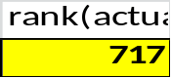
# of abs(Randomization Differences) larger than observed _______________

Observed significance level________________________________

