STA 6167 – Exam 1 – Spring 2014 – PRINT Name _______________________
For all significance tests, use α = 0.05 significance level.
Q.1. A simple linear regression was fit relating number of species of arctic flora observed (Y) and July mean temperature (X, in Celsius). The results of the regression model, based on n=19 temperature stations is given below.
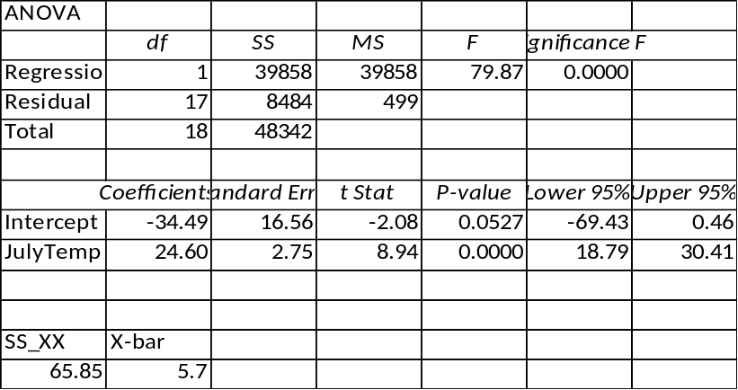
p.1.a. What proportion of the variation in number of species is “explained” by mean July temperature?

p.1.b. Compute a 95% Confidence Interval for the population mean number of species, with mean July temperature of 6 degrees.

p.1.c. Compute a 95% Prediction Interval for the number of species, at a single station with mean July temperature of 6 degrees.

Q.2. An experiment was conducted, relating the penetration depth of missiles (Y) to its impact factor (X). The results from the regression, and the residual versus fitted plot are given below (n=25).
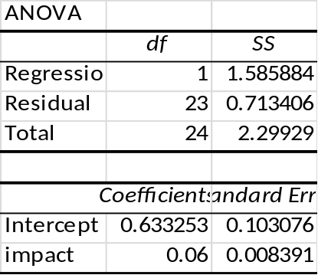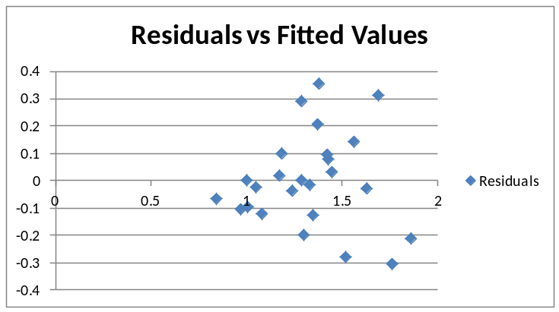
p.2.a. Test H₀: β₁ = 0 (Penetration depth is not associated with impact factor) based on the t-test.

Test Statistic: _____________________________________ Rejection Region: _______________________

p.2.b. Test H₀: β₁ = 0 (Penetration depth is not associated with impact factor) based on the F-test.

Test Statistic: _____________________________________ Rejection Region: _______________________

p.2.c. The residual plot appears to display non-constant error variance. A regression of the squared residuals on the impact factors (X) is fit, and the ANOVA is given below. Conduct the Breusch-Pagan test to test whether the errors are related to X. Do you reject the null hypothesis of constant variance? Yes or No
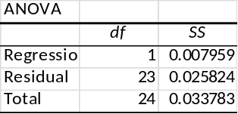

Test Statistic: _____________________________________________ Rejection Region: _____________________
Q.3. An experiment was conducted to measure air permeability of fabric (Y) as a function of the following factors: warp density (X₁), weft density (X₂), and Mass per unit area (X₃). There were n=30 observations, and 4 models are fit:
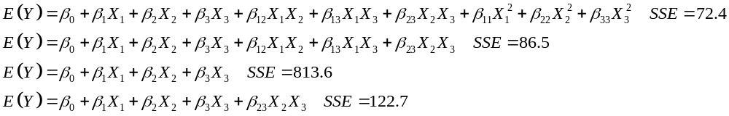
p.3.a. Use the first two models to test H₀: β₁₁ = β₂₂ = β₃₃ = 0.

Test Statistic: ______________________________________________ Rejection Region: ___________________
p.3.b. Use the 3rd and 4th models to test whether the weft-mass interaction is significant, controlling for all main effects.

Test Statistic: ______________________________________________ Rejection Region: ___________________
Q.4. A regression model was fit, relating the share of big 3 television network prime-time market share (Y, %) to household penetration of cable/satellite dish providers (X = MVPD) for the years 1980-2004 (n=25). The regression results and residual versus time plot are given below.
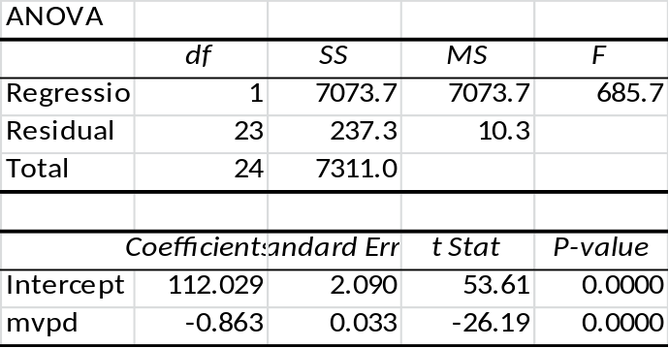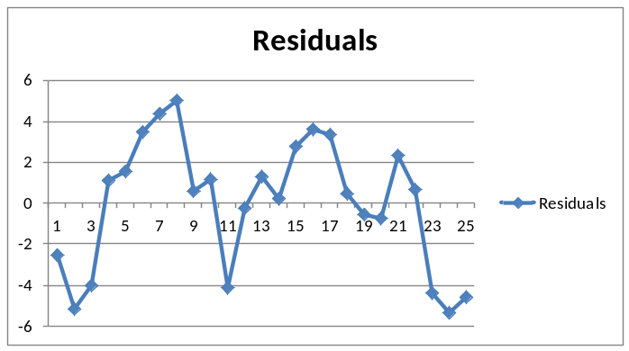
p.4.a. Compute the correlation between big 3 market share and MVPD.

p.4.b. The residual plot appears to display serial autocorrelation over time. Conduct the Durbin-Watson test, with null hypothesis that residuals are not autocorrelated.

Test Statistic: ____________________________________ Reject H₀? Yes or No
p.4.c. Data were transformed to conduct estimated generalized least squares (EGLS), to account for the auto-correlation. The parameter estimates and standard errors are given below. Obtain 95% confidence intervals for β₁, based on Ordinary Least Squares (OLS) and EGLS. Note that the error degrees’ of freedom are 23 for OLS and 22 for EGLS (estimated the autocorrelation coefficient).
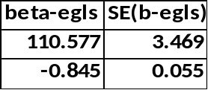

OLS 95% CI: ____________________________________ EGLS 95% CI: _________________________________
Q.5. Regression analyses were fit, relating various chemical levels to age for stranded bottlenose dolphins in South Carolina and Florida.
This plot gives the quadratic fit, relating mercury/selenium molar ratio (Y) to age (X) for the Florida dolphins. Complete the following parts. Note: The data were NOT centered. The model fit was: E(Y) = β₀ + β₁X + β₂X²
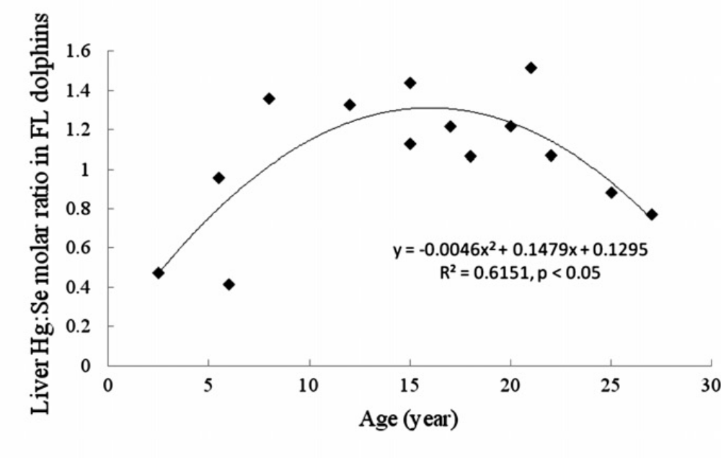

n = ____________ Predicted value when age = 15 ______________________________________________

Test H₀: β₁ = β₂ = 0

Test Statistic: ________________________________ Rejection Region: __________________________

Q.6. A study was conducted to determine which factors were associated with percent release (Y) of hydroxypropyl methylcellulose (HPMC) tablets. The factors were:
X1 = Carr’s compressibility index,
X2 = angle of repose,
X3 = solubility,
X4 =molecular weight,
X5 = compression force
X6 = apparent viscosity of 4% (w/v) HPMC.

The sample size was n=18, and the authors reported the fit of the following models.

p.6.a. Complete the table in terms of AIC and SBC (BIC).

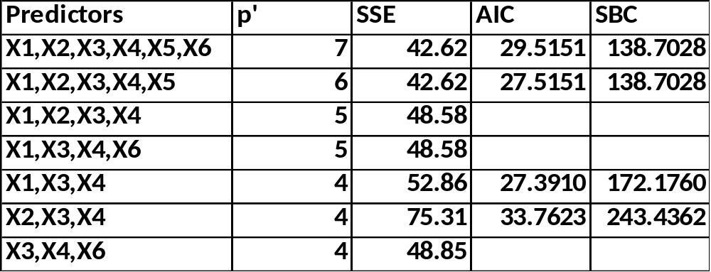

p.6.b. Which model is “best” based on AIC: ___________________________ BIC: ___________________________
p.6.c. R² for the complete model was 0.9278. Compute the total (corrected) sum of squares (TSS):

