Chapter 1 – Linear Regression with 1 Predictor

Statistical Model

where:

- is the (random) response for the i^{th} case
- 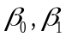 are parameters
- 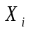 is a known constant, the value of the predictor variable for the i^{th} case
- 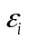 is a random error term, such that:

The last point states that the random errors are independent (uncorrelated), with mean 0, and variance 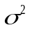. This also implies that:

Thus, 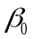 represents the mean response when 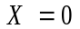 (assuming that is reasonable level of 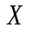), and is referred to as the Y-intercept. Also, 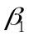 represent the change in the mean response as increases by 1 unit, and is called the slope.

Least Squares Estimation of Model Parameters

In practice, the parameters and are unknown and must be estimated. One widely used criterion is to minimize the error sum of squares:

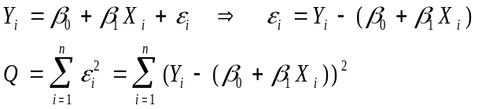

This is done by calculus, by taking the partial derivatives of 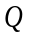 with respect to and and setting each equation to 0. The values of and that set these equations to 0 are the least squares estimates and are labelled 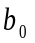 and 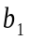.

First, take the partial derivates of with respect to and :
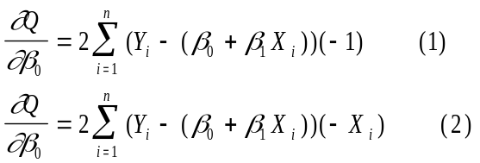

Next, set these these 2 equations to 0, replacing and with and since these are the values that minimize the error sum of squares:

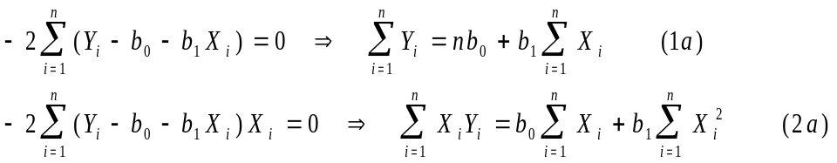

These two equations are referred to as the normal equations (although, note that we have said nothing YET, about normally distributed data).

Solving these two equations yields:

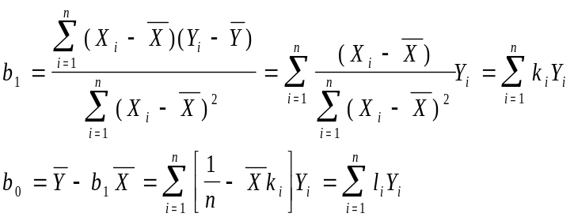

where 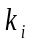 and are constants, and is a random variable with mean and variance given above:

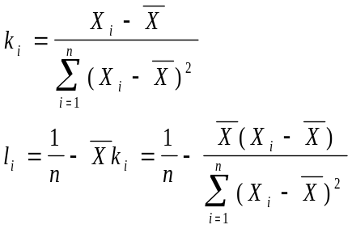

The fitted regression line, also known as the prediction equation is:

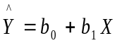

The fitted values for the individual observations aye obtained by plugging in the corresponding level of the predictor variable () into the fitted equation. The residuals are the vertical distances between the observed values () and their fitted values (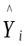), and are denoted as .

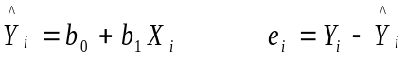

Properties of the fitted regression line

- 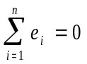 The residuals sum to 0
- 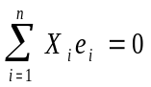 The sum of the weighted (by ) residuals is 0
- 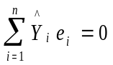 The sum of the weighted (by ) residuals is 0
- The regression line goes through the point (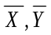)

These can be derived via their definitions and the normal equations.

Estimation of the Error Variance

Note that for a random variable, its variance is the expected value of the squared deviation from the mean. That is, for a random variable , with mean 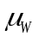 its variance is:

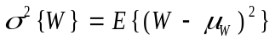

For the simple linear regression model, the errors have mean 0, and variance . This means that for the actual observed values , their mean and variance are as follows:

First, we replace the unknown mean 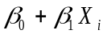 with its fitted value 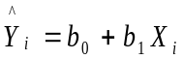, then we take the “average” squared distance from the observed values to their fitted values. We divide the sum of squared errors by n-2 to obtain an unbiased estimate of (recall how you computed a sample variance when sampling from a single population).
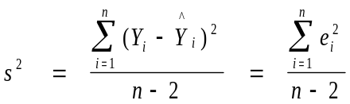

Common notation is to label the numerator as the error sum of squares (SSE).

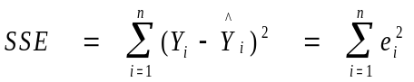

Also, the estimated variance is referred to as the error (or residual) mean square (MSE).

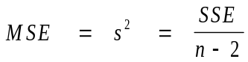

To obtain an estimate of the standard deviation (which is in the units of the data), we take the square root of the erro mean square. 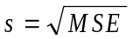.

A shortcut formula for the error sum of squares, which can cause problems due to round-off errors is:

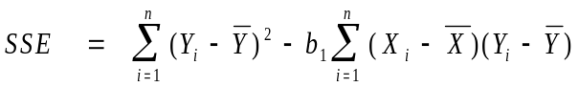

Some notation makes life easier when writing out elements of the regression model:

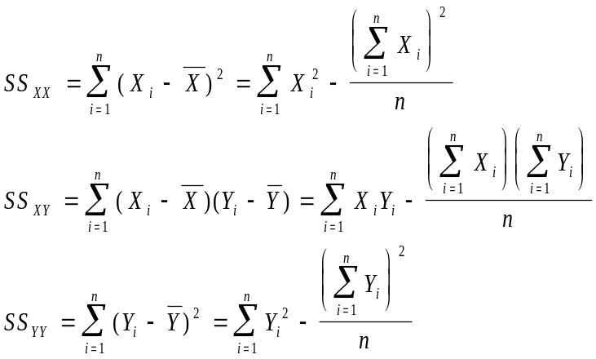

Note that we will be able to obtain most all of the simple linear regression analysis from these quantities, the sample means, and the sample size.

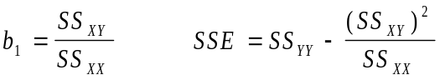

Normal Error Regression Model

If we add further that the random errors follow a normal distribution, then the response variable also has a normal distribution, with mean and variance given above. The notation, we will use for the errors, and the data is:

The density function for the i^{th} observation is:

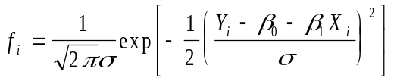

The likelihood function, is the product of the individual density functions (due to the independence assumption on the random errors).

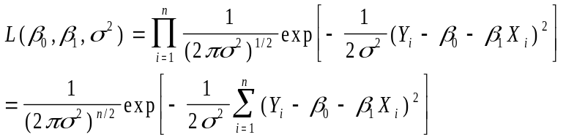

The values of 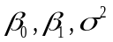 that maximize the likelihood function are referred to as maximum likelihood estimators. The MLE’s are denoted as: 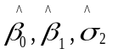. Note that the natural logarithm of the likelihood is maximized by the same values of that maximize the likelihood function, and it’s easier to work with the log likelihood function.

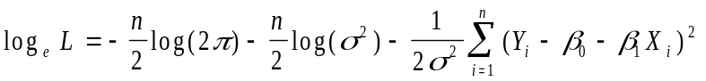

Taking partial derivatives with respect to yields:

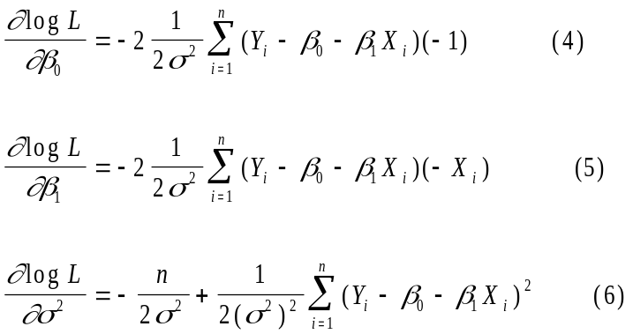

Setting these three equations to 0, and placing “hats” on parameters denoting the maximum likelihood estimators, we get the following three equations:

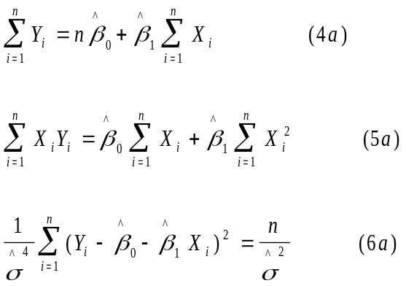

From equations 4a and 5a, we see that the maximum likelihood estimators are the same as the least squares estimators (these are the normal equations). However, from equation 6a, we obtain the maximum likelihood estimator for the error variance as:

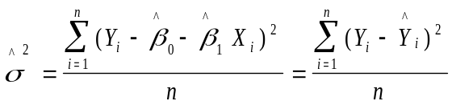

This estimator is biased downward. We will use the unbiased estimator 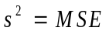 throughout this course to estimate the error variance.

Example – LSD Concentration and Math Scores

A pharmacodynamic study was conducted at Yale in the 1960’s to determine the relationship between LSD concentration and math scores in a group of volunteers. The independent (predictor) variable was the mean tissue concentration of LSD in a group of 5 volunteers, and the dependent (response) variable was the mean math score among the volunteers. There were n=7 observations, collected at different time points throughout the experiment.

Source: Wagner, J.G., Agahajanian, G.K., and Bing, O.H. (1968), “Correlation of Performance Test Scores with Tissue Concentration of Lysergic Acid Diethylamide in Human Subjects,” Clinical Pharmacology and Therapeutics, 9:635-638.

The following EXCEL spreadsheet gives the data and pertinent calculations.

Time (i) | Score (Y) | Conc (X) | Y-Ybar | X-Xbar | (Y-Ybar)**2 | (X-Xbar)**2 | (X-Xbar)(Y-Ybar) | Yhat | e | e**2
1 | 78.93 | 1.17 | 28.84286 | -3.162857 | 831.9104082 | 10.0036653 | -91.22583673 | 78.5828 | 0.3472 | 0.1205
2 | 58.20 | 2.97 | 8.112857 | -1.362857 | 65.81845102 | 1.85737959 | -11.05666531 | 62.36576 | -4.1658 | 17.354
3 | 67.47 | 3.26 | 17.38286 | -1.072857 | 302.1637224 | 1.15102245 | -18.64932245 | 59.75301 | 7.717 | 59.552
4 | 37.47 | 4.69 | -12.61714 | 0.357143 | 159.1922939 | 0.12755102 | -4.506122449 | 46.86948 | -9.3995 | 88.35
5 | 45.65 | 5.83 | -4.437143 | 1.497143 | 19.68823673 | 2.24143673 | -6.643036735 | 36.59868 | 9.0513 | 81.926
6 | 32.92 | 6.00 | -17.16714 | 1.667143 | 294.7107939 | 2.77936531 | -28.62007959 | 35.06708 | -2.1471 | 4.6099
7 | 29.97 | 6.41 | -20.11714 | 2.077143 | 404.6994367 | 4.31452245 | -41.78617959 | 31.37319 | -1.4032 | 1.969
Sum | 350.61 | 30.33 | 0 | 0 | 2078.183343 | 22.4749429 | -202.4872429 | 350.61 | 1E-14 | 253.88
Mean | 50.08714286 | 4.3328571
b1 | -9.009466
b0 | 89.123874
MSE | 50.776266

The fitted equation is: 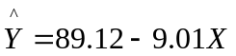 and the estimated error variance is 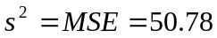, with corresponding standard deviation 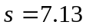.

A plot of the data and the fitted equation are given below, obtained from EXCEL.

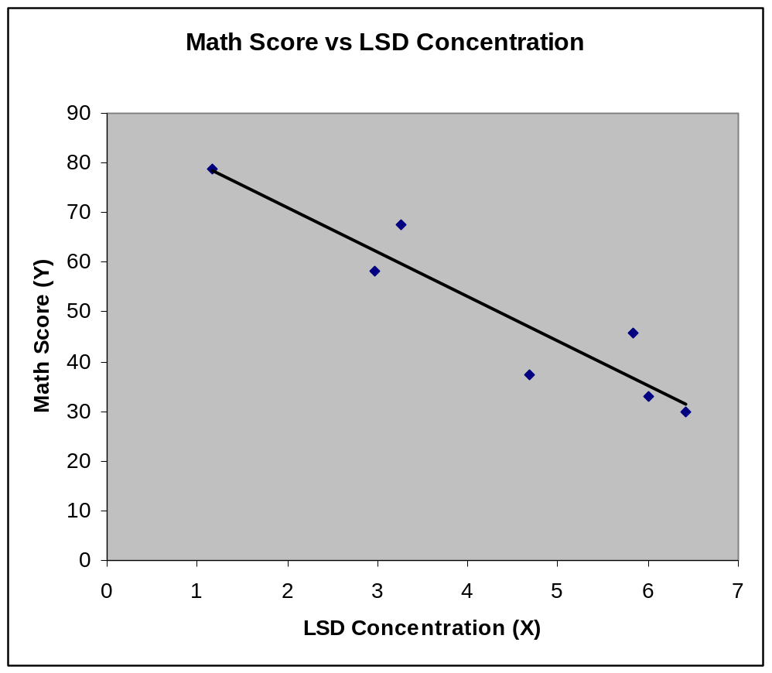

Output from various software packages is given below. Rules for standard errors and tests are given in the next chapter. We will mainly use SAS, EXCEL, and SPSS throughout the semester.

- EXCEL (Using Built-in Data Analysis Package)

Data Cells

Time (i) | Score (Y) | Conc (X)
1 | 78.93 | 1.17
2 | 58.2 | 2.97
3 | 67.47 | 3.26
4 | 37.47 | 4.69
5 | 45.65 | 5.83
6 | 32.92 | 6
7 | 29.97 | 6.41

Regression Coefficients

 | Coefficients | Standard Error | t Stat | P-value | Lower 95% | Upper 95%
Intercept | 89.12387 | 7.047547 | 12.64608 | 5.49E-05 | 71.00761 | 107.2401
Conc (X) | -9.00947 | 1.503076 | -5.99402 | 0.001854 | -12.8732 | -5.14569

Fitted Values and Residuals

Observation | Predicted Score (Y) | Residuals
1 | 78.5828 | 0.347202
2 | 62.36576 | -4.16576
3 | 59.75301 | 7.716987
4 | 46.86948 | -9.39948
5 | 36.59868 | 9.051315
6 | 35.06708 | -2.14708
7 | 31.37319 | -1.40319

- SAS (Using PROC REG)

Program (Bottom portion generates graphics quality plot for WORD)

options nodate nonumber ps=55 ls=76;
title ‘Pharmacodynamic Study’;
title2 ‘Y=Math Score X=Tissue LSD Concentration’;

data lsd;
input score conc;
cards;
78.93 1.17
58.20 2.97
67.47 3.26
37.47 4.69
45.65 5.83
32.92 6.00
29.97 6.41
;
run;

proc reg;
model score=conc / p r;
run;

symbol1 c=black i=rl v=dot;

proc gplot;
plot score*conc=1 / frame;
run;

quit;

Program Output (Some output suppressed)

Pharmacodynamic Study
Y=Math Score X=Tissue LSD Concentration

The REG Procedure
Model: MODEL1
Dependent Variable: score

Parameter Estimates

Parameter Standard
Variable DF Estimate Error t Value Pr > |t|
Intercept 1 89.12387 7.04755 12.65 <.0001
conc 1 -9.00947 1.50308 -5.99 0.0019

Output Statistics

Dep Var Predicted Std Error Std Error Student
Obs score Value Mean Predict Residual Residual Residual
1 78.9300 78.5828 5.4639 0.3472 4.574 0.0759
2 58.2000 62.3658 3.3838 -4.1658 6.271 -0.664
3 67.4700 59.7530 3.1391 7.7170 6.397 1.206
4 37.4700 46.8695 2.7463 -9.3995 6.575 -1.430
5 45.6500 36.5987 3.5097 9.0513 6.201 1.460
6 32.9200 35.0671 3.6787 -2.1471 6.103 -0.352
7 29.9700 31.3732 4.1233 -1.4032 5.812 -0.241

Plot (Including Regression Line)

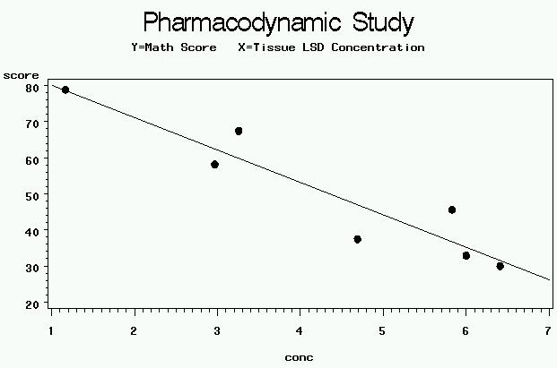

- SPSS (Spreadsheet/Menu Driven Package)

Output (Regression Coefficients Portion)

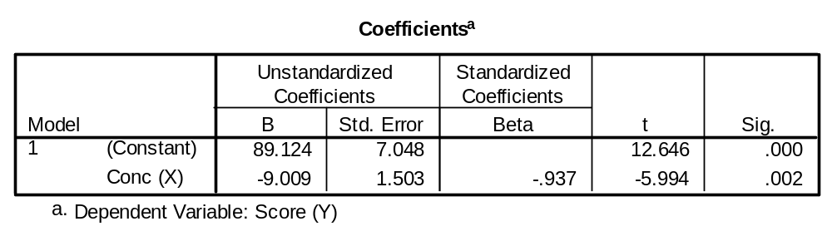

Plot of Data and Regression Line

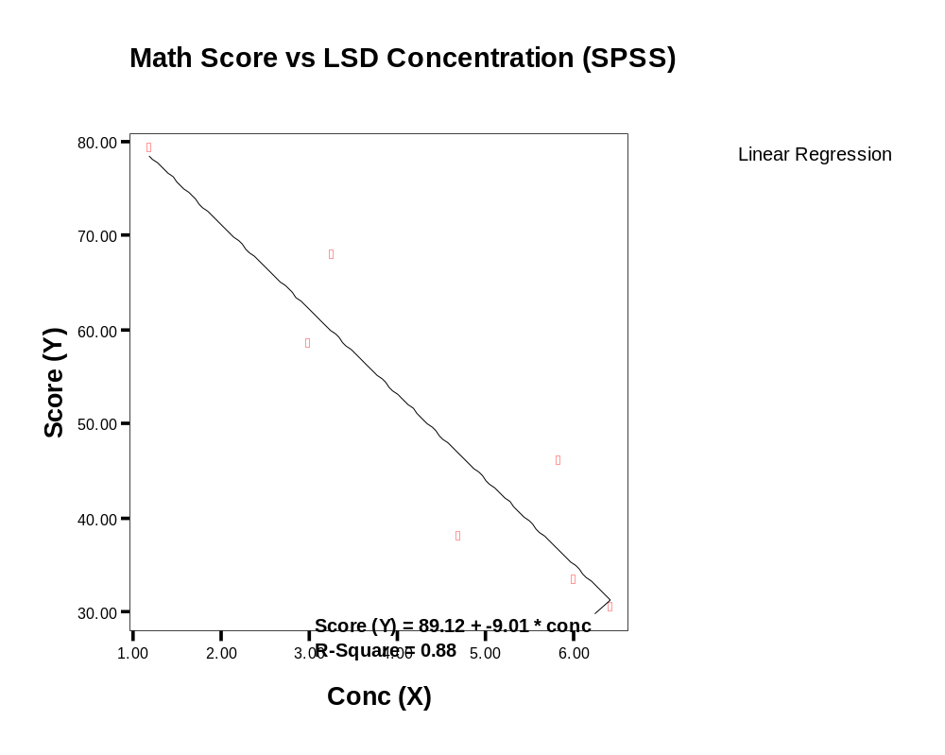

- STATVIEW (Spreadsheet/Menu Driven Package from SAS)

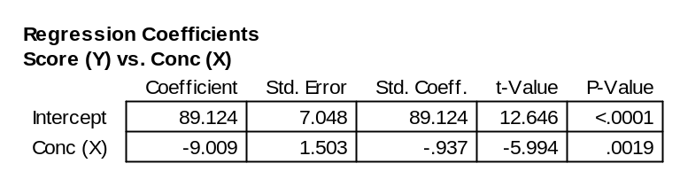
Output (Regression Coefficients Portion)
Graphic output

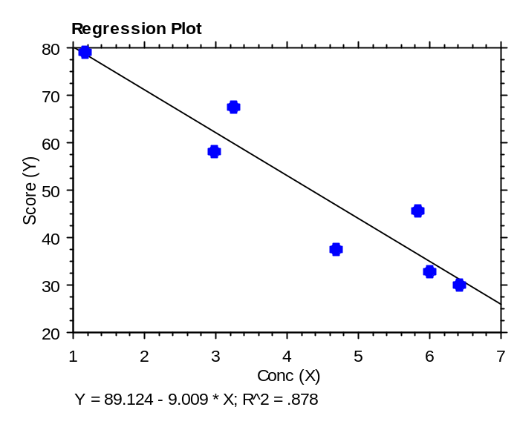

5) S-Plus (Also available in R)

Program Commands

- x <- c(1.17, 2.97, 3.26, 4.69, 5.83, 6.00, 6.41)
- y <- c(78.93, 58.20, 67.47, 37.47, 45.65, 32.92, 29.97)
- plot (x,y)
- fit <- lm(y ~ x)
- abline (fit)
- summary (fit)

Program Output

Residuals:
1 2 3 4 5 6 7
0.3472 –4.166 7.717 –9.399 9.051 –2.147 –1.403

Coefficients:
Value Std. Error t value Pr(>|t|)
(Intercept) 89.1239 7.0475 12.6461 0.0001
x -9.0095 1.5031 -5.9940 0.0019

Residual standard error: 7.126 on 5 degrees of freedom
Graphics Output

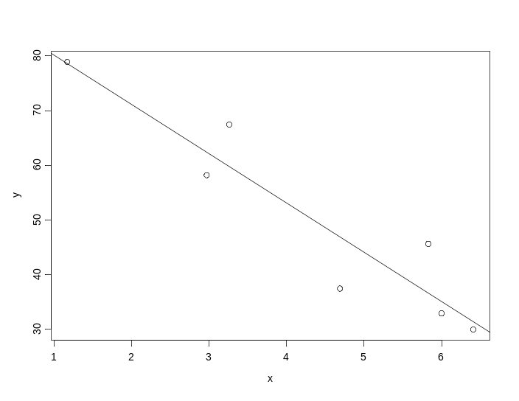

- STATA

Output (Regression Coefficients Portion)

score Coef. Std. Err. t P>t [95% Conf. Interval]

conc -9.009467 1.503077 -5.99 0.002 -12.87325 -5.145686
_cons 89.12388 7.047547 12.65 0.000 71.00758 107.2402

Graphics Output

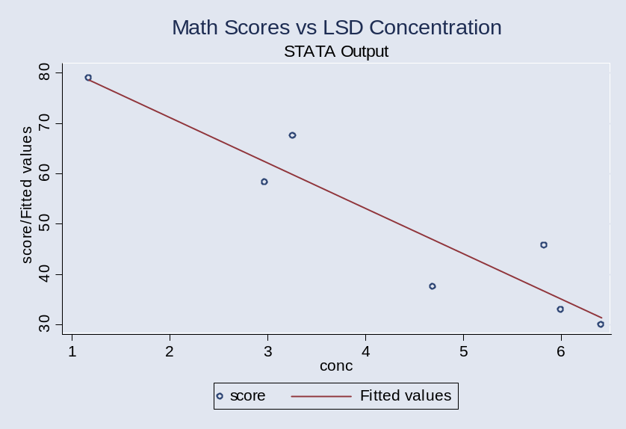

Chapter 2 – Inferences in Regression Analysis

Rules Concerning Linear Functions of Random Variables (P. 1318)

Let 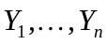 be n random variables. Consider the function 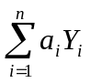 where the coefficients 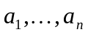 are constants. Then, we have:

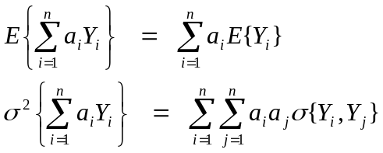

When are independent (as in the model in Chapter 1), the variance of the linear combination simplifies to:

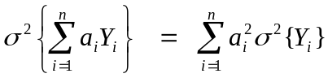

When are independent, the covariance of two linear functions and 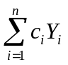 can be written as:

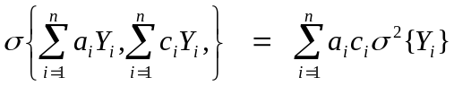

We will use these rules to obtain the distribution of the estimators 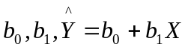

Inferences Concerning β₁

Recall that the least squares estimate of the slope parameter, 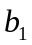 , is a linear function of the observed responses :

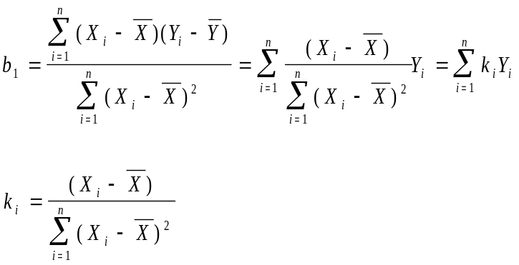

Note that 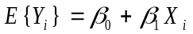, so that the expected value of is:

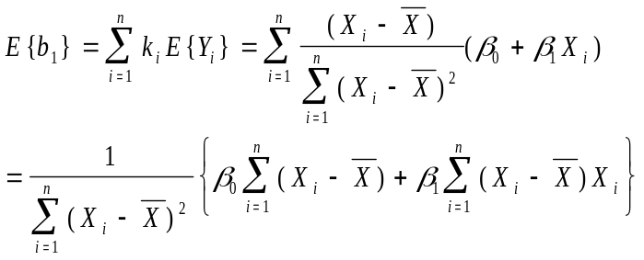

Note that 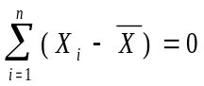 (why?), so that the first term in the brackets is 0, and that we can add 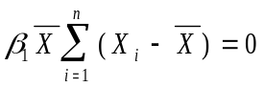 to the last term to get:

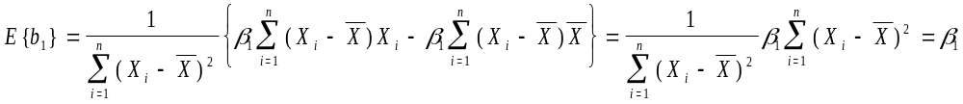
Thus, is an unbiased estimator of the parameter .

To obtain the variance of , recall that 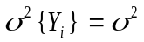. Thus:

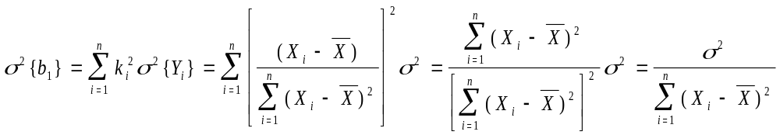

Note that the variance of decreases when we have larger sample sizes (as long as the added levels are not placed at the sample mean 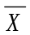). Since is unknown in practice, and must be estimated from the data, we obtain the estimated variance of the estimator by replacing the unknown with its unbiased estimate :

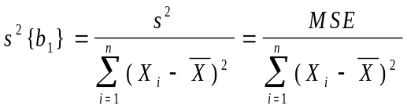

with estimated standard error:

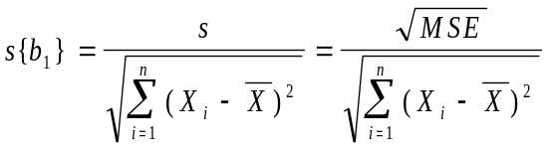

Further, the sampling distribution of is normal, that is:

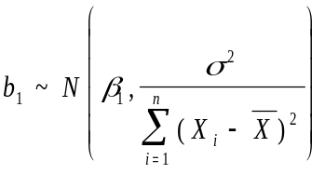

since under the current model, is a linear function of independent, normal random variables .

Making use of theory from mathematical statistics, we obtain the following result that allows us to make inferences concerning :

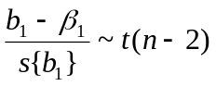 where t(n-2) represents Student’s t-distribution with n-2 degrees of freedom.

Confidence Interval for β₁

As a result of the fact that , we obtain the following probability statement:

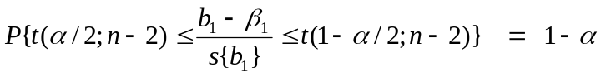 where 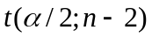 is the (α/2)100th percentile of the t-distribution with n-2 degrees of freedom. Note that since the t-distribution is symmetric around 0, we have that 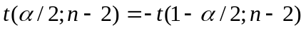. Traditionally, we obtain the table values corresponding to 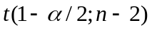, which is the value of that leaves an upper tail area of α/2. The following algebra results in obtaining a (1-α)100% confidence interval for β₁:

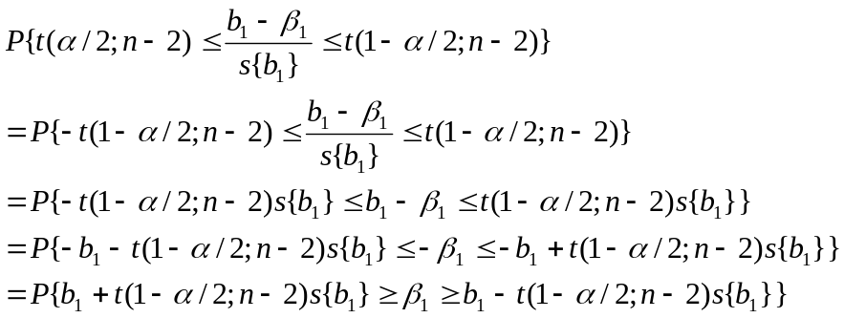

This leads to the following rule for a (1-α)100% confidence interval for β₁:

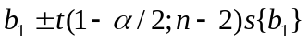

Some statistical software packages print this out automatically (e.g. EXCEL and SPSS). Other packages simply print out estimates and standard errors only (e.g. SAS).

Tests Concerning β₁

We can also make use of the of the fact that 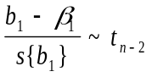 to test hypotheses concerning the slope parameter. As with means and proportions (and differences of means and proportions), we can conduct one-sided and two-sided tests, depending on whether a priori a specific directional belief is held regarding the slope. More often than not (but not necessarily), the null value for β₁ is 0 (the mean of Y is independent of X) and the alternative is that β₁ is positive (1-sided), negative (1-sided), or different from 0 (2-sided). The alternative hypothesis must be selected before observing the data.

2-sided tests

- Null Hypothesis: 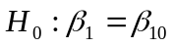
- Alternative (Research Hypothesis): 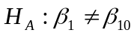
- Test Statistic: 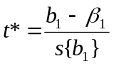
- Decision Rule: Conclude H_{A} if 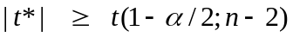, otherwise conclude H₀
- P-value: 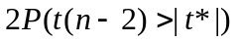

All statistical software packages (to my knowledge) will print out the test statistic and P-value corresponding to a 2-sided test with β₁₀=0.

1-sided tests (Upper Tail)

- Null Hypothesis:
- Alternative (Research Hypothesis): 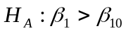
- Test Statistic:
- Decision Rule: Conclude H_{A} if 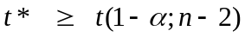, otherwise conclude H₀
- P-value: 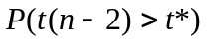

A test for positive association between Y and X (H_{A}:β₁>0) can be obtained from standard statisical software by first checking that b₁ (and thus t*) is positive, and cutting the printed P-value in half.

1-sided tests (Lower Tail)

- Null Hypothesis:
- Alternative (Research Hypothesis): 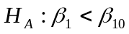
- Test Statistic:
- Decision Rule: Conclude H_{A} if 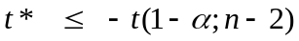, otherwise conclude H₀
- P-value: 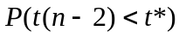

A test for negative association between Y and X (H_{A}:β₁<0) can be obtained from standard statisical software by first checking that b₁ (and thus t*) is negative, and cutting the printed P-value in half.

Inferences Concerning β₀

Recall that the least squares estimate of the intercept parameter, 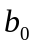 , is a linear function of the observed responses :

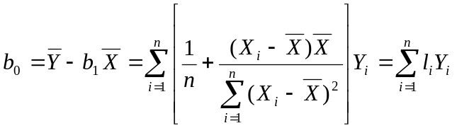

Recalling that 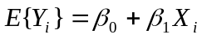:

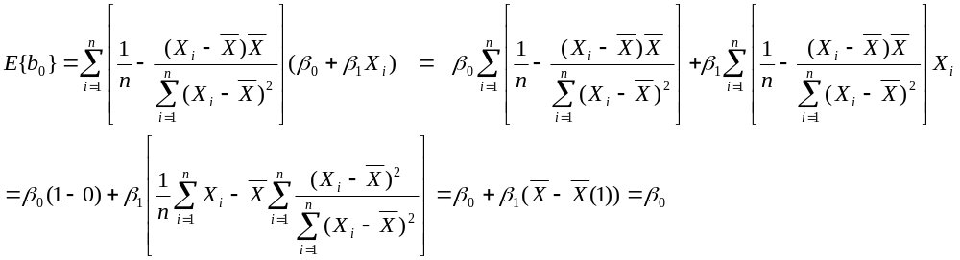
Thus, b₀ is an unbiased estimator or the parameter β_{0.} Below, we obtain the variance of the estimator of b₀.

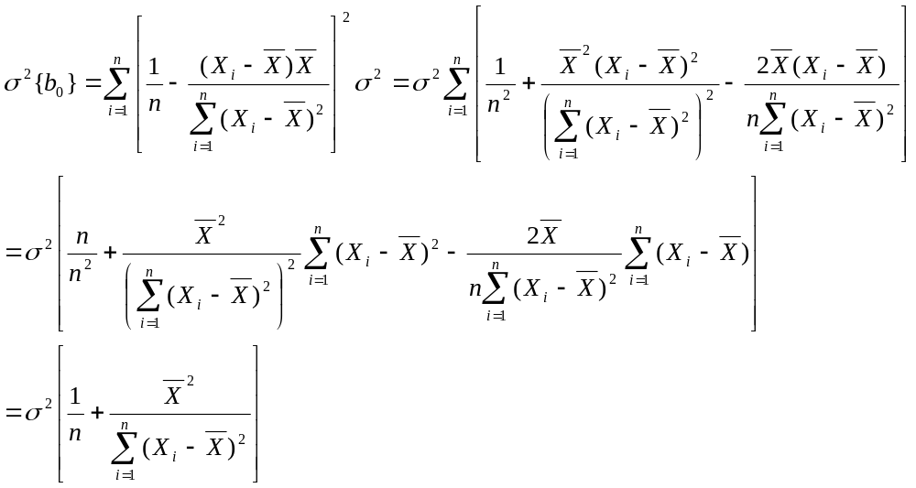
Note that the variance will decrease as the sample size increases, as long as X values are not all placed at the mean. Further, the sampling distribution is normal under the assumptions of the model. The estimated standard error of b₀ replaces σ² with its unbiased estimate s²=MSE and taking the square root of the variance.

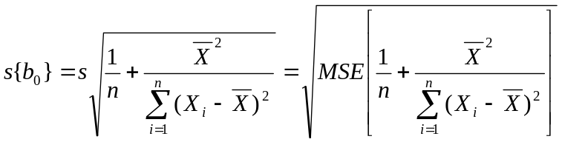

Note that 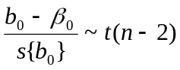, allowing for inferences concerning the intercept parameter β₀ when it is meaningful, namely when X=0 is within the range of observed data.
Confidence Interval for β₀
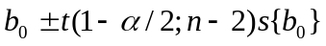
It is also useful to obtain the covariance of b₀ and b₁, as they are only independent under very rare circumstances:

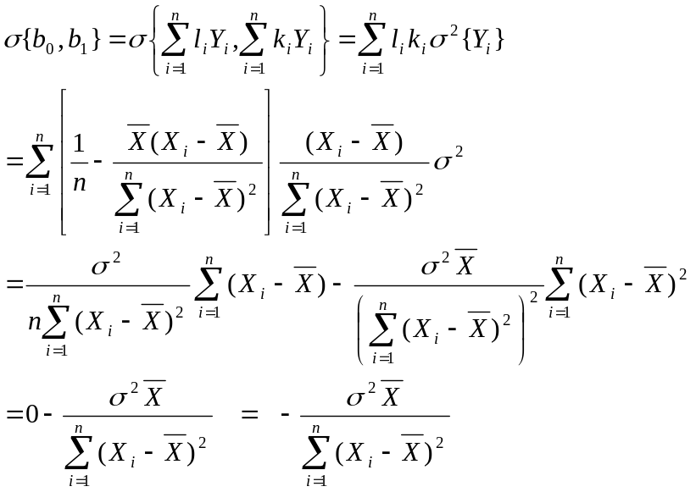
In practice, 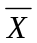 is usually positive, so that the intercept and slope estimators are usually negatively correlated. We will use the result shortly.

Considerations on Making Inferences Concerning β₀ and β₁

Normality of Error Terms
If the data are approximately normal, simulation results have shown that using the t-distribution will provide approximately correct significance levels and confidence coefficients for tests and confidence intervals, respectively. Even if the distribution of the errors (and thus Y) is far from normal, in large samples the sampling distributions of b₀ and b₁ have sampling distributions that are approximately normal as results of central limit theorems. This is sometimes referred to as asymptotic normality.

Interpretations of Confidence Coefficients and Error Probabilities
Since X levels are treated as fixed constants, these refer to the case where we repeated the experiment many times at the current set of X levels in this data set. In this sense, it’s easier to interpret these terms in controlled experiments where the experimenter has set the levels of X (such as time and temperature in a laboratory type setting) as opposed to observational studies, where nature determines the X levels, and we may not be able to reproduce the same conditions repeatedly. This will be covered later.

Spacing of X Levels
The variances of b₀ and b₁ (for given n and σ²) decrease as the X levels are more spread out, since their variances are inversely related to 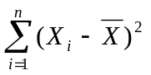. However, there are reasons to choose a diverse range of X levels for assessing model fit. This is covered in Chapter 4.

Power of Tests
The power of a statistical test refers to the probability that we reject the null hypothesis. Note that when the null hypothesis is true, the power is simply the probability of a Type I error (α). When the null hypothesis is false, the power is the probability that we correctly reject the null hypothesis, which is 1 minus the probability of a Type II error (π=1-β), where π denotes the power of the test and β is the probability of a Type II error (failing to reject the null hypothesis when the alternative hypothesis is true). The following procedure can be used to obtain the power of the test concerning the slope parameter with a 2-sided alternative.

- Write out null and alternative hypotheses: 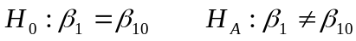
- Obtain the noncentrality measure, the standardized distance between the true value of β₁ and the value under the null hypothesis (β₁₀): 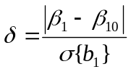
- Choose the probability of a Type I error (α=0.05 or α=0.01)
- Determine the degrees of freedom for error: df = n-2
- Refer to Table B.5 (pages 1346-7), identifying α (page), δ (row) and error degrees of freedom (column). The table provides the power of the test under these parameter values.
Note that the power increases within each tables as the noncentrality measure increases for a given degrees of freedom, and as the degrees of freedom increases for a given noncentrality measure.

Confidence Interval for E{Y_{h}}=β₀+β₁X_{h}
When we wish to estimate the mean at a hypothetical X value (within the range of observed X values), we can use the fitted equation at that value of X=X_{h} as a point estimate, but we haveto include the uncertainty in the regression estimators to construct a confidence interval for the mean.

Parameter: 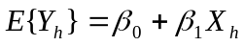
Estimator: 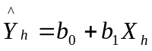

We can obtain the variance of the estimator (as a function of X=X_{h}) as follows:

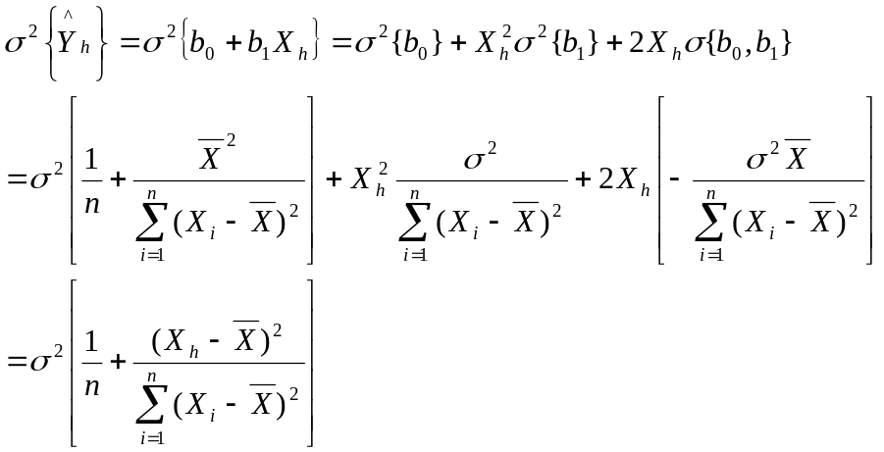

Estimated standard error of estimator: 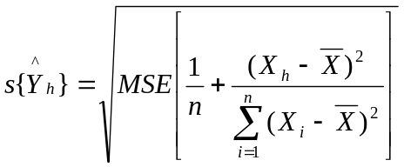
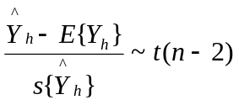 which can be used to construct confidence intervals for the mean response at specific X levels, and tests concerning the mean (tests are rarely conducted).

(1-α)100% Confidence Interval for E{Y_{h}}:
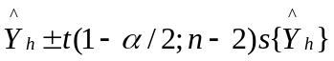

Predicting a Future Observation When X is Known

If 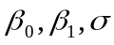 were known, we’d know that the distribution of responses when X=X_{h} is normal with mean 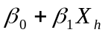 and standard deviation . Thus, making use of the normal distribution (and equivalently, the empirical rule) we know that if we took a sample item from this distribution, it is very likely that the value fall within 2 standard deviations of the mean. That is, we would know that the probability that the sampled item lies within the range 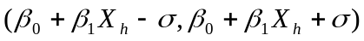 is approximately 0.95.
In practice, we don’t know the mean or the standard deviation . However, we just constructed a (1-α)100% Confidence Interval for E{Y_{h}}, and we have an estimate of (s). Intuitively, we can approximately use the logic of the previous paragraph (with the estimate of ) across the range of believable values for the mean. Then our prediction interval spans the lower tail of the normal curve centered at the lower bound for the mean to the upper tail of the normal curve centered at the upper bound for the mean. See Figure 2.5 on page 64 of the text book.
The prediction error is for the new observation is the difference between the observed value and its predicted value: 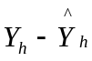. Since the data are assumed to be independent, the new (future) value is independent of its predicted value, since it wasn’t used in the regression analysis. The variance of the prediction error can be obtained as follows:
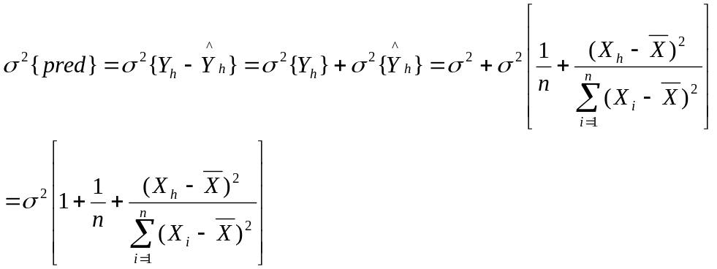
and an unbiased estimator is:
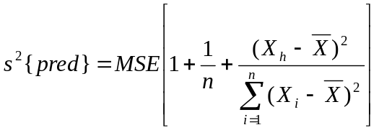

(1-α)100% Prediction Interval for New Observation When X=X_{h}
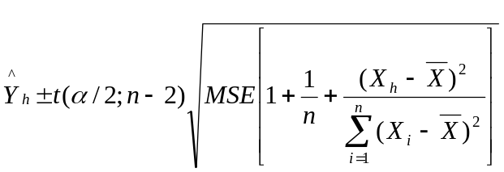
It is a simple extension to obtain a prediction for the mean of m new observations when X=X_{h}. The sample mean of m observations is 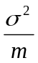 and we get the following variance for for the error in the prediction mean:
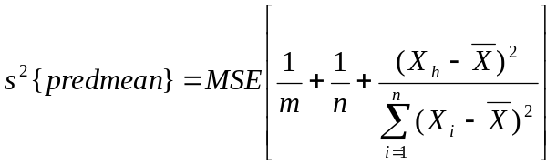
and the obvious adjustment to the prediction interval for a single observation.
(1-α)100% Prediction Interval for the Mean of m New Observations When X=X_{h}
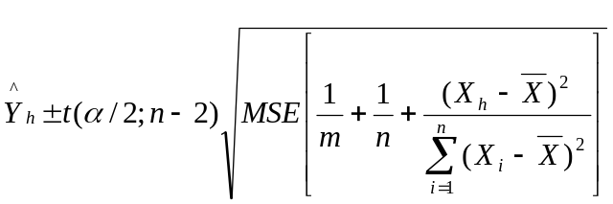
Confidence Band for the Entire Regression Line (Working-Hotelling Method)
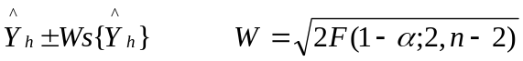

Analysis of Variance Approach to Regression

Consider the total deviations of the observed responses from the mean: 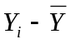. When these terms are all squared and summed up, this is referred to as the total sum of squares (SSTO).
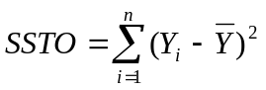
The more spread out the observed data are, the larger SSTO will be.
Now consider the deviation of the observed responses from their fitted values based on the regression model: 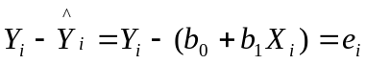. When these terms are squared and summed up, this is referred to as the error sum of squares (SSE). We’ve already encounterd this quantity and used it to estimate the error variance.
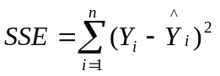
When the observed responses fall close to the regression line, SSE will be small. When the data are not near the line, SSE will be large.
Finally, there is a third quantity, representing the deviations of the predicted values from the mean. Then these deviations are squared and summed up, this is referred to as the regression sum of squares (SSR).
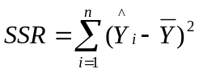
The error and regression sums of squares sum to the total sum of squares: 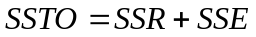 which can be seen as follows:
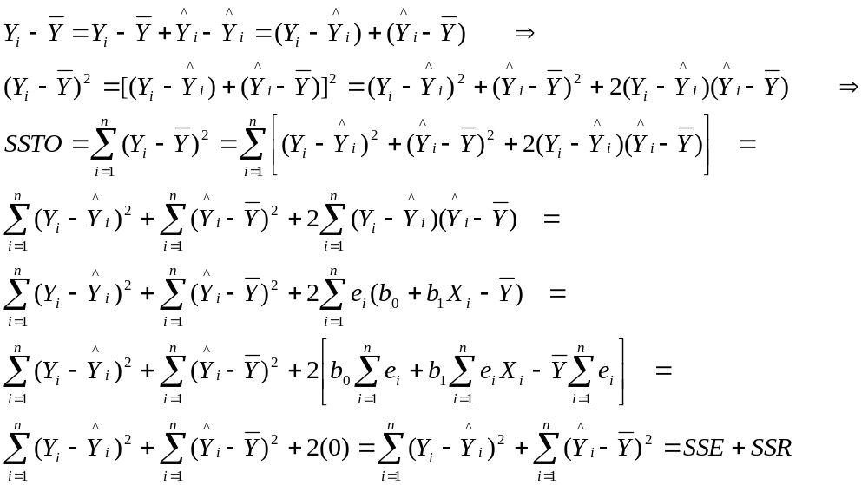
The last term was 0 since 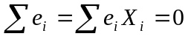,
Each sum of squares has associated with degrees of freedom. The total degrees of freedom is df_{T} = n-1. The error degrees of freedom is df_{E} = n-2. The regression degrees of freedom is df_{R} = 1. Note that the error and regression degrees of freedom sum to the total degrees of freedom: 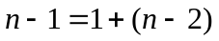.
Mean squares are the sums of squares divided by their degrees of freedom:
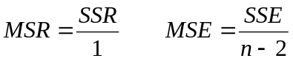
Note that MSE was our estimate of the error variance, and that we don’t compute a total mean square. It can be shown that the expected values of the mean squares are:
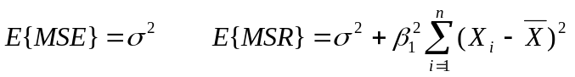
Note that these expected mean squares are the same if and only if β₁=0.
The Analysis of Variance is reported in tabular form:

Source | df | SS | MS | F
Regression | 1 | SSR | MSR=SSR/1 | F=MSR/MSE
Error | n-2 | SSE | MSE=SSE/(n-2)
C Total | n-1 | SSTO

F Test of β₁ = 0 versus β₁ ≠ 0
As a result of Cochran’s Theorem (stated on page 76 of text book), we have a test of whether the dependent variable Y is linearly related to the predictor variable X. This is a very specific case of the t-test described previously. Its full utility will be seen when we consider multiple predictors. The test proceeds as follows:
- Null hypothesis: 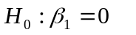
- Alternative (Research) Hypothesis: 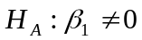
- Test Statistic: 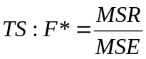
- Rejection Region: 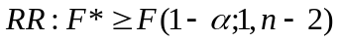
- P-value: 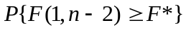

Critical values of the F-distribution (indexed by numerator and denominator degrees’ of freedom) are given in Table B.4, pages 1340-1345.
Note that this is a very specific version of the t-test regarding the slope parameter, specifically a 2-sided test of whether the slope is 0. Mathematically, the tests are identical:
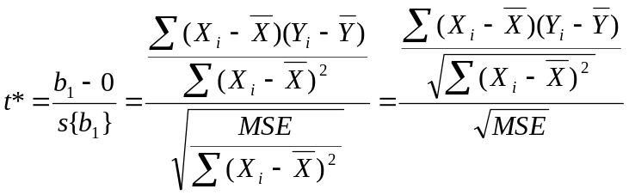
Note that:
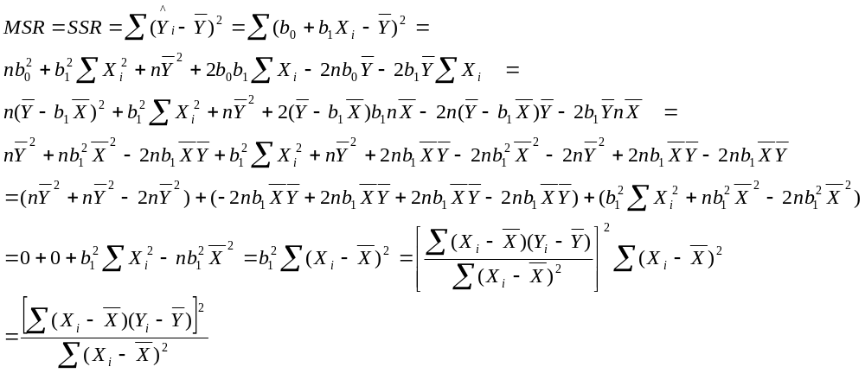
Thus:
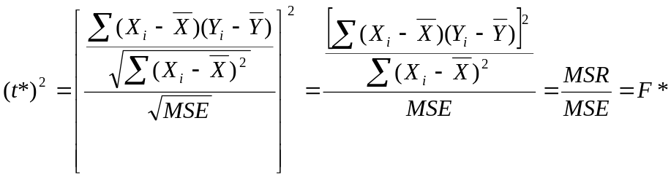Further, the critical values are equivalent: ,
check this from the two tables. Thus, the tests are equivalent.

General Linear Test Approach
This is a very general method of testing hypotheses concerning regression models. We first consider the the simple linear regression model, and testing whether Y is linearly associated with X. We wish to test 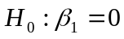 vs .

Full Model
This is the model specified under the alternative hypothesis, also referrred to as the unrestricted model. Under simple linear regression with normal errors, we have:
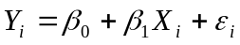
Using least squares (and maximum likelihood) to estimate the model parameters (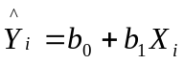), we obtain the error sum of squares for the full model:

Reduced Model
This the model specified by the null hypothesis, also referred to as the restricted model. Under simple linear regression with normal errors, we have:
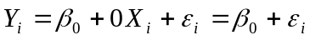
Under least squares (and maximum likelihood) to estimate the model parameter, we obtain as the estimate of β₀, and have 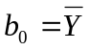as the fitted value for each observation. We when get the following error sum of squares under the reduced model:

Test Statistic

The error sum of squares for the full model will always be less that or equal to the error sum of squares for reduced model, by definition of least squares. The test statistic will be:

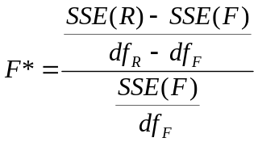 where 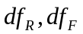 are the error degrees of freedom for the full and reduced models. We will use this method throughout course.
For the simple linear regression model, we obtain the following quantities:

thus the F-Statistic for the General Linear Test can be written:

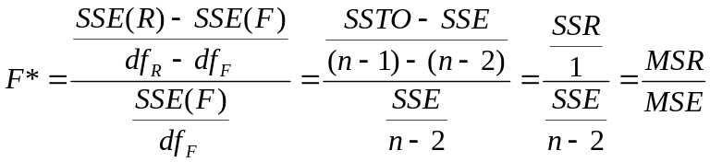

Thus, for this particular null hypothesis, the general linear test “generalizes” to the F-test.

Descriptive Measures of Association

Along with the slope, Y-intercept, and error variance; several other measures are often reported.

Coefficient of Determination (r²)

The coefficient of determination measures the proportion of the variation in Y that is “explained” by the regression on X. It is computed as the regression sum of squares divided by the total (corrected) sum of squares. Values near 0 imply that the regression model has done little to “explain” variation in Y, while values near 1 imply that the model has “explained” a large portion of the variation in Y. If all the data fall exactly on the fitted line, r²=1. The coefficient of determination will lie beween 0 and 1.

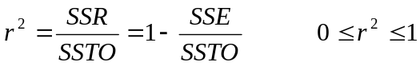

Coefficient of Correlation (r)

The coefficient of correlation is a measure of the strength of the linear association between Y and X. It will always be the same sign as the slope estimate (b₁), but it has several advantages:

- In some applications, we cannot identify a clear dependent and independent variable, we just wish to determine how two variables vary together in a population (peoples heights and weights, closing stock prices of two firms, etc). Unlike the slope estimate, the coefficient of correlation does not depend on which variable is labeled as Y, and which is labeled as X.
- The slope estimate depends on the units of X and Y, while the correlation coefficient does not.
- The slope estimate has no bound on its range of potential values. The correlation coefficient is bounded by –1 and +1, with higher values (in absolute value) implying stronger linear association (it is not useful in measuring nonlinear association which may exist, however).

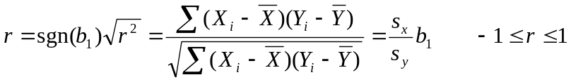

where sgn(b₁) is the sign (positive or negative) of b₁, and 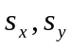 are the sample standard deviations of X and Y, respectively.

Issues in Applying Regression Analysis

- When using regression to predict the future, the assumption is that the conditions are the same in future as they are now. Clearly any future predictions of economic variables such as tourism made prior to September 11, 2001 would not be valid.
- Often when we predict in the future, we must also predict X, as well as Y, especially when we aren’t controlling the levels of X. Prediction intervals using methods described previously will be too narrow (that is, they will overstate confidence levels).
- Inferences should be made only within the range of X values used in the regression analysis. We have no means of knowing whether a linear association continues outside the range observed. That is, we should not extrapolate outside the range of X levels observed in experiment.
- Even if we determine that X and Y are associated based on the t-test and/or F-test, we cannot conclude that changes in X cause changes in Y. Finding an association is only one step in demonstrating a causal relationship.
- When multiple tests and/or confidence intervals are being made, we must adjust our confidence levels. This is covered in Chapter 4.
- When X_{i} is a random variable, and not being controlled, all methods described thus far hold, as long as the X_{i} are independent, and their probability distribution does not depend on 

