MAR 5620
Managerial Statistics
Fall 2004 (Module 1)

Dr. Larry Winner
University of Florida

Introduction (Section 1.1)

This course applies and extends methods from STA 2023 to business applications. We begin with a series of definitions and descriptions:

Descriptive Statistics: Methods used to describe a set of measurements, typically either numerically and/or graphically.

Inferential Statistics: Methods to use a sample of measurements to make statements regarding a larger set of measurements (or a state of nature).

Population: Set of all items (often referred to as units) of interest to a researcher. This can be a large, fixed population (e.g. all undergraduate students registered at UF in Fall 2003). It can also be a conceptual population (e.g. All potential consumers of a product during the product’s shelf life).

Parameter: A numerical descriptive measure, describing a population of measurements (e.g. The mean number of credit hours for all UF undergraduates in Fall 2003).

Sample: Set of items (units) drawn from a population.

Statistic: A numerical descriptive measure, describing a sample.

Statistical Inference: Process of making a decision, estimate, and/or a prediction regarding a population from sample data. Confidence Levels refer to how often estimation procedures give correct statements when applied to different samples from the population. Significance levels refer to how often a decision rule will make incorrect conclusions when applied to different samples from the population.

Data Collection (Section 1.8 and Supplement)

Data Collection Methods

- Observational Studies – Researchers obtain data by directly observing individual units. These can be classified as prospective, where units are sampled first, and observed over a period of time, or retrospective studies where individuals are sampled after the event of interest and asked about prior conditions.

- Experimental Studies – Researchers obtain data by randomly assigning subjects to experimental conditions and observing some response measured on each subject. Experimental studies are by definition prospective.

- Surveys – Researchers obtain data by directly soliciting information, often including demographic characteristics, attitudes, and opinions. Three common types are: personal interview, telephone interview, and self-administered questionnaire (usually completed by mail).

Examples

Example – Studies of Negative Effects of Smoking

A study was conducted at the Mayo Clinic in the 1910s, comparing patients diagnosed with lip cancer (cases) with patients in the hospital with other conditions (controls). Researchers obtained information on many demographic and behavioral variables retrospectively. They found that among the lip cancer cases, 339 out of 537 subjects had been pipe smokers (63%), while among the controls not suffering from lip cancer, 149 out of 500 subjects had been pipe smokers. Source: A.C. Broders (1920). “Squamous—Cell Epithelioma of the Lip”, JAMA, 74:656-664.

Pipe Smoker? | Cases | Controls | Total
Yes | 339 | 149 | 488
No | 198 | 351 | 549
Total | 537 | 500 | 1037

A huge cohort study was conducted where almost 200,000 adult males between the ages of 50 and 70 were followed from early 1952 through October 31, 1953. The men were identified as smokers and nonsmokers at the beginning of the trial, and the outcome observed was whether the man died during the study period. This study is observational since the men were not assigned to groups (smokers/nonsmokers), but is prospective since the outcome was observed after the groups were identified. Of 107822 smokers, 3002 died during the study period (2.78%). Of 79944 nonsmokers, 1852 died during the study period (2.32%). While this may not appear to be a large difference, the nonsmokers tended to be older than smokers (many smokers had died before the study was conducted). When controlling for age, the difference is much larger. Source: E.C. Hammond and D. Horn (1954). “The Relationship Between Human Smoking Habits and Death Rates”, JAMA,155:1316-1328.

Group | Death | Not Death | Total
Smokers | 3002 | 104280 | 107822
Nonsmokers | 1852 | 78092 | 79944
Total | 4854 | 182912 | 187766

Example – Clinical Trials of Viagra

A clinical trial was conducted where men suffering from erectile dysfunction were randomly assigned to one of 4 treatments: placebo, 25 mg, 50 mg, or 100 mg of oral sildenafil (Viagra). One primary outcome measured was the answer to the question: “During sexual intecourse, how often were you able to penetrate your partner?” (Q.3). The dependent variable, which is technically ordinal, had levels ranging from 1(almost never or never) to 5 (almost always or always). Also measured was whether the subject had improved erections after 24 weeks of treatment. This is an example of a controlled experiment. Source: I. Goldstein, et al (1998). “Oral Sildenafil in the Treatment of Erectile Dysfunction”, New England Journal of Medicine, 338:1397-1404.

Treatment | # of subjects | Mean | Std Dev | # improving erections
Placebo | 199 | 2.2 | 2.8 | 50
25 mg | 96 | 3.2 | 2.0 | 54
50 mg | 105 | 3.5 | 2.0 | 81
100 mg | 101 | 4.0 | 2.0 | 85

Plot of mean response versus dose:

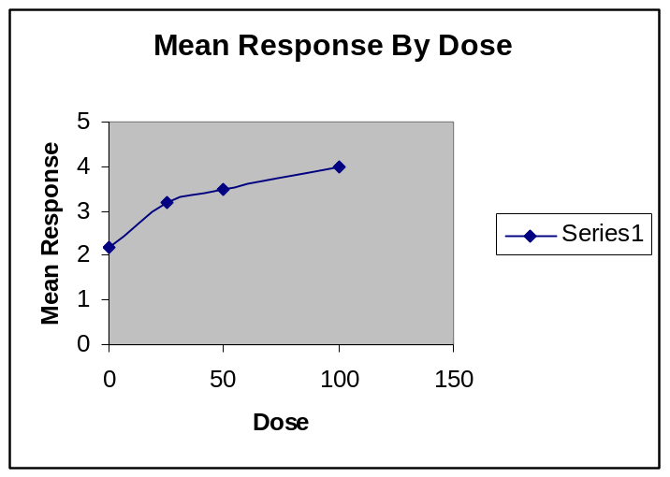

Example – Accounting/Finance Salary Survey

Careerbank.com conducts annual salary surveys of professionals in many business areas. They report the following salary and demographic information based on data from 2575 accounting, finance, and banking professionals who replied to an e-mail survey. Source: www.careerbank.com

Male: 52% Female: 48%

Mean Salary (% of Gender)
Highest Level of Education Men Women
None $61,868 (5%) $35,533 (16%)
Associates $46,978 (7%) $37,148 (14%)
Bachelors $60,091 (59%) $46,989 (53%)
Masters $78,977 (28%) $57,527 (17%)
Doctorate $90,700 (2%) $116,750 (<1%)

What can be said of the distributions of education levels?

What can be said for salaries, controlling for education levels? What is another factor that isn’t considered here?

Sampling (Section 1.10)

Goal: Make a statement or prediction regarding a larger population, based on elements of a smaller (observed and measured) sample.

Estimate: A numerical descriptive measure based on a sample, used to make a prediction regarding a population parameter.

- Political polls are often reported in election cycles, where a sample of registered voters are obtained to estimate the proportion of all registered voters who favor a candidate or referendum.

- A sample of subjects are given a particular diet supplement, and their average weight change during treatment is used to predict the mean weight change that would be obtained had it been given to a larger population of subjects.

Target Population: The population which a researcher wishes to make inferences concerning.

- Cholesterol reducing drugs were originally targeted at older males with high cholesterol. Later studies showed effects measured in other patient populations as well. This is an example of expanding a market.

- Many videogames are targeted at teenagers. Awareness levels of a product should be measured among this demographic, not the general population.

Sampled Population: The population from which the sample was taken.

- Surveys taken in health clubs, upscale restaurants, and night clubs are limited in terms of their representation of general populations such as college students or young professionals. However, they may represent a target population for marketers.

- Surveys in the past have been based on magazine subscribers and telephone lists when these were higher status items (see Literary Digest story on Page 143). In the early days of the internet, internet based surveys were also potentially biased. Not as large of a concern now.

Self-Selected Samples: Samples where individuals respond to a survey question via mailin reply, internet click, or toll phone call. Doomed to bias since only highly interested parties reply. Worse: Respondents may reply multiple times.

Sampling Plans (Section 1.10)

Simple Random Sample: Sample where all possible samples of size n from a population of N items has an equal opportunity of selected. There must exist a frame (listing of all elements in the population). Random numbers are assigned to each element, elements are sorted by the random number (smallest to largest), and the first n (of the sorted list of) items are sampled. This is the gold standard of sampling plans and should be used whenever possible.

Stratified Random Sample: Sample where a population has been divided into group of mutually exclusive and exhaustive sets of elements (strata), and simple random samples are selected from each strata. This is useful when the strata are of different sizes of magnitude, and the researcher wishes the sampled population to resemble the target population with respect to strata sizes.

Cluster Sample: Sample where a population has been broken down into clusters of individuals (typically, but not necessarily, geographically based). A random sample of clusters are selected, and each element within each cluster is observed. This is useful when it is very time consuming and cost prohibitive to travel around an area for personal surveys.

Systematic Sample: Sample is taken by randomly selecting an element from the beginning of a listing of elements (frame). Then every k^{th} element is selected. This is useful when a directory exists of elements (such as a campus phone directory), but no computer file of elements can be obtained. It is also useful when the elements are ordered (ranked) by the outcome of interest.

Sampling and Nonsampling Errors (Section 1.12)

Sampling Error: Refers to the fact that sample means and proportions vary from one sample to another. Our estimators will be unbiased, in the sense that the sampling errors tend to average out to 0 across samples. Our estimates will also be efficient in that the spread of the distribution of the errors is as small as possible for a given sample size.

Nonsampling Errors: Refer to errors that are not due to sampling.

- Recording/acquisition error: Data that are entered incorrectly at the site of observation or at the point of data entry.

- Response error or bias: Tendency for certain subjects to be more or less likely to complete a survey or to answer truthfully.

- Selection Bias: Situation where some members of target population cannot be included in sample. (e.g. Literary Digest example or studies conducted in locations that some subjects do not enter).

Types of Variables (Section 1.11 and Supplement)

Measurement Types: We will classify variables as three types: nominal, ordinal, and interval.

Nominal Variables are categorical with levels that have no inherent ordering. Assuming you have a car, it’s brand (make) would be nominal (e.g. Ford, Toyota, BMW…). Also, we will treat binary variables as nominal (e.g. whether a subject given Olestra based potato chips displayed gastro-intestinal side effect).

Ordinal Variables are categorical with levels that do have a distinct ordering, however, relative distances between adjacent levels may not be the same (e.g. Film reviewers may rate movies on a 5-star scale, College athletic teams and company sales forces may be ranked by some criteria).

Interval Variables are numeric variables that preserve distances between levels (e.g. Company quarterly profits (or losses, stated as negative profits), time for an accountant to complete a tax form).

Relationship Variable Types: Most often, statistical inference is focused on studying the relationship between (among) two (or more) variables. We will distinguish between dependent and independent variables.

Dependent variables are outcomes (also referred to as responses or endpoints) that are hypothesized to be related to the level(s) of other input variable(s). Dependent variables are typically labeled as Y.

Independent variables are inputs (also referred to as predictors or explanatory variables) that are hypothesized to cause or be associated with levels of the dependent variable. Independent variables are typically labeled as X when there is a single dependent variable.

Graphical Descriptive Methods (Chapter 2)

Single Variable (Univariate) Graphs:

Interval Scale Outcomes:

Histograms separate individual outcomes into bins of equal width (where extreme bins may represent all individuals below or above a certain level). The bins are typically labeled by their midpoints. The heights oh the bars over each bin may be either the frequency (number of individuals falling in that range) or the percent (fraction of all individuals falling in that range, multiplied by 100%). Histograms are typically vertical.

Stem-and-Leaf Diagrams are simple depictions of a distribution of measurements, where the stems represent the first digit(s), and leaves represent last digits (or possibly decimals). The shape will look very much like a histogram turned on its side. Stem-and-leaf diagrams are typically horizontal.

Nominal/Ordinal/Interval Scale Outcomes:

Pie Charts count individual outcomes by level of the variable being measured (or range of levels for interval scale variables), and represent the distribution of the variable such that the area of the pie for each level (or range) are proportional to the fraction of all measurements.

Bar Charts are similar to histograms, except that the bars do not need to physically touch. They are typically used to represent frequencies or percentages of nominal and ordinal outcomes

Two Variable (Bivariate) Graphs:

Scatter Diagrams are graphs where pairs of outcomes (X,Y) are plotted against one another. These are typically interval scale variables. These graphs are useful in determining whether the variables are associated (possibly in a positive or negative manner). The vertical axis is typically the dependent variable and the horizontal axis is the independent variable (one major exception are demand curves in economics).

Sub-Type Barcharts represent frequencies of nominal/ordinal dependent variables, broken down by levels of a nominal/ordinal independent variable.

Three-Dimensional Barcharts represent frequencies of outcomes where the two variables are placed on perpendicular axes, and the “heights” represent the counts of number of individual observations falling in each combination of categories. These are typically reserved for nominal/ordinal variables.

Time Series Plots are graphs of a single (or more) variable versus time. The vertical axis represents the response, while the horizontal axis represents time (day, week, month, quarter, year, decade,…). These plots are also called line charts.

Data Maps are maps, where geographical units (mutually exclusive and exhaustive regions such as states, counties, provinces) are shaded to represent levels of a variable.

Examples

Example – Time Lost to Congested Traffic

The following EXCEL spreadsheet contains the mean time lost annually in congested traffic (hours, per person) for n=39 U.S. cities. Source: Texas Transportation Institute (5/7/2001).

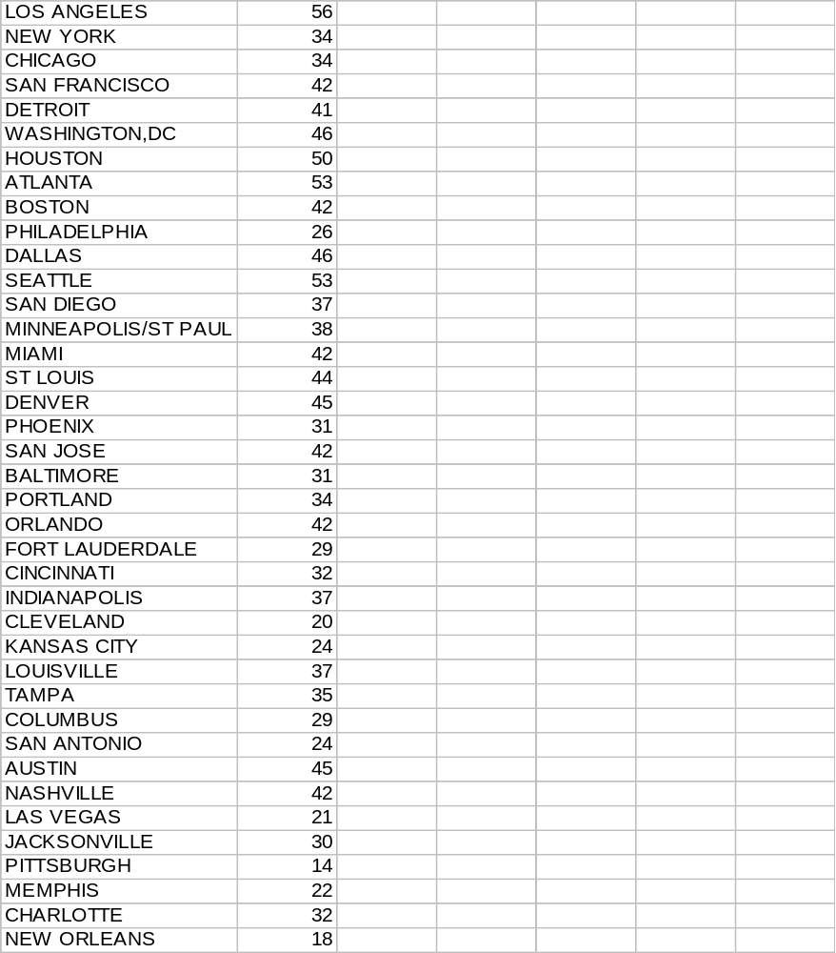

A histogram of the times, using default numbers of bins and upper endpoints from EXCEL 97:

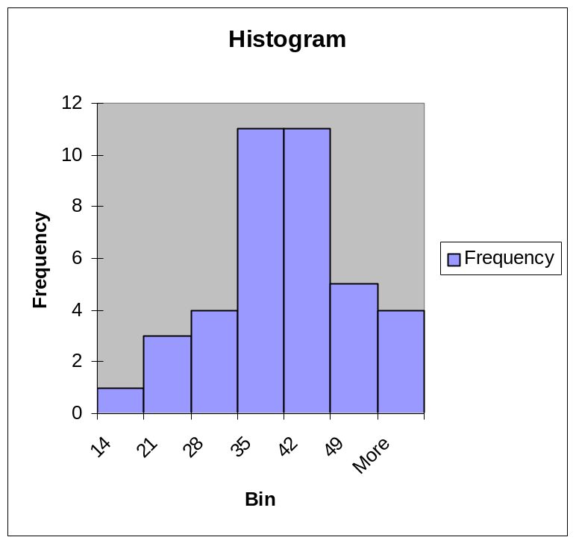

A stem-and-leaf diagram of the times:

Stem & Leaf Display
Stems | Leaves
1 | ->48
2 | ->01244699
3 | ->0112244457778
4 | ->122222245566
5 | ->0336

Example – AAA Quality Ratings of Hotels & Motels in FL

The following EXCEL 97 worksheet gives the AAA ratings (1-5 stars) and the frequency counts for Florida hotels. Source: AAA Tour Book, 1999 Edition.

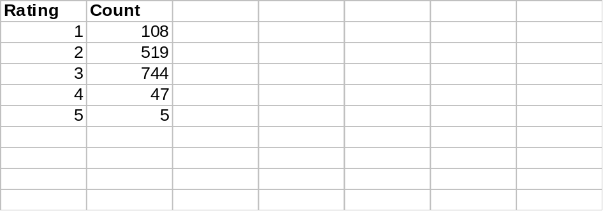

A bar chart, representing the distribution of ratings:
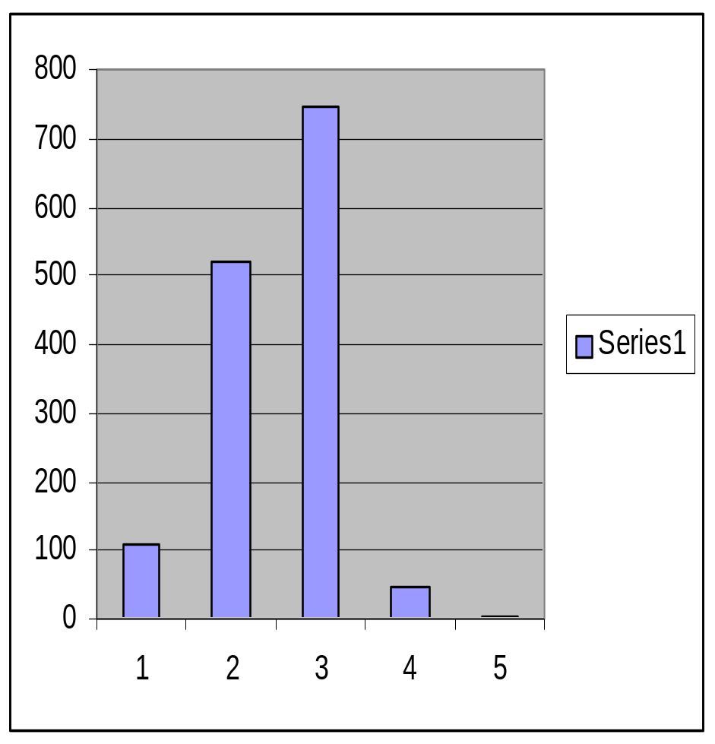

A pie chart, representing the distribution of ratings:

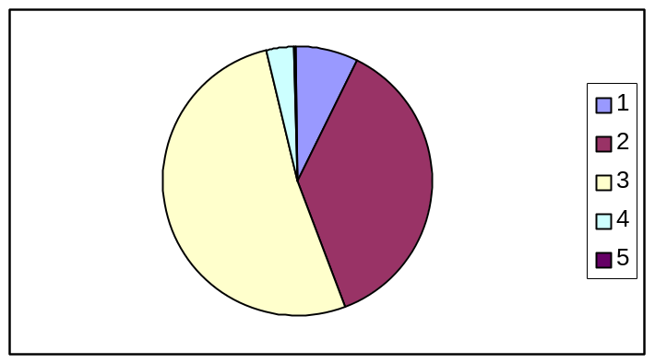

Note that the large majority of hotels get ratings of 2 or 3.

Example – Production Costs of a Hosiery Mill

The following EXCEL 97 worksheet gives (approximately) the quantity produced (Column 2) and total costs (Column 3) for n=48 months of production for a hosiery mill. Source: Joel Dean (1941), “Statistical Cost Functions of a Hosiery Mill, Studies in Business Administration. Vol 14, #3.

1 | 46.75 | 92.64
2 | 42.18 | 88.81
3 | 41.86 | 86.44
4 | 43.29 | 88.8
5 | 42.12 | 86.38
6 | 41.78 | 89.87
7 | 41.47 | 88.53
8 | 42.21 | 91.11
9 | 41.03 | 81.22
10 | 39.84 | 83.72
11 | 39.15 | 84.54
12 | 39.2 | 85.66
13 | 39.52 | 85.87
14 | 38.05 | 85.23
15 | 39.16 | 87.75
16 | 38.59 | 92.62
17 | 36.54 | 91.56
18 | 37.03 | 84.12
19 | 36.6 | 81.22
20 | 37.58 | 83.35
21 | 36.48 | 82.29
22 | 38.25 | 80.92
23 | 37.26 | 76.92
24 | 38.59 | 78.35
25 | 40.89 | 74.57
26 | 37.66 | 71.6
27 | 38.79 | 65.64
28 | 38.78 | 62.09
29 | 36.7 | 61.66
30 | 35.1 | 77.14
31 | 33.75 | 75.47
32 | 34.29 | 70.37
33 | 32.26 | 66.71
34 | 30.97 | 64.37
35 | 28.2 | 56.09
36 | 24.58 | 50.25
37 | 20.25 | 43.65
38 | 17.09 | 38.01
39 | 14.35 | 31.4
40 | 13.11 | 29.45
41 | 9.5 | 29.02
42 | 9.74 | 19.05
43 | 9.34 | 20.36
44 | 7.51 | 17.68
45 | 8.35 | 19.23
46 | 6.25 | 14.92
47 | 5.45 | 11.44
48 | 3.79 | 12.69
A scatterplot of total costs (Y) versus quantity produced (X):

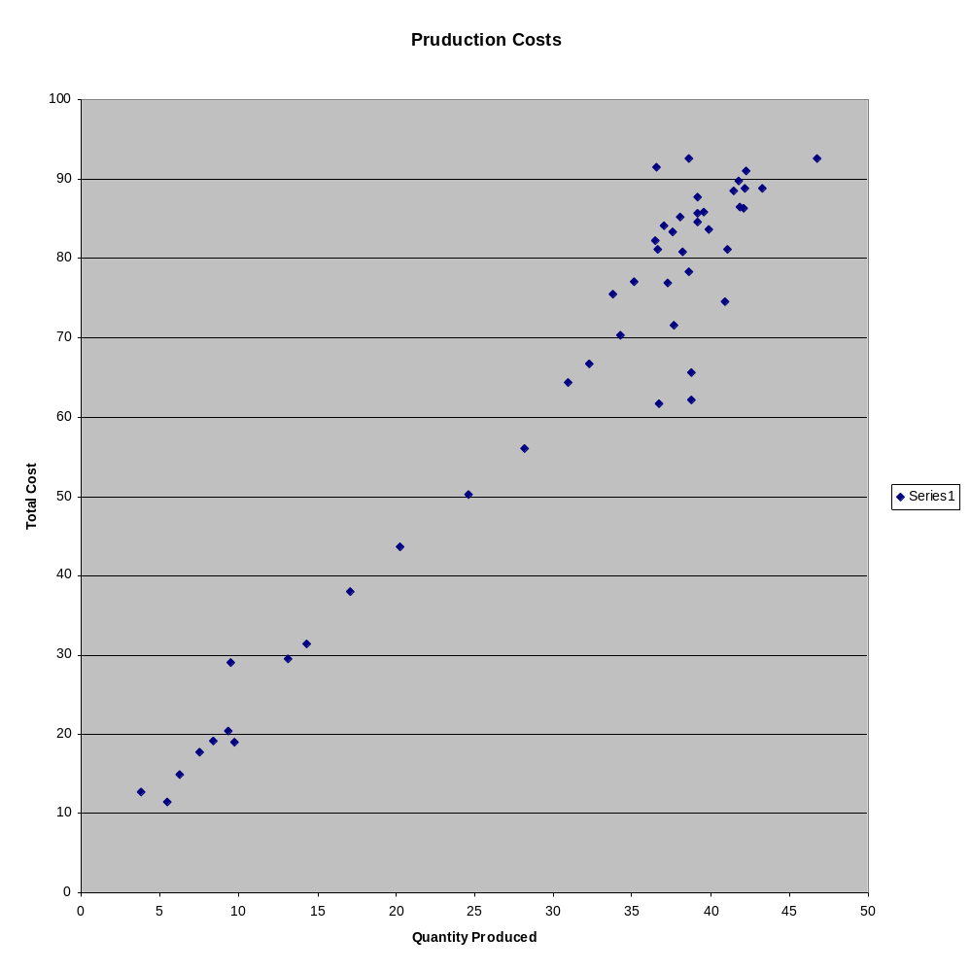
Note the positive association between total cost and quantity produced.

Example – Tobacco Use Among U.S. College Students

The following EXCEL 97 worksheet gives frequencies of college students by race (White(not hispanic), Hispanic, Asian, and Black) and current tobacco use (Yes, No). Source: Rigotti, Lee, Wechsler (2000). “U.S. College Students Use of Tobacco Products”, JAMA 284:699-705.

A cross-tabulation (AKA contingency table) classifying students by race and smoking status. The numbers in the table are the number of students falling in each category:

 |  | Smoke
Race |  | Yes | No
 | White | 3807 | 6738
 | Hispanic | 261 | 757
 | Asian | 257 | 860
 | Black | 125 | 663

A sub-type bar chart depicting counts of smokers/nonsmokers by race:

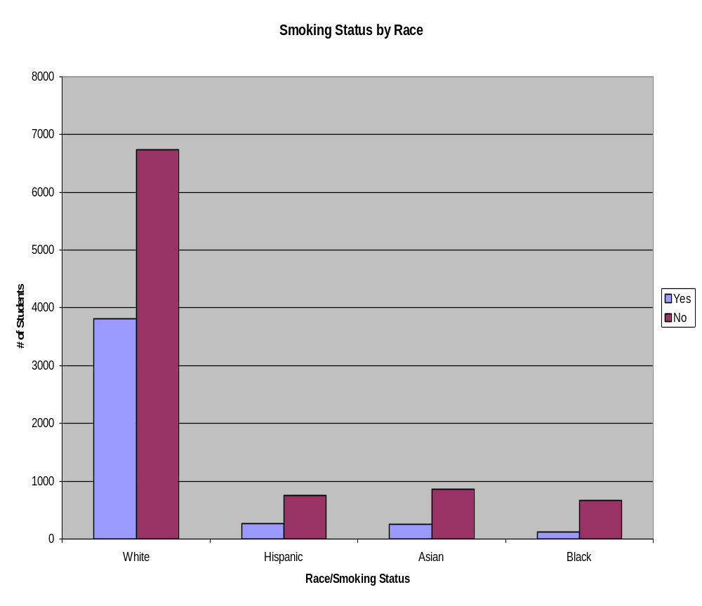

There is some evidence that a higher fraction of white students than black students currently smoked at the time of the study (the relative height of the Yes bar to No bar is higher for Whites than Blacks.

A 3-dimensional bar chart of smoking status by race:
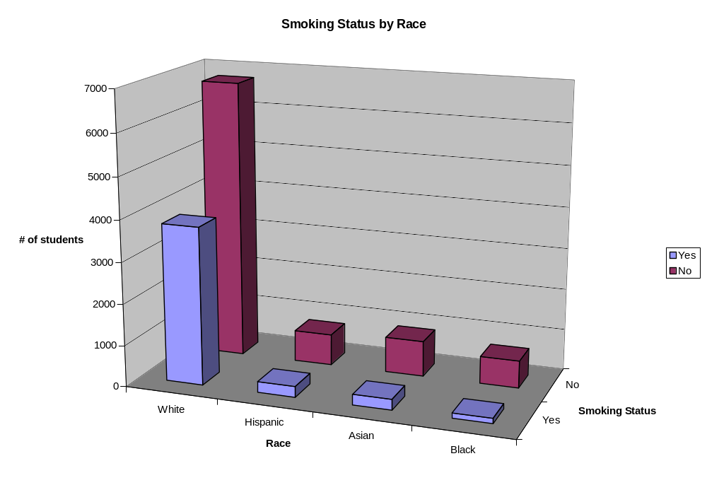

Example – NASDAQ Stock Index Over Time

This data set is too large to include as an EXCEL worksheet. The following is a graph of the NASDAQ market index versus day of trading from the beginning of the NASDAQ stock exchange (02/05/71) until (03/08/02). Source:

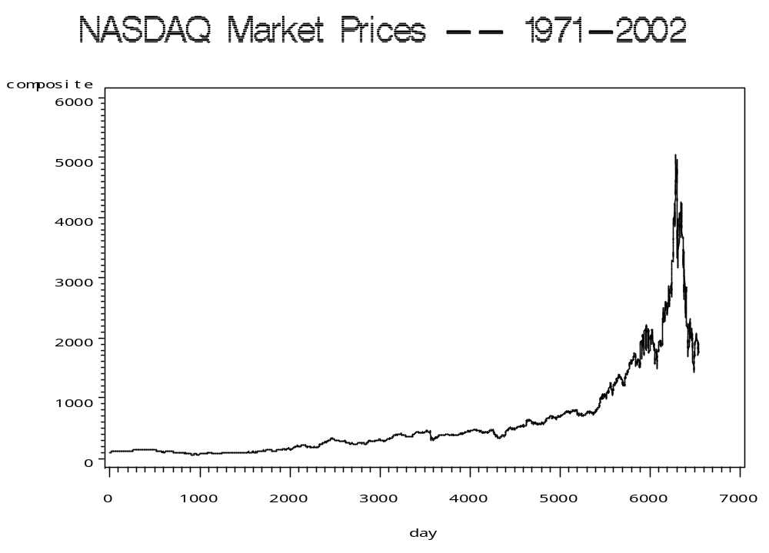

This is appears to be an example of a financial bubble, where prices were driven up dramatically, only to fall drastically.

Example – U.S. Airline Yield 1950-1999
The following EXCEL 97 worksheet gives annual airline performance measure (Yield in cents per revenue mile in 1982 dollars) for U.S. airlines. Source: Air Transport Association.

Year | Yield82
1950 | 27.62
1951 | 28.29
1952 | 25.17
1953 | 24.11
1954 | 22.98
1955 | 23.86
1956 | 22.5
1957 | 21.51
1958 | 19.52
1959 | 22.78
1960 | 21.4
1961 | 20.13
1962 | 20.15
1963 | 19.2
1964 | 18.53
1965 | 17.95
1966 | 16.86
1967 | 15.89
1968 | 15.15
1969 | 14.95
1970 | 14.39
1971 | 14.44
1972 | 14.04
1973 | 13.78
1974 | 14.27
1975 | 13.61
1976 | 13.51
1977 | 13.42
1978 | 12.27
1979 | 11.58
1980 | 12.89
1981 | 13.08
1982 | 11.78
1983 | 11.25
1984 | 11.27
1985 | 10.46
1986 | 9.62
1987 | 9.44
1988 | 9.69
1989 | 9.68
1990 | 9.42
1991 | 9.03
1992 | 8.6
1993 | 8.72
1994 | 8.2
1995 | 8.15
1996 | 8
1997 | 7.89
1998 | 7.76
1999 | 7.48
A time series plot (line chart) of airline yields versus year in constant (1982) dollars:

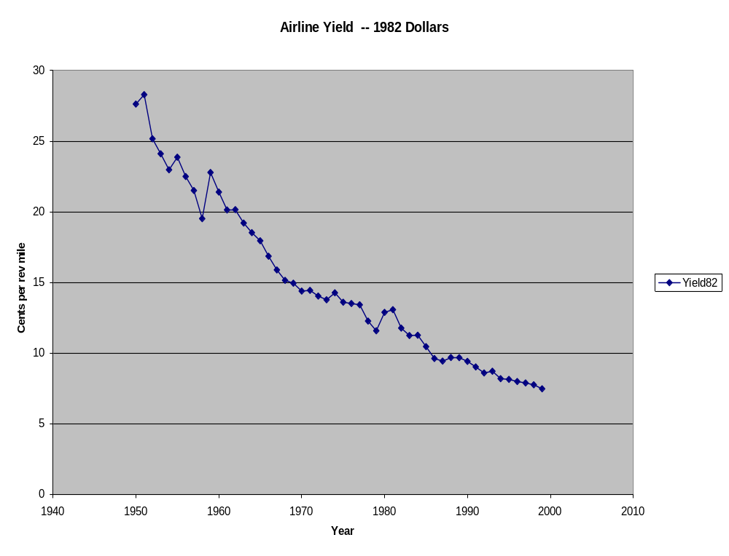

Example – 1994 Per Capita Income for Florida Counties

The following graph is a map of per capita income for Florida Counties in 1994: Not in textbook.
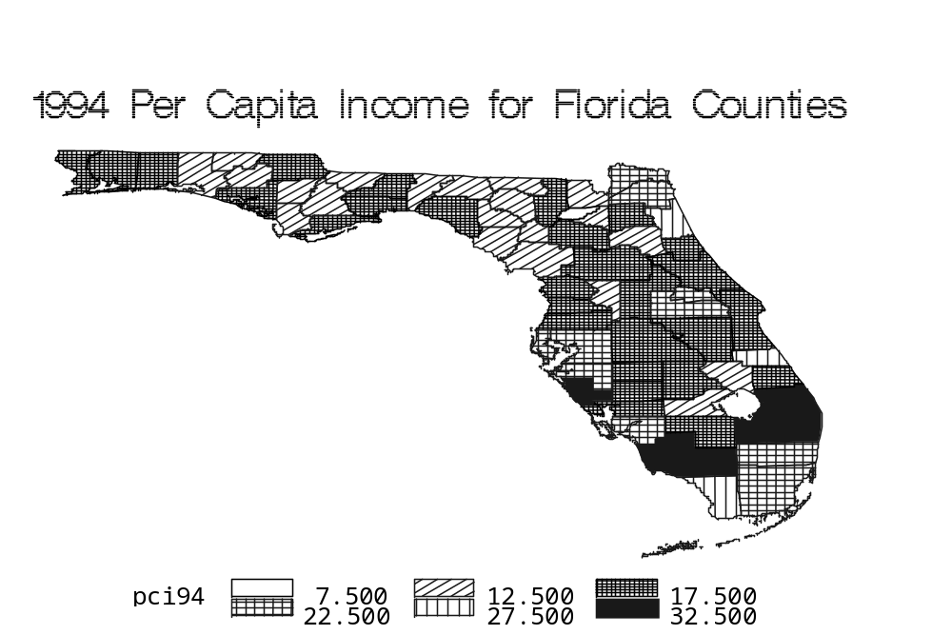

It can be seen that the counties with the highest per capita incomes tend to be in the southern portion of the state and counties with the lowest per capita incomes tend to be on the panhandle (northwest).

Numerical Descriptive Measures (Chapter 3)

Measures of Central Location (Sections 3.1,3.3)

Arithmetic Mean: The sum of all measurements, divided by the number of measurements. Only appropriate for interval scale data.

Population Mean (N items in population, with values X₁,…,X_{N}):

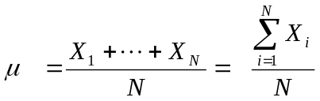

Sample Mean (n items in sample with values x₁,…,x_{n}):

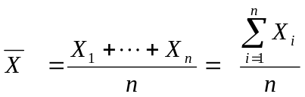

Note that measures such as per capita income are means. To obtain it, the total income for a region is obtained and divided by the number of people in the region. The mean represents what each individual would receive if the total for that variable were evenly split by all individuals.

Median: Middle observation among a set of data. Appropriate for interval of ordinal data. Computed in same manner for populations and samples.

- Sort data from smallest to largest.
- The median is the middle observation (n odd) or mean of middle two (n even).

Measures of Variability (Sections 3.2,3.3)

Variance: Measure of the “average” squared distance to the mean across a set of measurements.

Population Variance (N items in population, with values x₁,…,x_{N}):

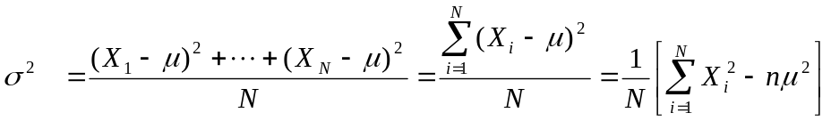

Sample Variance (n items in sample, with values x₁,…,x_{n}):

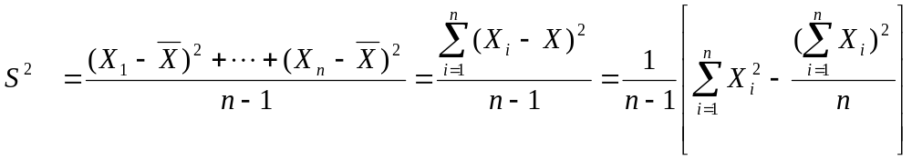

Standard Deviation: Positive square root of the variance. Is measured in the same units as the data. Population: σ. Sample: s.

Coefficient of Variation: Ratio of standard deviation to the mean, often reported as a percentage.

Population: 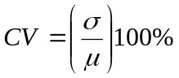 Sample: 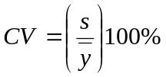

Measures of Linear Relationship (Sections 3.5, 12.1-2)

Covariance: Measure of the extent that two variables vary together. Covariance can be positive or negative, depending on the direction of the relationship. There are no limits on range of covariance.

Population Covariance (N pairs of items in population, with values (X_{i},Y_{i}))

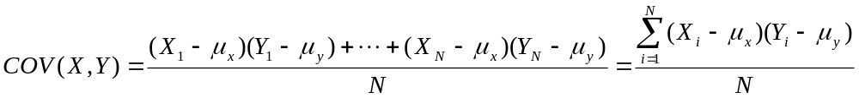

Sample Covariance (n pairs of items in sample, with values (X_{i},Y_{i}))

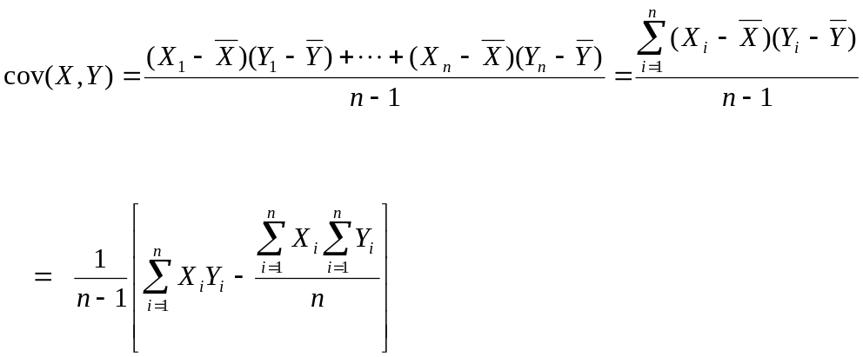

Coefficient of Correlation: Measure of the extent that two variables vary together. Correlations can be positive or negative, depending on the direction of the relationship. Correlations are covariances divided by the product of standard deviations of the two variables, and can only take on values between –1 and 1. Higher correlations (in absolute value) are consistent with stronger linear relationships.

Population Coefficient of Correlation: ρ = COV(X,Y) / (σ_{x} σ_{Y}) -1 ≤ ρ ≤ 1

Sample Coefficient of Correlation: r = cov(x,y) / (s_{x} s_{y}) -1 ≤ r ≤ 1

Least Squares Estimation of a Linear Relation Between 2 Interval Variables

Dependent Variable: Y is the random outcome being observed

Independent Variable: X is a variable that is believed to be related to (causing) Y.

Procedure:

- Plot the Y values on the vertical (up and down) axis versus their corresponding X values on the horizontal (left to right) axis. (This step isn’t necessary, but is very useful in understanding the relationship).

- Fit the best line: Ŷ = b₀ + b₁x that minimizes the sum of squared deviations between the actual values and their predicted values based on their corresponding x levels:

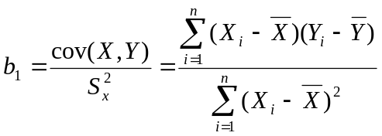Slope: How much Y tends to change as X increases by 1 unit.

Y-intercept: Where the line crosses the Y-axis (when X=0).

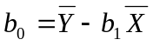

Examples
Example – Diluted Earnings Per Share

The following table gives diluted earnings per share (EPS) for a sample of n=10 publicly traded firms for calendar year 2002. Sources: Corporate Annual Reports.

Firm EPS (X) Rank (X -- X-bar) (X – X-bar)²
Merck 3.14 9 3.14-2.115 = 1.025 (1.025)² = 1.050625
MBNA 1.34 2 1.34-2.115 = -0.775 (-0.775)² = 0.600625
Gentex 1.12 1 1.12-2.115 = -0.995 (-0.995)² = 0.990025
General Dynamics 4.52 10 4.52-2.115 = 2.405 (2.405)² = 5.784025
Wachovia 2.60 8 2.60-2.115 = 0.485 (0.485)² = 0.235225
Pepsico 1.85 6 1.85-2.115 = -0.265 (-0.265)² = 0.070225
Pfizer 1.46 4 1.46-2.115 = -0.655 (-0.655)² = 0.429025
Aflac 1.55 5 1.55-2.115 = -0.565 (-0.565)² = 0.319225
Johnson & Johnson 2.16 7 2.16-2.115 = 0.045 (0.045)² = 0.002025
General Electric 1.41 3 1.41-2.115 = -0.705 (-0.705)² = 0.497025
Sum 21.15 -- 0.000 9.978050

- To obtain the simple (unweighted) mean for these firms EPS values, we obtain the total of the EPS values and divide by the number of firms:

- To obtain the median for these firms EPS values, we first order them from smallest to largest, then take the average of the middle two values (fifth and sixth). See ranks in table:

Median = (1.55+1.85)/2 = 3.40/2 = 1.70

- To obtain the sample variance, we first obtain each firms deviation from mean, square it, sum these across firms and divide by n-1. To get sample standard deviation, we take positive square root of sample variance. See calculations in table:
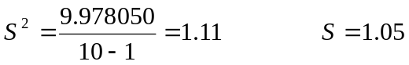

Example – Times Wasted in Traffic (Continuation of Example)

The following EXCEL spreadsheet contains descriptive statistics of time lost annually in congested traffic (hours, per person) for n=39 U.S. cities. Source: Texas Transportation Institute (5/7/2001).

Column1
Mean | 35.89744
Standard Error | 1.632495
Median | 37
Mode | 42
Standard Deviation | 10.19493
Sample Variance | 103.9366
Kurtosis | -0.50803
Skewness | -0.13792
Range | 42
Minimum | 14
Maximum | 56
Sum | 1400
Count | 39

Note that the coefficient of variation is the standard deviation divided by the mean:

CV = 10.19/35.90 = 0.28, which is 28% when stated as a percentage.

Example – Defense Expenditures and GNP

The following table gives defense expenditures (Y, in billions of dollars) and gross national product (X, in billions of dollars) for n=6 Latin American nations in 1997. This is treated as a sample for computational purposes. Calculations are given in tabular form.

Nation Y X (Y-Y-bar) (X-X-bar)
Brazil 14.15 788.2 14.15-5.05 = 9.10 788.2-291.5 = 496.7
Mexico 4.29 389.8 4.29-5.05 = -0.76 389.8-291.5 = 98.3
Argentina 3.70 318.8 3.70-5.05 = -1.35 318.8-291.5 = 27.3
Colombia 3.46 92.5 3.46-5.05 = -1.59 92.5-291.5 = -199.0
Chile 2.86 74.1 2.86-5.05 = -2.19 74.1-291.5 = -217.4
Venezuela 1.86 85.5 1.86-5.05 = -3.19 85.5-291.5 = -206.0
Mean 5.05 291.5 --- ----

Sums of squares and cross-products:

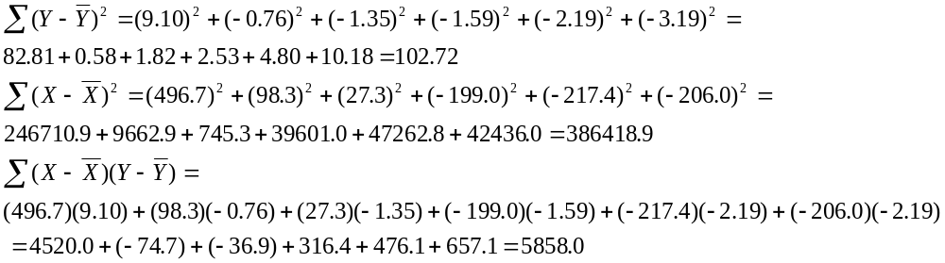
Variances, standard deviations, Covariance, Correlation, and Regression Equation:

S_{y}² = 102.72/(6-1) = 20.54 S_{y} = 4.53

S_{x}² = 386418.9/(6-1) = 77283.8 S_{x} = 278.0

cov(X,Y) = 5858.0/(6-1) = 1171.6 r = 1171.6/(278.0*4.53) = 0.93

b₁ = 1171.6 / 77283.8 = 0.01516 b₀ = 5.05 – 0.01516(291.5) = 0.63

Ŷ = 0.63 + 0.01516X

Plot of data and least squares fitted equation.

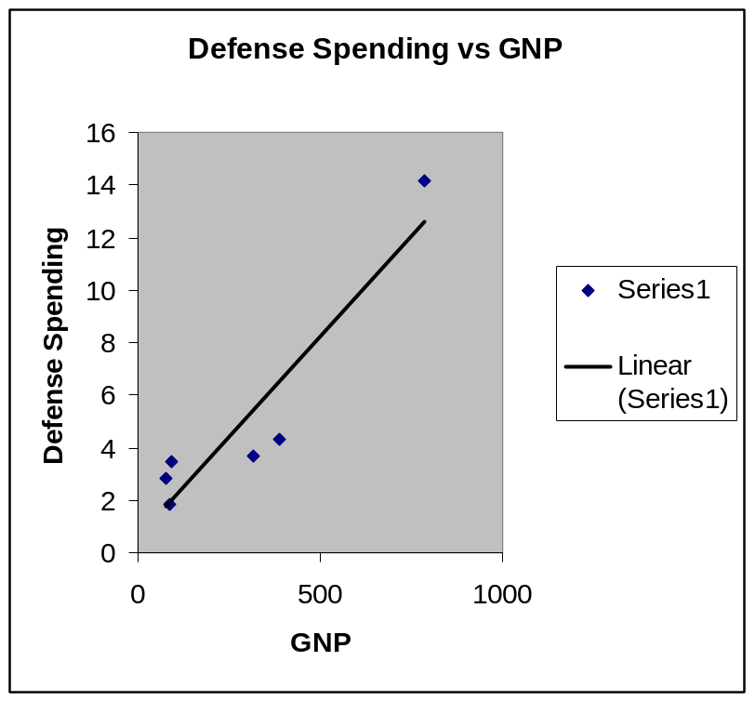

Variances and Covariance.

 | GNP | Defense
GNP | 77283.77
Defense | 1171.613 | 20.54207

Correlation.

 | GNP | Defense
GNP | 1
Defense | 0.929861 | 1

Example – Estimation of Cost Function

For the hosiery mill data in a previous Example, we estimate the cost function by least squares. The y-intercept (b₀) can be interpreted as fixed cost, and the slope (b₁) represents the unit variable costs. Y is in $1000s and X is in 1000s of dozens of pairs of socks.

 | Coefficients
Intercept | 3.128201
X | 2.005476

Ŷ = 3.13 + 2.01X, thus fixed costs are estimated to be $3130 since units are $1000s, and unit variable costs are approximately $2.00 per dozen pairs (this data was from the 1940s).

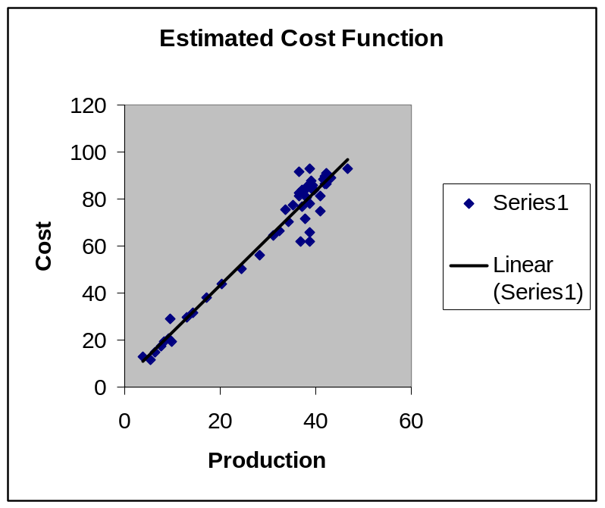

Example - Computation of Corporate ‘Betas’

A widely used measure of a company’s performance is their beta. This is a measure of the firm’s stock price volatility relative to the overall market’s volatility. One common use of beta is in the capital asset pricing model (CAPM) in finance, but you will hear them quoted on many business news shows as well. It is computed as (Value Line):

The “beta factor” is derived from a least squares regression analysis
between weekly percent changes in the price of a stock and weekly
percent changes in the price of all stocks in the survey over a period
of five years. In the case of shorter price histories, a smaller period
is used, but never less than two years.

In this example, we will compute the stock beta over a 28-week period for Coca-Cola and Anheuser-Busch, using the S&P500 as ‘the market’ for comparison. Note that this period is only about 10% of the period used by Value Line. Note: While there are 28 weeks of data, there are only n=27 weekly changes.

The included Excel worksheet provides the dates, weekly closing prices, and weekly percent changes of: the S&P500, Coca-Cola, and Anheuser-Busch. The following summary calculations are also provided, with X representing the S&P500, Y_{C} representing Coca-Cola, and Y_{A} representing Anheuser-Busch. All calculations should be based on 4 decimal places.

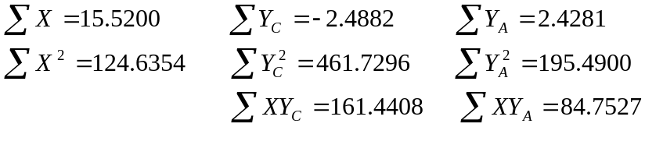

- Compute the stock betas (slopes of the least squares regression lines) for Coca-Cola (b_{c}) and Anhueser-Busch (b_{a}).

a) b_{c} = -0.1888 b_{a} = 0.1467
b) b_{c} = 1.2984 b_{a} = 0.6800
c) b_{c} = 1.4075 b_{a} = 0.7204
d) b_{c} = 0.3529 b_{a} = 0.4269

- Explain why you would be able to determine which plot represents Coca-Cola, and which represents Anhueser-Busch, even if I could figure out how to remove the axis labels.

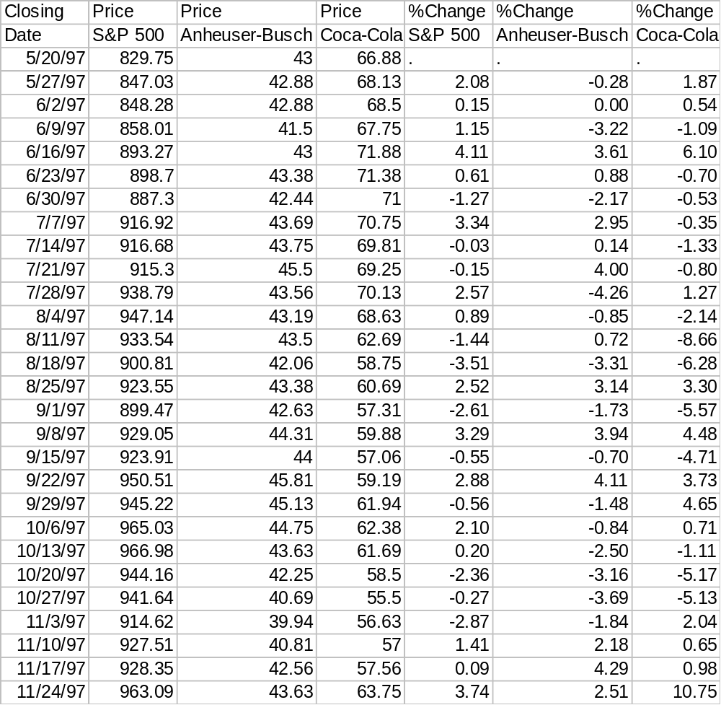

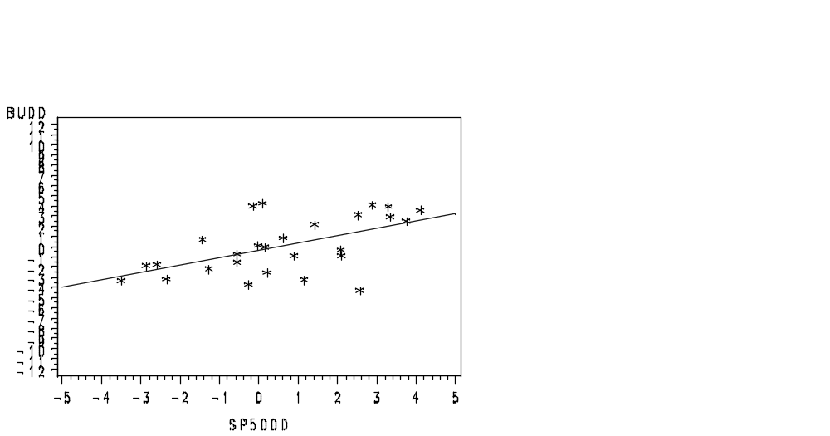
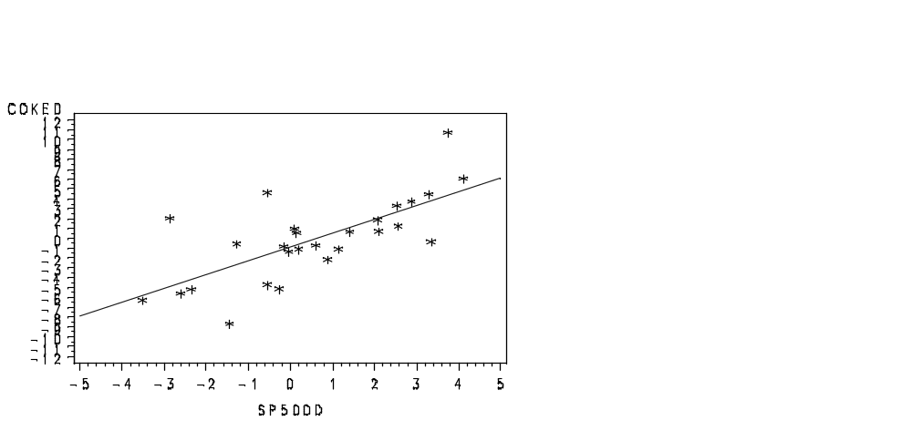

Basic Probability (Chapter 4)

Approaches to assigning probabilities to outcomes

- Classical Approach: Based on mathematical means of determining all outcomes of an experiment, and assigning probabilities based on counting rules. We will not pursue this approach any further here.
- Relative Frequency Appoach: Based on on “long-run” relative frequencies of what happens when an experiment is conducted repeatedly.
- Subjective Approach: Based on assessing degrees of belief on certain events occurring. In most financial settings, probabilities bust be based subjectively, since an experiment cannot be conducted repeatedly.

General Concepts:

- Events: Distinct outcomes of an experiment, possibly made up of groups of simpler events. Events are often labelled by capital letters, such as A and B, often with subscripts.
- Probabilities: Numerical measures of the likelihood (frequency) of the various events. When a listing of all simple events is known, their probabilities are all non-negative and sum to 1.
- Intersection: The intersection of two events, A and B, is the event that both events occur.
- Contingency Tables: Crosstabulations of the number of units corresponding to outcomes of events A and B
- Marginal Probability: Probabilities corresponding to individual event outcomes.
- Joint Probability: Probabilities corresponding to combinations of event outcomes.

Example – Phase III Clinical Trial for Pravachol

Among a population (for now) of adult males with high cholesterol, approximately half of the males were assigned to receive Pravachol (Bristol--Myers Squibb), and approximately half received a placebo. The outcome observed was whether or not the patient suffered from a cardiac event within five years of beginning treatment. The counts of patients falling into each combination of treatment and outcome are given below. Source: J. Shepherd, et al, (1995), “Prevention of Coronary Heart Disease with Pravastatin in Men with Hypocholsterolemia”, NEJM, 333:1301-1307.

 | Cardiac Event
Treatment | Yes (B₁) | No (B₂) | Total
Pravachol (A₁) | 174 | 3128 | 3302
Placebo (A₂) | 248 | 3045 | 3293
Total | 422 | 6173 | 6595

The probability a patient received pravachol and suffered a cardiac event:

P(A₁ and B₁) = 174 / 6595 = 0.0264

The probability a patient received pravachol and did not suffer a cardiac event:

P(A₁ and B₂) = 3128 / 6595 = 0.4743

The probability a patient received placebo and suffered a cardiac event:

P(A₂ and B₁) = 248 / 6595 = 0.0376

The probability a patient received pravachol and did not suffer a cardiac event:

P(A₁ and B₂) = 3045 / 6595 = 0.4617

These represent joint probabilities of treatment and cardiac event status.

Joint, Marginal, and Conditional Probability

Marginal Probability: Probabilities obtained for events, by summing across joint probabilities given in the table of probabilities. For the Pravachol data:

Probability a subject received Pravachol (A₁):

P(A₁) = P(A₁ and B₁) + P(A₁ and B₂) = .0264+ .4743 = .5007

Probability a subject received Placebo (A₂):

P(A₂) = P(A₂ and B₁) + P(A₂ and B₂) = .0376+ .4617 = .4993

Probability a subject suffered a cardiac event (B₁):

P(B₁) = P(A₁ and B₁) + P(A₂ and B₁) = .0264+ .0376 = .0640

Probability a subject did not suffer a cardiac event (B₂):

P(B₂) = P(A₁ and B₂) + P(A₂ and B₂) = .4743+ .4617 = .9360

Below is a table, representing the joint and marginal probabilities. Note that this is simply obtained by dividing each count in the previous table by 6595.

 | Cardiac Event
Treatment | Yes (B1) | No (B2) | Total
Pravachol (A1) | 0.0264 | 0.4743 | 0.5007
Placebo (A2) | 0.0376 | 0.4617 | 0.4993
Total | 0.0640 | 0.9360 | 1.0000

About half of the subjects received pravachol, the other half received placebo. Approximately 6.4% (0.0640) of the subjects suffered a cardiac event (1 in 16).

Conditional Probability: The probability that one event occured, given another event has occurred. The probability that event A has occurred given that B has occurred is written as P(A | B) and is computed as the first of the following equations:

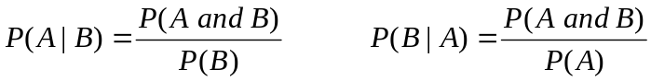

Among patients receiving Pravachol (A₁), what is the probability that a patient suffered a cardiac event (B₁)?
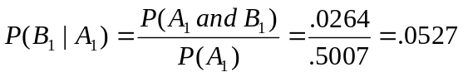

Note that this could also be obtained from the original table of cell counts by taking 174/3302.

Among patients receiving Placebo (A₂), what is the probability that a patient suffered a cardiac event (B₁)?

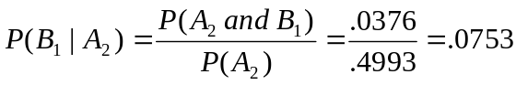

Among subjects receiving Pravachol, 5.27% suffered a cardiac event, a reduction compared to the 7.53% among subjects receiving placebo. We will later treat this as a sample and make an inference concerning the effect of Pravachol.

Independence: Two events A and B are independent if P(A|B) = P(A) or P(B|A) = P(B).

Since P(B₁|A₁) = .0527 ≠ .0640 = P(B₁), treatment and cardiac event outcome are not independent in this population of subjects.

Bayes’ Theorem (Section 4.3)

Sometimes we can easily obtain probabilities of the form P(A|B) and P(B) and wish to obtain P(B|A). This is very important in decision theory with respect to updating information. We start with a prior probability, P(B), we then observe an event A, and obtain P(A|B). Then, we update our probability of B in light of knowledge that A has occurred.

First note: P(A|B) = P(A and B) / P(B) ==> P(A and B) = P(A|B) * P(B)

Second note: If factor B can be broken down into k mutually exclusive and exhaustive events B₁, ..., B_{k}, then:

P(A) = P(A and B₁) + ... + P(A and B_{k}) = P(A|B₁)*P(B₁) + ... + P(A|B_{k})*P(B_{k})

Third note: Given we know A has occurred, then the probability B_{i} occured is:

Example – Cholera and London’s Water Companies

Epidemiologist John Snow conducted a massive survey during a cholera epidemic in London during 1853-1854. He found that water was being provided through the pipes of two companies: Southwark & Vauxhall (W₁) and Lambeth (W₂). Apparently, the Lambeth company was obtaining their water upstream in the Thames River from the London sewer outflow, while the S&V company got theirs near the sewer outflow.

The following table gives the numbers (or counts) of people who died of cholera and who did not, seperately for the two firms. Source: W.H. Frost (1936). Snow on Cholera, London, Oxford University Press.

 | Cholera Death
Water Company | Yes (C) | No | Total
S&V (W₁) | 3702 | 261211 | 264913
Lambeth (W₂) | 407 | 170956 | 171363
Total | 4109 | 432167 | 436276

- What is the probability a randomly selected person received water from the Lambeth company? From the S&V company?

- What is the probability a randomly selected person died of cholera? Did not die of cholera?

- What proportion of the Lambeth consumers died of cholera? Among the S&V consumers? Is the incidence of cholera death independent of firm?

- What is the probability a person received water from S&V, given (s)he died of cholera?

Example - Moral Hazard

A manager cannot observe whether her salesperson works hard. She believes based on prior experience that the probability her salesperson works hard (H) is 0.30. She believes that if the salesperson works hard, the probability a sale (S) is made is 0.75. If the salesperson does not work hard, the probability the sale is made is 0.15. She wishes to obtain the probability the salesperson worked hard based on his/her sales performance.

Step 1: What do we want to compute?

What is the probability that the salesperson worked hard if the sale was made?

Prob(Work Hard | Sale) = Prob(Work Hard & Sale) / Prob (Sale)

If not made?

Prob(Work Hard | No Sale) = Prob(Work Hard & No Sale) / Pr(No Sale)

Step 2: What is given/implied?

Prob(Works Hard)=P(H)=0.30
Prob(Sale | Works Hard) = P(S|H)=0.75
Prob(No Sale | Works Hard) = P(Not S | H) = 1-0.75 = 0.25

Prob(Not Work Hard)= P(Not H) = 1-P(H) = 1-0.30=0.70
Prob(Sale | Not Work Hard)=P(S|Not H)=0.15
Prob(No Sale | Not Work Hard) = P(Not S | Not H) = 1-0.15 = 0.85

Step 3: Compute probabilities in step 1 from information given in step 2:

Prob(Works Hard & Sale) = P(H)*P(S|H) = 0.30(0.75) = 0.225
Prob(Not Work Hard & Sale) = P(Not H)*P(S|Not H) = 0.70(0.15) = 0.105
Prob(Sale) = Prob(Works Hard & Sale) + Prob(Not Work Hard & Sale) = 0.225+0.105=0.330

Prob(Work Hard | Sale) = Prob(Work Hard & Sale) / Prob (Sale) = 0.225/0.330 = 0.682

Prob(Works Hard &No Sale) = P(H)*P(Not S|H) = 0.30(0.25) = 0.075
Prob(Not Work Hard & No Sale) = P(Not H)*P(Not S|Not H) = 0.70(0.85) = 0.595
Prob(No Sale) = Prob(Works Hard & No Sale) + Prob(Not Work Hard & No Sale) = 0.075+0.595=0.670

Prob(Work Hard | No Sale) = Prob(Work Hard & No Sale) / Prob (No Sale) = 0.075/0.670 = 0.112
%
Note the amount of updating of the probability the salesperson worked hard,
depending on whether the sale was made.

This is a simplified example of a theoretical area
in information economics (See e.g. D.M. Kreps, A Course in Microeconomic Theory, Chapter 16).
Example -- Adverse Selection (Job Market Signaling)

Consider a simple model where there are two types of workers -- low quality and high quality. Employers are unable to determine the worker's quality type. The workers choose education levels to signal to employers their quality types. Workers can either obtain a college degree (high education level) or not obtain a college degree (low education level). The effort of obtaining a college degree is lower for high quality workers than for low quality workers. Employers pay higher wages to workers with higher education levels, since this is a (imperfect) signal for their quality types.

Suppose you know that in the population of workers, half are low quality and half are high quality. Thus, prior to observing a potential employee's education level, the employer thinks the probability the worker will be high quality is 0.5. Among high quality workers, 80% will pursue a college degree (20% do not pursue a degree), and among low quality workers, 15% pursue a college degree (85% do not). You want to determine the probability that a potential employee is high quality given they have obtained a college degree. Given they have not obtained a college degree.

Step 1: What do we want to compute?

Prob(High Quality|College) = Prob(High Quality & College) / Prob(College) = ?
Prob(High Quality|No College) = Prob(High Quality & No College) / Prob(No College) = ?

Step 2: What is given?

Prob(High Quality) = 0.50
Prob(College|High Quality) = 0.80 Prob(No College|High Quality) = 1-0.80 = 0.20

Prob(Low Quality) = 0.50
Prob(College | Low Quality) = 0.15 Prob(No College|Low Quality)=1-0.15=0.85

Step 3: Computing probabilities in step 1 based on information in step 2:

Prob(High Quality and College) = 0.50(0.80) = 0.400
Prob(Low Quality and College) = 0.50(0.15) = 0.075
Prob(College) = 0.400 + 0.075 = 0.475

Prob(High Quality | College) = 0.400/0.475 = 0.842

Prob(High Quality and No College) = 0.50(0.20) = 0.100
Prob(Low Quality and No College) = 0.50(0.85) = 0.425
Prob(No College) = 0.100 + 0.425 = 0.525

Prob(High Quality | No College) = 0.100/0.525 = 0.190

This is a simplified example of a theoretical area
in information economics (See e.g. D.M. Kreps, A Course in Microeconomic Theory, Chapter 17).

Random Variables and Discrete Probability Distributions

Chapter 5

Random Variable: Function or rule that assigns a number to each possible outcome of an experiment.

Discrete Random Variable: Random variable that can take on only a finite or countably infinte set of outcomes.

Continuous Random Variable: Random variable that can take on any value across a continuous range. These have an uncountable set of possible values.

Probability Distribution: Table, graph, or formula, describing the set of values a random variable can take on as well as probability masses (for discrete random variables) or densities (for continuous random variables).

Requirements for a Probability Distribution for a discrete random variable:

- 0 ≤ p(x) ≤ 1 for every possible outcome x

- sum of p(x) values across all possible outcomes is 1

Example –AAA Florida Hotel Ratings

In a previous Example, we observed the distribution of quality ratings among Florida hotels. By treating this as a population (it includes all hotels rated by AAA), we can set this up as a probability distribution. Source: AAA Tour Book, 1999 Ed.

The following table gives the frequency and proportion of hotels by quality rating. The probability distribution is obtained by dividing the frequency counts by the total number of hotels rated (1423). The random variable X is the quality rating of a randomly selected hotel.

Rating (x) # of hotels P(x)
1 108 108/1423 = .07590
2 519 519/1423 = .36472
3 744 744/1423 = .52284
4 47 47/1423 = .03303
5 5 5/1423 = .00351
Sum 1423 1.00000

The shape of the probability distribution is identical to the histogram in Example 2, with the vertical axis rescaled (all frequencies turned into probabilities by dividing by 1423).

- What is the probability a randomly selected hotel gets a quality rating of 4 or higher?

- What is the median rating?

Describing the Population/Probability Distribution

Population Mean (Expected Value):
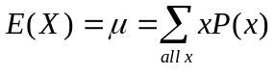

Population Variance:

Population Standard Deviation:
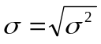

AAA Rating Example (Note this variable is technically ordinal, so this is for demonstration purposes only):

Rating (x) p(x) xp(x) x²p(x)
1 .07590 1(.07590)=0.07590 1(.07590)=0.07590
2 .36472 2(.36472)=0.72944 4(.36472)=1.45888
3 .52284 3(.52284)=1.56852 9(.52284)=4.70556
4 .03303 4(.03303)=0.13212 16(.03303)=0.52848
5 .00351 5(.00351)=0.01755 25(.00351)=0.08775
Sum 1.00000 2.52353 6.85657

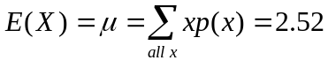
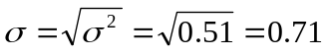
Example - Adverse Selection (Akerlof's Market for Lemons)

George Akerlof shared the Nobel Prize for Economics in 2002 for an extended version of this model. There are two used car types: peaches and lemons. Sellers know the car type, having been driving it for a period of time. Buyers are unaware of a car's quality. Buyers value peaches at $3000 and lemons at $2000. Sellers value peaches at $2500 and lemons at $1000. Note that if sellers had higher valuations, no cars would be sold.

Suppose that 2/5 (40%) of the cars are peaches and the remaining 3/5 (60%) are lemons. What is the expected value to a buyer, if (s)he purchases a car at random? We will let X represent the value to the buyer, which takes on the values 3000 (for peaches) and 2000 (for lemons).

Thus, buyers will not pay over $2400 for a used car, and since the value of peaches is $2500 to sellers, only lemons will be sold, and buyers will learn that, and pay only $2000.

At what fraction of the cars being peaches, will both types of cars be sold?

For a theoretical treatment of this problem, see e.g. D.M. Kreps, A Course in Microeconomic Theory, Chapter 17.

Bivariate Distributions (Section 5.2)

Often we are interested in the outcomes of 2 (or more) random variables. In the case of two random variables, we will label them X and Y.

Suppose you have the opporunity to purchase shares of two firms. Your (subjective) joint probability distribution (p(x,y)) for the return on the two stocks is given below, where:

p(x,y) = Prob(X=x and Y=y) (this is like an intersection of events in Chapter 6):
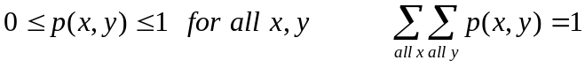

 | Stock B Return (Y)
Stock A Return (X) | 0% | 10%
-5% | 0.15 | 0.35
15% | 0.35 | 0.15

For instance, the probability they both perform poorly (X=-5 and Y=0) is small (0.15). Also, the probaility that they both perform strongly (X=15 and Y=10) is small (0.15). It’s more likely that one will perform strongly, while the other will perform weakly (X=15 and Y=0) or (X=-5 and Y=10), each outcome with probability 0.35. We can think of these firms as substitutes.

Marginal Distributions

Marginally, what is the probability distribution for stock A (this is called the marginal distribution)? For stock B? These are given in the following table, and are computed by summing the joint probabilities across the level of the other variable.

Stock A Stock B
x p(x)=p(x,0)+p(x,10) y p(y)=p(-5,y)+p(15,y)
-5 .15+.35 = .50 0 .15+.35 = .50
15 .35+.15 = .50 10 .35+.15 = .50

Hence, we can compute the mean and variance for X and Y:
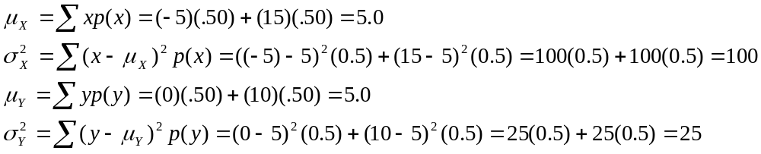

So, both stocks have the same expected return, but stock A is riskier, in the sense that its variance is much larger. Note that the standard deviations are the square roots of the variances: σ_{X} = 10.0 and σ_{Y} = 5.0

How do X and Y "co-vary" together?

Covariance

For these two firms, we find that the covariance is negative, since high values of X tend to be seen with low values of Y and vice versa. We compute the Covariance of their returns in the following table. (μ_{X} = μ_{Y} = 5)

x y p(x,y) xy x-μ_{X} y-μ_{Y} xyp(x,y) (x-μ_{X})( y-μ_{Y})p(x,y)
-5 0 .15 0 -10 -5 0(.15)=0 (-10)(-5)(.15)=7.5
-5 10 .35 -50 -10 5 -50(.35)=-17.5 (-10)(5)(.35)=-17.5
15 0 .35 0 10 -5 0(.35)=0 (10)(-5)(.35)=-17.5
15 10 .15 150 10 5 150(.15)=22.5 (10)(5)(.15)=7.5
Sum 5.0 -20.0

COV(X,Y) = -20.0 = 5.0-(5.0)(5.0)

The negative comes from the fact that when X tends to be large, Y tends to be small and vice versa, based on the joint probability distribution.

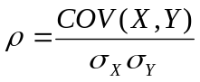Coefficient of Correlation

For the stock data:

COV(X,Y) = -20.0, σ_{X} = 10.0, σ_{Y} = 5.0, ρ = -20/(10*5)=-20/50 = -0.40

Functions of Random Variables

Probability Distribution of the Sum of Two Variables

Suppose you purchase 1 unit of each stock. What is your expected return (in percent). You want the probability distribuion for the random variable X+Y. Consider the joint probability distribution of X and Y, and compute X+Y for each outcome.

x y p(x,y) x+y (x+y)p(x,y) (x+y)²p(x,y)
-5 0 .15 -5+0=-5 (-5)(.15)=-0.75 (25)(.15)=3.75
-5 10 .35 -5+10=5 (5)(.35)=1.75 (25)(.35)=8.75
15 0 .35 15+0=15 (15)(.35)=5.25 (225)(.35)=78.75
15 10 .15 15+10=25 (25)(.15)=3.75 (625)(.15)=93.75
Sum 1.00 --- 10.00 185.00

Thus, the mean, variance, and standard deviation of X+Y (the sum of the returns) are: 10.00, 85.00, and 9.22, respectively.

Rules for the Mean and Variance of X+Y

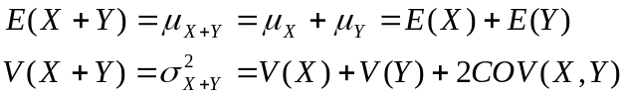

For the stock return example, we have:

E(X) = 5 E(Y) = 5 V(X) = 100 V(Y) = 25 COV(X,Y) = -20

which gives us:

E(X+Y) = 5+5 = 10 V(X+Y) = 100+25+2(-20)=85

which is in agreement with what we computed by generating the probability distribution for X+Y by “brute force” above.

Probability Distribution of a Linear Function of Two Variables

Consider a portfolio of two stocks, with Returns (R₁,R₂), and fixed weights (w₁,w₂)

Return of portfolio: R_{p} = w₁R₁ + w₂R₂ where w₁+w₂ = 1, w₁≥0, w₂≥0

Expected Return on portfolio: E(R_{p}) = w₁E(R₁) + w₂E(R₂)

Variance of Return on Portfolio: V(R_{p}) = (w₁)²V(R₁) + (w₂)²V(R₂) + 2w₁w₂COV(R₁,R₂)

Note that the rules for expected value and variance of linear functions does not depend on the weights summing to 1.

For stock portfolio from two stocks given above, set R₁ = X and R₂ = Y:

R_{p} = w₁R₁ + w₂R₂ = w₁R₁ + (1-w₁)R₂

Expected Return: E(R_{p}) = w₁(5) + (1-w₁)(5) = 5

Variance of Return:

V(R_{p}) = (w₁)²(100) + (1-w₁)²(25) + 2w₁(1-w₁)(-20)

Compute the variance if:

i) w₁=0.25 and w₂=0.75 ii) w₁=0.00 and w₂=1.00 iii) w₁=1.00 and w₂=0.00

To minimize the variance of returns, we expand the equation above in terms of w₁, take its derivative with respect to w₁, set it equal to 0, and solve for w₁:

- V(R_{p}) = 165(w₁)² – 90w₁ + 25

ii) dV(R_{p})/dw₁ = 2(165)w₁ – 90 = 0

iii) 330w₁ = 90 ==> w₁* = 90/330 = 0.2727

No matter what portfolio we choose, expected returns are 5.0, however we can minimize the variance of the return (risk) by buying 0.27 parts of Stock A and (1-0.27)=0.73 parts of stock B.

A classic paper on this topic (more mathematically rigorous than this example, where each stock has only two possible outcomes) is given in: Harry M. Markowitz, ``Portfolio Selection,'' Journal of Finance, 7 (March 1952), pp 77-91.

Decision Making (Sections 16.1-2)

Often times managers must make long-term decisions without knowing what future events will occur that will effect the firm's financial outcome from their decisions. Decision analysis is a means for managers to consider their choices and help them select an optimal strategy. For instance:

- Financial officers must decide among certain investment strategies without knowing the state of the economy over the investment horizon.

- A buyer must choose a model type for the firm's fleet of cars, without knowing what gas prices will be in the future.

- A drug company must decide whether to aggressively develop a new drug without knowing whether the drug will be effective the patient population.

The decision analysis in its simplest form include the following components:

- Decision Alternatives (acts) - These are the actions that the decision maker has to choose from.

- States of Nature - These are occurrences that are out of the control of the decision maker, and that occur after the decision has been made.

- Payoffs - Benefits (or losses) that occur when a particular decision alternative has been selected and a given state of nature has observed.

- Payoff Table - A tabular listing of payoffs for all combinations of decision alternatives and states of nature.

Case 1: Decision Making Under Certainty

In the extremely unlikely case that the manager knows which state of nature will occur, the manager will simply choose the decision alternative with the highest payoff conditional on that state of nature. Of course, this is a very unlikely situation unless you have a very accurate psychic on the company payroll.

Case 2: Decision Making Under Uncertainty

When the decision maker does not know which state will occur, or even what probabilities to assign to the states of nature, several options occur. The two simplest criteria are:

- Maximax - Look at the maximum payoff for each decision alternative. Choose the alternative with the highest maximum payoff. This is an optimistic strategy.
- Maximin - Look at the minimum payoff for each decision alternative. Choose the alternative with the highest minimum payoff. This is a pessimistic strategy.

Case 3: Decision Making Under Risk

In this case, the decision maker does not know which state will occur, but does have probabilities to assign to the states. Payoff tables can be written in the form of decision trees. Note that in diagarams below, squares refer to decision alternatives and circles refer to states of nature.

Expected Monetary Value (EMV): This is the expected payoff for a given decision alternative. We take each payoff times the probability of that state occuring, and sum it across states. There will be one EMV per decision alternative. One criteria commonly used is to select the alternative with the highest EMV.

Return-to-Risk Ratio: EMV of an act, divided by its standard deviation

Expected Value of Perfect Information (EVPI): This is a measure of how valuable it would be to know what state will occur. First we obtain the expected payoff with perfect information by multiplying the probability of each state of nature and its highest payoff, then summing over states of nature. Then we subtract off the highest EMV to obtain EVPI.

Example – Fashion Designer’s Business Decision

A fashion designer has to decide which of three fashion lines to introduce (lines A, B, C) for the upcoming season. The designer believes there are three possibilities on how the economy will be perform (Positive, Neutral, Negative). Her beliefs about profits (payoffs) under each scenario are given in the following table. Her firm only has enough resources and staff to produce a single line.

Economy Performance

Positive Neutral Negative

A 600 100 -400

Line B 100 300 100

C 500 400 -100

- Give the decision alternatives (acts)

Her firm can produce either Line A, B, or C. These are her choices.

- Give the states of nature

Nature can produce either a positive, neutral, or negative economy. She has no control over this.

- If the designer is certain that the economy performance will be neutral, which line should he introduce for the season? Why?

Under a neutral economy, Line A makes 100, Line B makes 300, and Line C makes 400. Clearly, she would choose Line C.

- When the designer has no idea what the economy performance will be, she wants to maximize the minimum profits he will make. That is, she is pessimistic regarding nature. Which strategy will he choose? Why?

If she is pessimistic, she considers the worst case scenario (minimum) under each state of nature, and chooses the alternative with the highest minimum value (maximin). Minimums: Line A: -400 Line B: 100 Line C: -100 Choose B

- The designer consults her financial guru, and he tells her that the probability that the economy performance will be positive is 0.6, probability of neutral is 0.3, and probability of negative is 0.1. Give the expected monetary value (EMV) of each strategy:

Line A: EMV(A) = 0.6(600) + 0.3(100) + 0.1(-400) = 360+30-40=350
Line B: EMV(B) = 0.6(100) + 0.3(300) + 0.1(100) = 60+90+10=160
Line C: EMV(C) = 0.6(500) + 0.3(400) + 0.1(-100) = 300+120-10=410

- Return-to Risk Ratios: The standard deviations and R-T-R ratios are:

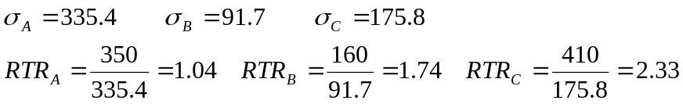

- Based on the probabilities in the previous problem, how much would you be willing to pay for Perfect information regarding the economy’s state (that is, give EVPI).

Under Positive economy, you select A, making 600 with probability 0.6
Under Neutral economy, you select C, making 400 with probability 0.3
Under Negative economy, you select B, making 100 with probability 0.1

E(Payoff Given perfect information) = 600(0.6)+400(0.3)+100(0.1)=360+120+10=490

EVPI = 490 – 410 = 80. You would be willing to pay up to 80 for this information

Example - Merck's Decision to Build New Factory

Around 1993, Merck had to decide whether to build a new plant to manufacture the AIDS drug Crixivan. The drug had not been tested at the time in clinical trials. The plant would be very specialized as the process to synthesize the drug was quite different from the process to produce other drugs.

Consider the following facts that were known at the time (I obtained most numbers through newspaper reports, and company balance sheets, all numbers are approximate):

- Projected revenues - $500M/Year
- Merck profit margin - 25%
- Prior Probability that drug will prove effective and obtain FDA approval - 0.10
- Cost of building new plants - $300M
- Sunk costs - $400M (Money spent in development prior to this decision)
- Length of time until new generation of drugs - 8 years

Ignoring tremendous social pressure, does Merck build the factory now, or wait two years and observe the results of clinical trials (thus, forfeiting market share to Hoffman Laroche and Abbott, who are in fierce competition with Merck).

Assume for this problem that if Merck builds now, and the drug gets approved, they will make $125M/Year (present value) for eight years (Note 125=500(0.25)). If they wait, and the drug gets approved, they will generate $62.5M/Year (present value) for six years. This is a by product of losing market share to competitors and 2 years of production. Due to the specificity of the production process, the cost of the plant will be a total loss if the drug does not obtain FDA approval.

a) What are Merck's decision alternatives?

b) What are the states of nature?

c) Give the payoff table and decision tree.

d) Give the Expected Monetary Value (EMV) for each decision. Ignoring social
pressure, should Merck go ahead and build the plant?

e) At what probability of the drug being successful, is Merck indifferent
to building early or waiting. That is, for what value are the EMV's equal
for the decision alternatives?

Note: Merck did build the plant early, and the drug did receive FDA approval.
Binomial Distribution (Section 5.3, EH5.2)

Binomial Experiment:
- Experiment Consists of n “trials”
- Each trial has 2 possible outcomes (Success,Failure)
- Probability of a Success is p for each trial
- Outcomes of trials are independent of one another
- Random variable, X, is the number of successes in the n trials and can take on values: 0,1,…,n
- Binomial distribution is indexed by 2 parameters: n and p
- Notation: X ~ Bin(n,p)

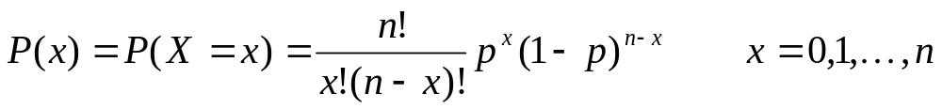

These probabilities are tabulated in Table E.6 of text

Mean, Variance, and standard deviation of X:

Example:

An inexpensive diagnostic test is given to a random sample of n=10 rural children who are known from an invasive procedure to have a disease. The test is known to have a sensitivity (the percentage patients with the disease who test positive on the diagnostic test) of 90% (p=0.90).

What is the probability that 8 test positive?

Note that this is the same as P(X=2|X~Bin(10,.10)) in Table E.6.

What is the probability at least 8 test positive?

What is the mean and standard deviation of X?

Probaility Distribution:

x | P(X=x)
0 | 1E-10
1 | 9E-09
2 | 3.64E-07
3 | 8.75E-06
4 | 0.000138
5 | 0.001488
6 | 0.01116
7 | 0.057396
8 | 0.19371
9 | 0.38742
10 | 0.348678

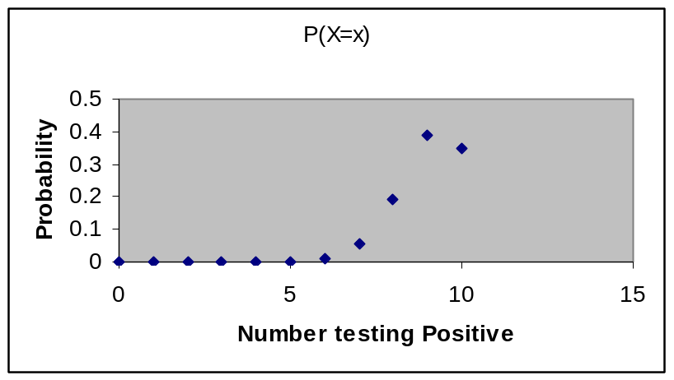

Poisson Distribution (Section 5.5, EH5.4)

Poisson process:
- Events occur at random across an area (time, length, surface area)
- Probability of event occuring in a given area is the same for all areas of equal size
- The number of events occuring in one area is independent of numbers of occurences in other areas
- As the size of the area gets smaller, the probability of 2 or more occurences in that area gets smaller
- Mean number of occurrence in area of unit length is parameter λ
- The random number of occurences in a unit length is random variable X
- Notation: X~Poi(λ)

These probabilities are tabulated in Table E.7 of text

Mean, Variance, and standard deviation of X:

Example:

Calls arrive at a computer help center according to a Poisson distribution with mean of 5 per hour.

What is the probability that there will be at least one call in any given hour?

Probability Distribution

x | P(X=x)
0 | 0.006738
1 | 0.03369
2 | 0.084224
3 | 0.140374
4 | 0.175467
5 | 0.175467
6 | 0.146223
7 | 0.104445
8 | 0.065278
9 | 0.036266
10 | 0.018133
11 | 0.008242
12 | 0.003434
13 | 0.001321
14 | 0.000472
>14 | 0.000226

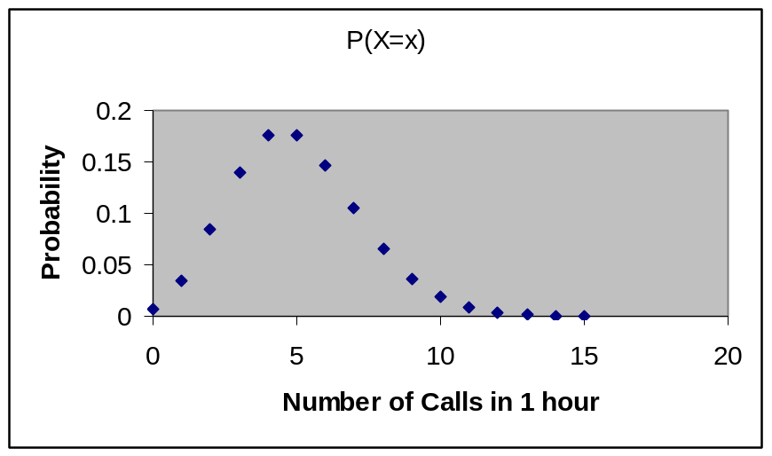

Continuous Probability Distributions

Chapter 6, Supplement

Normal Distributions (Section 6.1, Table E.2)

The normal distribution is a family of symmetric distributions that are indexed by two parameters, the mean (μ) and the variance (σ² ) (or by the standard deviation, σ). The mean represents the center of the distribution, while the variance (and standard deviation) measure the dispersion or the spread of the distribution. While there are infinitely many normal distributions, they all share the following properties. Let X be a random variable that is normally distributed:

- P(X ≥ μ) = P(X ≤ μ) = 0.5

- P(μ-kσ ≤ X ≤ μ+kσ) is the same for all distributions for any positive constant k

- P(X ≤ μ+kσ) is given in the standard normal (Z) table on page E.2 for k in the range of –3.99 to 3.99.

- The distribution is symmetric, and has total area under the curve of 1.0

- Approximately 68% of measurements lie within 1 standard deviation of the mean

- Approximately 95% of measurements lie within 2 standard deviations of the mean

To obtain probabilities:
- Convert the endpoint(s) of the region of interest (say X₀) into a z-score by subtracting off the mean and dividing by the standard deviation. This measures the number of standard deviations X₀ falls above (if positive) or below (if negative) the mean:
Z₀ = (X₀-μ)/σ
- Find Z₀ on the outside border of Table E.2. The value in the body of the table is equivalently:
P(Z ≤ Z₀) = 1-P(Z ≥ Z₀) = P(X ≤ μ+Z₀σ) = 1-P(X ≥ μ+Z₀σ)

3) P(Z_{Lo} ≤ Z ≤ Z_{Hi}) = P(Z ≤ Z_{Hi}) - P(Z ≤ Z_{Lo})

Example – GRE Scores 1992-1995

Scores on the Verbal Ability section of the Graduate Record Examination (GRE) between 10/01/92 and 9/30/95 had a mean of 479 and a standard deviation of 116, based on a population of N=1188386 examinations. Scores can range between 200 and 800. Scores on standardized tests tend to be approximately normally distributed. Let X be a score randomly selected from this population. Useful shorthand notation is to write:, X ~ N(μ=479,σ=116).

What is the probability that a randomly selected student scores at least 700?

P(X ≥700) = P(Z ≥ (700-479)/116 = 1.91) = 1-P(Z ≤ 1.91) = 1-.9719 = .0281

What is the probability the student scores between 400 and 600?

P(400 ≤ X ≤ 600) =? Z_{Lo} = (400-479)/116 = -0.68 Z_{Hi} = (600-479)/116 = 1.04

P(400 ≤ X ≤ 600) = P(Z ≤ 1.04) - P(Z ≤ -0.68) = .8508 - .2482 = .6026

Above what score do the top 5% of all students score above?

Step 1: Find the z-value that leaves a probability of 0.05 in the upper tail (and a probability of 0.9500 below it). P(Z ≤ 1.645)=0.9500. That is, only the top 5% of students score more than 1.645 standard deviations above the mean.

Step 2: Convert back to original units: 1.645 standard deviations is 1.645σ = 1.645(116) = 191, and add back to the mean: μ+1.645σ = 479+191 = 670.
The top 5% of students scored above 670 (assuming scores are approximately normally distributed).

Source: “Interpreting Your GRE General Test and Subject Test Scores -- 1996-97,” Educational Testing Service.

Normal probability density function: (Notation: X~N(μ,σ))

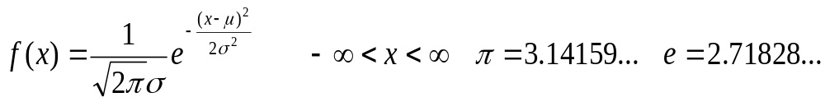

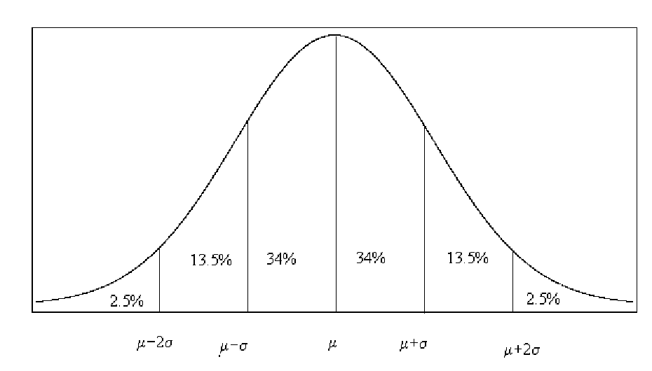

Example - Normal Distribution -- Galton’s Measurements

The renowned anthropologist Sir Francis Galton studied measurements of many variables occurring in nature. Among the measurements he obtained in the Anthropologic Laboratory in the International Exhibition of 1884 among adults are (where μ_{M} and σ_{M} represent the mean and standard deviation for males and μ_{F} and σ_{F} represent the mean and standard deviation for females:

- Standing height (inches) --- μ_{M}=67.9 σ_{M}=2.8 μ_{F}=63.3 σ_{F}=2.6
- Sitting height (inches) --- μ_{M}=36.0 σ_{M}=1.4 μ_{F}=33.9 σ_{F}=1.3
- Arm span (inches) --- μ_{M}=69.9 σ_{M}=3.0 μ_{F}=63.0 σ_{F}=2.9
- Weight (pounds) --- μ_{M}=143 σ_{M}=15.5 μ_{F}=123 σ_{F}=14.3
- Breathing Capacity (in³) --- μ_{M}=219 σ_{M}=39.2 μ_{F}=138 σ_{F}=28.6
- Pull Strength (pounds) --- μ_{M}=74 σ_{M}=12.2 μ_{F}=40 σ_{F}=7.3

These were based on enormous samples and Galton found that their relative frequency distributions were well approximated by the normal distribution (that is, they were symmetric and mound-shaped). Even though these are sample means and standard deviations, they are based on almost 1000 cases, so we will treat them as population parameters.

- What proportion of males stood over 6 feet (72 inches) in Galton’s time?

- What proportion of females stood under 5 feet (60 inches)?

- Sketch the approximate distributions of sitting heights among males and females on the same plot.

- Above what weight do the heaviest 10% of males fall?

- Below what weight do the lightest 5% of females fall?

- Between what bounds do the middle 95% of male breathing capacities lie?

- What fraction of women have pull strengths that exceed the pull strength that 99% of all men exceed?

- Where would you fall in the distributions of these men/women from a century ago?

Source: Galton, F. (1889), Natural Inheritance, London: MacMillan and Co.

Other Continuous Distributions Used for Statistical Inference

t-distribution: A symmetric, mound shaped distribution, indexed by a parameter called degrees of freedom, closely related to the standard normal distribution. Critical values for certain upper tail areas (.25, .10, .05, .025, .010, .005) are given for a wide range of degrees of freedom in Table E.3. Distribution is symmetric around 0, and unbounded. Lower tail critical values are obtained by symmetry of the distribution.

Chi-Square distribution (χ²): A skewed right distribution, indexed by a parameter called degrees of freedom, related to squares of standard normal random variables. Critical values for certain upper tail areas (.995, .990, .975, .950, .900, .750, .250,.100, .050, .025, .010, .005) are given for a wide range of degrees of freedom in Table E.4. Distribution is skewed right and only defined for postive values.

F-disribution: A skewed right distribution, indexed by 2 parameters, called numerator and denominator degrees’ of freedom, related to ratios of chi-square random variables. Critical values for upper tail areas are given for upper tail areas (.050, .025, .010, .005) are given for wide ranges of degrees’ of freedom in Table E.5. Distribution is skewed right and only defined for positive values. To get lower tail critical values are obtained by reversing numerator and denominator and taking reciprocal of table value.

Examples will be given when we get to inference problems using these distributions.

Sampling Distributions (Sections 6.5-6.7)

Sampling Distributions of estimators: Probability distributions for estimators that are based on random samples. Sample means and sample proportions vary from one sample to another. Their sampling distributions refer to how these quantities vary from one sample to another.

Interval Scale Outcomes:

If a population of interval scale outcomes has mean μ and variance σ², then the sampling distribution of sample mean 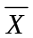, obtained from random samples of size n has the following mean, variance, and standard deviation (note that standard deviations of estimators are referred to as standard errors): Section 6.6.
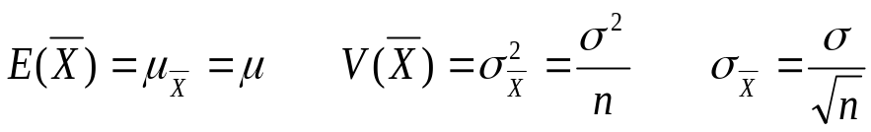

- If the distribution of individual measurements is normal, the sampling distribution is normal, regardless of sample size.

- If the distribution of indivinual measurements is nonnormal, the sampling distribution is approximately normal for large sample sizes. This is a result of the so-called Central Limit Theorem.

When independent random samples of sizes n₁ and n₂ are sampled from two populations with means μ₁ and μ₂, and variances σ₁² and σ₂², respectively, the samplling distribution for the difference between the two sample means, 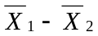, has the following mean, variance, and standard deviation and the same rules regarding normality (Section 9.1):

- Standard deviations of sampling distributions for estimators are referred to as STANDARD ERRORS.

- When population variances (σ², σ₁², σ₂²) are unknown, we replace them with their sample variances (s², s₁², s₂²), and refer to the resulting standard errors as ESTIMATED STANDARD ERRORS.

Nominal outcomes:

If among a population of elements, the proportion that has some characteristic is p, then if elements are taken at random in samples of size n, the sample proportion of elements having the characteristic, p_{s}, has a sampling distribution with the following mean, variance, and standard deviation (standard error): Section 6.7.

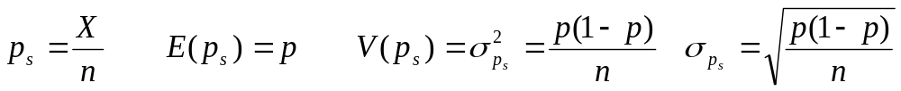

For large samples, the sampling distribution is approximately normal. To obtain the ESTIMATED STANDARD ERROR, replace p with p_{s}.

When independent random samples of sizes n₁ and n₂ are sampled from two populations with proportions of elements having a characteristic of p₁ and p₂, respectively, the samplling distribution for the difference between the two sample sample proportions, p_{S1}-p_{S2}, has the following mean, variance, and standard deviation and the same rules regarding normality and estimated standard errors. Section 9.3:

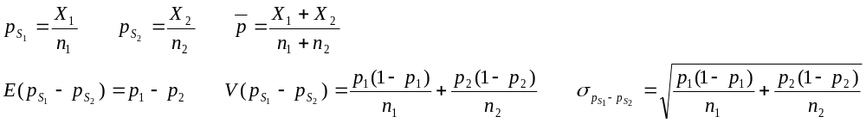

Example: Sampling Distributions -- Galton’s Measurements

The renowned anthropologist Sir Francis Galton studied measurements of many variables occurring in nature. Among the measurements he obtained in the Anthropologic Laboratory in the International Exhibition of 1884 among adults are (where μ_{M} and σ_{M} represent the mean and standard deviation for males and μ_{F} and σ_{F} represent the mean and standard deviation for females:

- Standing height (inches) --- μ_{M}=67.9 σ_{M}=2.8 μ_{F}=63.3 σ_{F}=2.6
- Sitting height (inches) --- μ_{M}=36.0 σ_{M}=1.4 μ_{F}=33.9 σ_{F}=1.3
- Arm span (inches) --- μ_{M}=69.9 σ_{M}=3.0 μ_{F}=63.0 σ_{F}=2.9
- Weight (pounds) --- μ_{M}=143 σ_{M}=15.5 μ_{F}=123 σ_{F}=14.3
- Breathing Capacity (in³) --- μ_{M}=219 σ_{M}=39.2 μ_{F}=138 σ_{F}=28.6
- Pull Strength (pounds) --- μ_{M}=74 σ_{M}=12.2 μ_{F}=40 σ_{F}=7.3

These were based on enormous samples and Galton found that their relative frequency distributions were well approximated by the normal distribution (that is, they were symmetric and mound-shaped). Even though these are sample means and standard deviations, they are based on almost 1000 cases, so we will treat them as population parameters. Source: Galton, F. (1889), Natural Inheritance, London: MacMillan and Co.

- Give the approximate sampling distribution for the sample mean , for samples in each of the following cases:

- Standing heights of 25 randomly selected males

- Sitting heights of 35 randomly selected females

- Arm spans of 9 randomly selected males

- Weights of 50 randomly selected females

- The differences in heights between 10 females 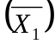 and 10 males 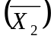

- The differences in heights between 3 females and 3 males

- Obtain the following probabilities:

- A sample of 25 males has a mean standing height exceeding 70 inches

- A sample of 35 females has a mean sitting height below 32 inches

- A sample of 9 males has an arm span between 69 and 71 inches

- A sample of 50 females has a mean weight above 125 pounds.

- A sample of 10 females has a higher mean height than a sample of 10 males.

- A sample of 3 females has a higher mean height than a sample of 3 males

Example – Imported Footwear in the United States
The following table gives the U.S. consumption for footwear and the number of imports (both in units of 1000s of pairs) for the years 1993-2000, as well as the proportion of pairs consumed that were imports. Source: Shoe Stats 2001. American Apparel and Footwear Association (AAFA).

Year Consumption Imports Proportion Imports (p)
1993 1,567,405 1,347,901 1,347,901/1,567,405 = .8600
1994 1,637,449 1,425,834 1,425,834/1,637,449 = .8708
1995 1,594,204 1,409,232 1,409,232/1,594,204 = .8840
1996 1,538,008 1,376,080 1,376,080/1,538,008 = .8947
1997 1,640,993 1,488,118 1,488,118/1,640,993 = .9068
1998 1,619,407 1,499,465 1,499,465/1,619,407 = .9259
1999 1,693,646 1,615,821 1,615,821/1,693,646 = .9540
2000 1,793,661 1,745,540 1,745,540/1,793,661 = .9732

- What is the approximate sampling distribution for the proportion of imported pairs among random samples of n=500 pairs purchased in 1993?

The sampling distribution would be approximately normal with mean .8600 and standard error (deviation) of .0155. If we took a random sample of 500 pairs there would be a very good chance (95%) that the proportion of imports would be in the range: .8600 ± 2(.0155) = .8600 ± .0310 = (.8290 , .8910).

- What is the approximate sampling distribution for the proportion of imported pairs among random samples of n=500 pairs purchased in 2000?

- Would you expect that a sample proportion of imports of 500 pairs purchased in 1993 is higher than a sample proportion of imports of 500 pairs purchased in 2000? First, get the sampling distribution for the difference, then give a range that contains the difference in sample means with probability 0.95 (95%).

Mean: .8600 - .9732 = -.1132
Standard Error:
Shape: Approximately Normal:
Would expect difference to lie in the range: -.1132 ±2(.0170) = (-.1472 , -.0792) ... < 0

- Repeat parts 1-3 for samples of 1000 pairs.

Confidence Interval Estimation of Mean (Sections 7.1-2)

Case 1 (σ Known): Section 7.1

Parameter: μ (Unknown, fixed value)

Estimator: (observed from a random sample of population)

Sampling Distribution: 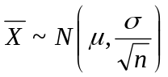

From Z-table, we know: 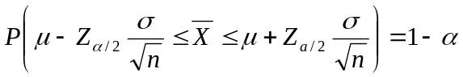

(1-α)100% Confidence Interval for μ:

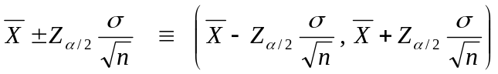

90% Confidence: α/2=0.050 Z_{0.050} = 1.645
95% Confidence: α/2=0.025 Z_{0.025} = 1.960
99% Confidence: α/2=0.005 Z_{0.005} = 2.326

Case 2 (σ Unknown): Section 7.2

Parameter: μ (Unknown, fixed value)

Estimator: (observed from a random sample of population)

Sampling Distribution: 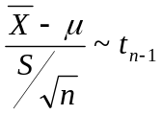 (Student’s t distribution with n-1 degrees of freedom, the number of independent observations in the sample estimate S of the parameter σ)

From t-table, we know: 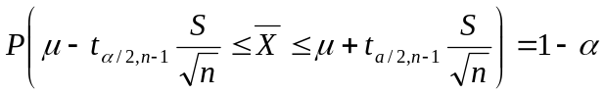

(1-α)100% Confidence Interval for μ:

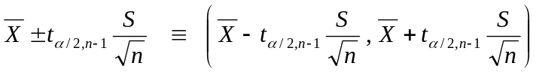

90% Confidence: α/2=0.050
95% Confidence: α/2=0.025
99% Confidence: α/2=0.005

Confidence Interval Estimation of Proportion (Sect. 7.3)

Parameter: p (Unknown, fixed value)

Estimator: p_{s} (observed from a random sample of population)

Sampling Distribution: 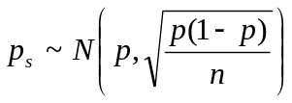

(1-α)100% Confidence Interval for p:

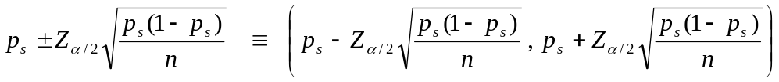

90% Confidence: α/2=0.050 Z_{0.050} = 1.645
95% Confidence: α/2=0.025 Z_{0.025} = 1.960
99% Confidence: α/2=0.005 Z_{0.005} = 2.326

Determining Sample Size (Section 7.4)

Sampling Error - the difference between a sample quantity (mean or proportion) and the true parameter.

Bound on error of estimation (with (1-α)100% confidence):

Mean: 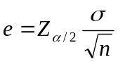 Proportion: 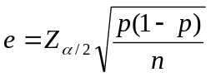

e is also referred to as the margin of error.

Goal: Choose n so that you will have a specified margin of error (note that if we use the standard 95% confidence level, Z_{.025}=1.96≈ 2

Mean: 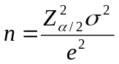 Proportion: 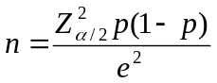

Applications in Auditing (Section 7.5)

Estimating a Population Total Amount:

N=Total number of sales vouchers/Records
μ=Mean value of all sales vouchers/Records

n=Number of sales vouchers/Records in random sample
= Mean value of sales vouchers/records in sample

(1-α)100% CI for Population Total (Nμ):

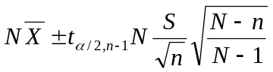

Estimating total (not mean) Finite population correction factor

Estimating a Population Mean Auditing Error

For a random sample of n items being audited, compute:

D_{i} = audited value – original value for record i

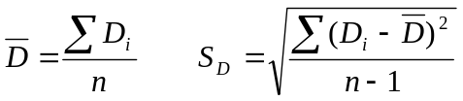

(1-α)100% CI for Total Difference (Error):

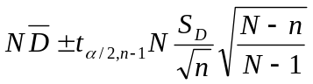

Upper Bound Estimate for Noncompliance Rate

p_{s} = sample proportion of items shipped without authorization

(1-α)100% Upper Confidence Limit for a Proportion:

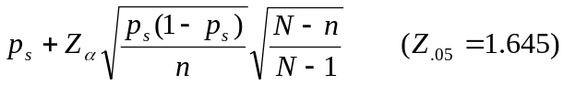

Hypothesis Testing (Chapter 8)

Methods to make inference regarding unknown parameters. Often referred to as decision making under uncertainty.

- Null Hypothesis (H₀) – Represents a current state of nature or that two groups of subjects are the same (e.g. The proportion of defective items produced has not changed over time, or that the mean clinical response is the same for patients receiving an active drug and those receiving a placebo). Null hypotheses always contain an equal sign.

- Alternative Hypothesis (H₁) – Represents a contradiction to the null hypothesis. Typically is a research claim the experimenter wishes to demonstrate. Can be 1-sided (e.g. proportion defective has decreased since last year) or 2-sided (mean responses differ for those receiving active drug and those receiving placebo).

- Test Statistic – Quantity based on sample data and the parameter value under the null hypothesis, that is used to test the research claim.

- Rejection Region – Range of values of the test statistic for which we reject the null hypothesis in favor of the alternative hypothesis.

- P-value – Measure of the strength of the evidence against the null hypothesis in favor of the alternative hypothesis. Technically, the probability that we would have obtained sample data as strong or stronger than our current sample in favor of the alternative hypothesis, had the null been true.

- Type I Error – Rejecting the null hypothesis in favor of the alternative when the null is true. α=P(Type I Error)

- Type II Error – Failing to reject the null hypothesis when the alternative hypothesis is true. β=P(Type II error)

- Power – Probability that we reject the null hypothesis. When H₀ is false, power=1-β.

2-Tailed Z-test for Mean (σ Known) (Section 8.2)

- H₀: μ = μ₀ (μ₀ is a specified constant)
- H₁: μ ≠ μ₀

- Test Statistic: 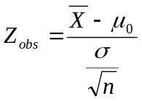

- Decision Rule/Rejection Region: (α=P(Type I Error))
Conclude μ > μ₀ if Z_{obs} ≥ Z_{α/2}
Do not reject μ = μ₀ if -Z_{α/2} < Z_{obs} < Z_{α/2}
Conclude μ < μ₀ if Z_{obs} ≤ -Z_{α/2}

- P-value: 2P(Z ≥ |Z_{obs}|)

Note: If the P-value ≤ α, we reject the null hypothesis, otherwise we fail to reject the null hypothesis.

1-Tailed Z-test for Mean (σ Known) (Section 8.3)

To show that μ is larger than μ₀:
- H₀: μ = μ₀ (μ₀ is a specified constant)
- H₁: μ > μ₀

- Test Statistic:

- Decision Rule/Rejection Region: (α=P(Type I Error))
Conclude μ > μ₀ if Z_{obs} ≥ Z_{α}
Do not reject μ = μ₀ if Z_{obs} < Z_{α}

- P-value: P(Z ≥ Z_{obs})

To show that μ is smaller than μ₀:
- H₀: μ = μ₀ (μ₀ is a specified constant)
- H₁: μ < μ₀

- Test Statistic:

- Decision Rule/Rejection Region: (α=P(Type I Error))
Conclude μ < μ₀ if Z_{obs} ≤ -Z_{α}
Do not reject μ = μ₀ if Z_{obs} > -Z_{α}

- P-value: P(Z ≤ Z_{obs})

2-Tailed t-test for Mean (σ Unknown) (Section 8.4)

- H₀: μ = μ₀ (μ₀ is a specified constant)
- H₁: μ ≠ μ₀
- Test Statistic: 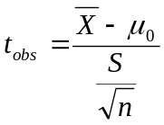

- Decision Rule/Rejection Region: (α=P(Type I Error))
Conclude μ > μ₀ if t_{obs} ≥ t_{α/2,n-1}
Do not reject μ = μ₀ if -t_{α/2,n-1} < t_{obs} < t_{α/2,n-1}
Conclude μ < μ₀ if t_{obs} ≤ -t_{α/2,n-1}

- P-value: 2P(t ≥ |t_{obs}|)

This test is based on the assumption that the population of measurements is approximately normal when the sample size is small (say less than 30). No such assumtion needed for larger samples.

2-Tailed Z-test for Proportion (Section 8.5)

- H₀: p = p₀ (p_{o} is a specified constant)
- H₁: p ≠ p₀

- Test Statistic: 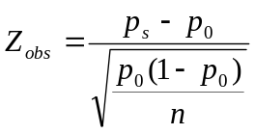

- Decision Rule/Rejection Region: (α=P(Type I Error))
Conclude μ > μ₀ if Z_{obs} ≥ Z_{α/2}
Do not reject μ = μ₀ if -Z_{α/2} < Z_{obs} < Z_{α/2}
Conclude μ < μ₀ if Z_{obs} ≤ -Z_{α/2}

- P-value: 2P(Z ≥ |Z_{obs}|)
Comparing 2 Populations – Chapter 9

We often wish to compare two groups with respect to either interval scale or nominal outcomes. Typical research questions may include:

- Does a new drug decrease blood pressure more than a currently prescribed medication?

- Are men or women more likely to like a certain product after exposure to a particular advertisement?

- Does a new fat substitute cause higher rates of an undesirable side effect than traditional additives?

- Do firms’ stock performances differ between two industries?

We are generally interested in questions of the forms:

- Are the population mean scores the same for two groups, or are they different (or does one group have a higher mean than the other)?

- Are the population proportions with a certain characteristic the same for two groups, or are they different (or does one group have a higher proportion than the other)?

In each case, we wish to make statements concerning 2 POPULATIONS, based on 2 SAMPLES.

Comparing Two Population Means (Section 9.1)

Hypothesis Testing Concerning μ₁−μ₂

- Null Hypothesis (H₀): Two populations have same mean responses (μ₁−μ₂ = 0)

2a. Alternative Hypothesis (H_{A}): Means are not Equal (μ₁−μ₂ ≠ 0)
2b. Alternative Hypothesis (H_{A}): Mean for group 1 is higher (μ₁−μ₂ > 0)

- Test Statistic:
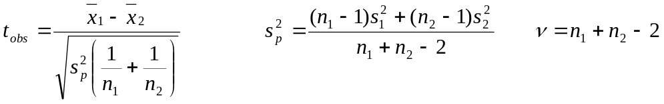

- Decision Rule (based on α=0.05 probability of a Type I error):

Alternative 2a: Conclude that means differ if absolute value of the test statistic exceeds t_{.025,ν} (the critical value leaving 0.025 in the upper tail of the t-distribution with νdegrees of freedom).

Alternative 2b: Conclude that the mean for group 1 is higher if the test statistic
exceeds t_{.05,ν} (the critical value leaving 0.05 in the upper tail of the
t-distribution with νdegrees of freedom).

- P-value: Measure of the extent that the data contradicts the null hypothesis. P-values below α (0.05) are contradictory to the null hypothesis. That is, if the there were no difference in the population means, we would find it unlikely that the sample means differ to this extent. We will rely on computer software to compute P-values, but will need to interpret them throughout the course.

95% Confidence Interval for μ₁−μ₂

- 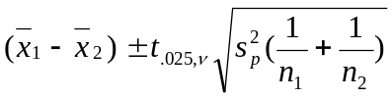Construct interval:

- Based on interval:

- If interval is entirely above 0, conclude μ₁>μ₂ (risking type I error)
- If interval is entirely below 0, conclude μ₁<μ₂ (risking type I error)
- If interval contains 0, conclude μ₁=μ₂ (risking type II error)

Comments on Tests and Confidence Intervals

- Type I Error – Concluding that group means differ (H_{A}) when in fact they are equal (H₀). We construct tests to keep the probability of a Type I error small (α=0.05)

- Type II Error – Concluding that group means are equal (H₀), when in fact they differ (H_{A}). The methods we use are the most powerful (under normality assumptions) at detecting differences if they exist, for given sample sizes. We can reduce the risk of type II errors by increasing sample sizes.

- Normal Distributions – The test and confidence interval are derived under the assumption that the two distributions are normally distributed. As long as the sample sizes are reasonably large, all results hold, even if this assumption does not hold true (Central Limit Theorem). For small samples, nonparametric methods are available (See Chapter 17).

- Equal Variances – The test and confidence interval are based on an assumption that the two populations have equal variances. If the variances differ, adjustments can be made to the degrees of freedom and standard error of the difference between the two means. Virtually, all computer software provides the test for equal variance, as well as the test and confidence interval for the comparison of means under both equal and unequal variances. For the test of equal variances, see Section 13.5, and for methods of manually making the adjustments, see Page 395. For large samples, particularly when sample sizes are approximately equal, we won’t be concerned by this and use the estimated standard error: 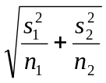

- Equivalence of 2 sided tests and Confidence Intervals – When conducting a test with alternative 2a on the previous page, and constructing a confidence interval on the same page, you will always make the same conclusion regarding μ₁−μ₂.

- Large Sample tests – When the samples are large, we often approximate the critical values of the t-distribution with corresponding values of the z-distribution, with z_{.05} = 1.645 and z_{.025} = 1.96 (or 2.0 when doing calculations).
Example - Prozac for Borderline Personality Disorder

Pharmaceutical companies often test efficacy of approved drugs for new indications to expand their market. It is much less costly to have an FDA approved drug be approved for new purposes than developing new drugs from scratch.

The efficacy of fluoxetine (Prozac) on anger in patients with borderline personality disorder was studied in 22 patients with BPD. Among the measurements made by researchers was the Profile of Mood States (POMS) anger scale. Patients received either fluoxetine or placebo for 12 weeks, with measurements being made
before and after treatment.

The following table gives post-treatment summary statistics for the two treatment groups. Low scores are better since the patient displays less anger.

First, we obtain a 95% confidence interval for the difference in true mean scores for the two treatment groups. Then, we conduct a test to determine whether Prozac has a different mean response from placebo (a 2-sided test allows for the possibility that Prozac may actually increase scores. This test, and all tests in this course, will be conducted at the α=0.05 significance level.

Prozac (Trt 1) Placebo(Trt 2)
Sample Size (n_{i}) 13 9
Sample Mean (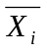) 40.3 44.9
Sample Std Dev (s_{i}) 5.1 8.7

A test of equal variances is not significant, we will use the method based on equal variances.

To set up a 95% confidence interval, we need to obtain the pooled variance (s_{p}²), the degrees of freedom (ν), and the critical t-value (t_{.025,ν}).

95% Confidence Interval for true difference of mean scores (μ₁−μ₂):

This interval contains 0, we cannot conclude that the true mean scores differ.

Hypothesis test concerning μ₁−μ₂

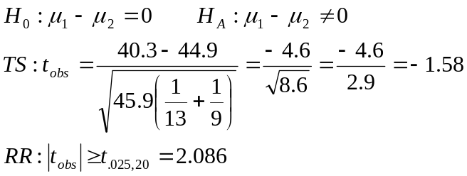
Since the test statistic does not fall in the rejection region, we do not reject
the null hypothesis of no treatment effect (μ₁=μ₂).

The P-value is the probability that we would have seen a difference in sample means this large or larger, given there was no difference in population means. It is the tail area it the t-distribution with 20 degrees of freedom below –1.58 and above 1.58. This is larger than 0.05 since by definition of the table values, the area below –2.086 is .025, and the area above 2.086 is .025.

Notes: We are assuming the underlying distributions of POMS scores are approximately normally distributed. Further, these are very small sample sizes, so by concluding in favor of the null hypothesis, we are at a substantial risk of making a Type II error. Lilly, the manufacturer of Prozac would want to conduct a larger trial to measure efficacy, since a Type II error could cause an effective drug to be deemed ineffective. This could cost the company revenues from selling the drug in an expanded market.

Source: Salzman, et al (1995), “Effects of Fluoxetine on Anger in Symptomatic Volunteers with Borderline Personality Disorder,” Journal of Clinical Psychopharmacology, 15:23-29.

Example: Dose-Response Study for Erectile Dysfunction Drug

The efficacy of intracavernosal alprostadil in men suffering from erectile dysfunction (impotence). The measure under study (X) was duration (in minutes) of erection as measured by RigiScan (>70% rigidity). We define μ_{Η} as the true mean duration on the high dose, and μ_{L} as the true mean duration on the low dose, and 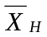 and 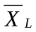 as the sample means. The manufacturer wishes to demonstrate that its drug is effective, in the sense that at higher doses there will be higher effect.

- What are the appropriate null and alternative hypotheses?

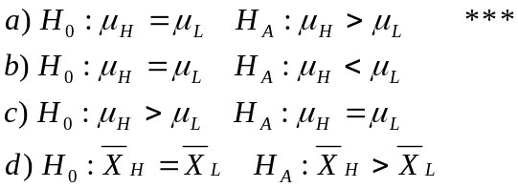

The researchers reported the following information from a clinical trial (the data are duration of erection, in minutes):

Dose
Low High
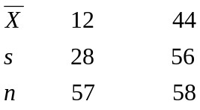

A test of equal variances does find that they are unequal. The adjustment of degrees of freedom is from 57+58-2=113 to 84 (Page 395). Since df is large, we’ll use z-distribution to approximate t-distribution critical values, but will use standard error based on unequal variances (although with approximately equal sample sizes, they are mathematically equivalent).

2) Compute the appropriate test statistic for testing the test described in 1).
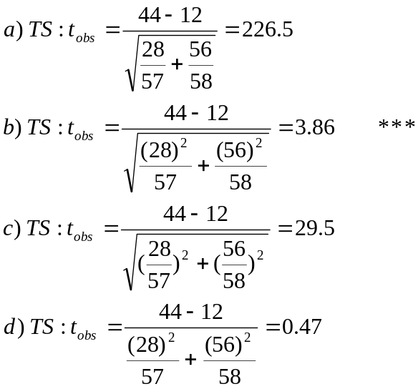

- The appropriate rejection region for this test (α = .05) is:

- RR: t_{obs} > 1.96
- RR: |t_{obs}|> 1.96
- RR: t_{obs} > 1.645 ***
- RR: t_{obs} < -1.645

- Is your P-value larger/smaller than 0.05?

- Is it likely that you have made a Type II error in this problem? Yes/No

- In many situations, statistical tests of this form are criticized for detecting “statistical”, but not “practical” or “clinical” differences? You should have concluded that the drug is effective. By how much do the sample means differ? Does this difference seem “real”? Recall that duration is measured in minutes.

Source: Linet, O.I. and F.G. Ogric (1996). “Efficacy and Safety of Intracevernosal Alprostadil in Men With Erectile Dysfunction,” New England Journal of Medicine, 334:873-877.

Example: Salary Progression Gap Between Dual Earner and Traditional Male Managers

A study compared the salary progressions from 1984 to 1989 among married male managers of Fortune 500 companies with children at home. For each manager, the salary progression was computed as:

X=(1989 salary – 1984 salary)/1984 salary

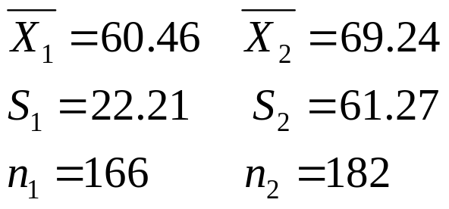The researchers were interested in determining if there are differences in mean salary progression between dual earner (group 1) and traditional (group 2) managers. The authors report the following sample statistics:

- If the authors wish to test for differences in mean salary progressions between dual earner and traditional male managers, what are the appropriate null and alternative hypotheses?
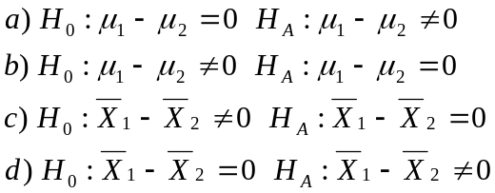
- Compute the test statistic to be used for this hypothesis test (there’s no need to pool the variances for this large of pair of samples).
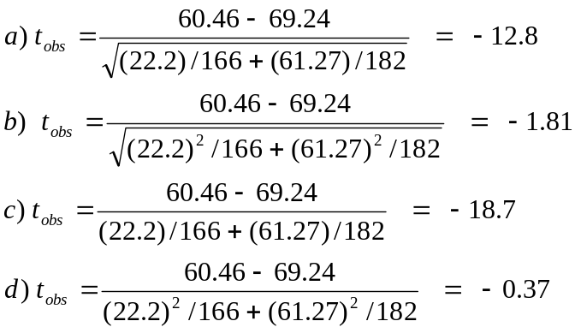

- What is the appropriate rejection region (based on α=0.05)?
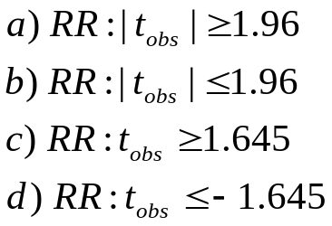

- What is your conclusion based on this test?

- Reject H₀, do not conclude differences exist between the 2 groups
- Reject H₀, conclude differences exist between the 2 groups
- Don’t Reject H₀, do not conclude differences exist between the 2 groups
- Don’t Reject H₀, do conclude differences exist between the 2 groups

- Based on this conclusion, we are at risk of (but aren’t necessarily) making a:

- Type I error
- Type II error
- Both a) and b)
- Neither a) or b)

Source: Stroh, L.K. and J.M. Brett (1996), “The Dual-Earner Dad Penalty in Salary Progression”, Human Resource Management;35:181-201.

Comparing Two Population Proportions (Section 9.3)

Hypothesis Testing Concerning p₁−p₂ (Large Sample)

- Null Hypothesis (H₀): Two populations have same proportions with a characterisic (p₁−p₂ = 0)

2a. Alternative Hypothesis (H_{A}): Proportions are not Equal (p₁−p₂ ≠ 0)
2b. Alternative Hypothesis (H_{A}): Mean for group 1 is higher (p₁−p₂ > 0)

- Test Statistic:
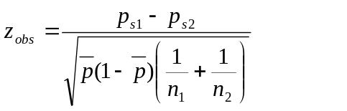

- Decision Rule (based on α=0.05 probability of a Type I error):

Alternative 2a: Conclude that means differ if absolute value of the test statistic exceeds z_{.025} = 1.96 (the critical value leaving 0.025 in the upper tail of the z-distribution).

Alternative 2b: Conclude that the mean for group 1 is higher if the test statistic
exceeds z_{.05} = 1.645 (the critical value leaving 0.05 in the upper tail of the
z-distribution).

- P-value: Measure of the extent that the data contradicts the null hypothesis. P-values below α (0.05) are contradictory to the null hypothesis. That is, if the there were no difference in the population means, we would find it unlikely that the sample means differ to this extent. We will rely on computer software to compute P-values, but will need to interpret them throughout the course.

95% Confidence Interval for p₁−p₂

- 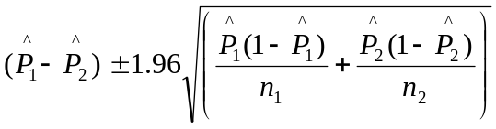Construct interval:

- Based on interval:

- If interval is entirely above 0, conclude p₁>p₂ (risking type I error)
- If interval is entirely below 0, conclude p₁<p₂ (risking type I error)
- If interval contains 0, conclude p₁=p₂ (risking type II error)
Example: Gastrointestinal Symptoms From Olestra

Anecdotal reports have been spread through the mainstream press that the fat-free substitute Olestra is a cause of gastrointestinal side effects, even though such effects were not expected based on clinical trials.

A study was conducted to compare the effects of olestra based chips versus regular chips made with triglyceride. The goal was to determine whether or not the levels of gastrointestinal side effects differed between consumers of olestra based chips and regular chips.

- If we are interested in comparing the rates of gastrointestinal side effects among all potential chip users, we are interested in making an inference concerning (note that by ‘rates’, we mean fraction of users suffering side effects):

The difference between the true proportions of olestra and triglyceride chip eaters suffering from gastrointestinal symptoms.

- If we wish to determine whether or not differences exist between the two groups (the null hypothesis being no differences exist), we wish to test (let the olestra group be group 1, the regular group be group 2):

H₀: p₁-p₂ = 0 H_{A}: p₁-p₂ ≠ 0

- Do you think the researchers should let the studies’ subjects know which type of potato chip they are eating? Why or why not?

No, this may introduce a response bias, particularly if subjects had heard the rumors regarding side effects of olestra

- The following information was gathered in a double-blind randomized trial at a Chicago movie theater, where 563 subjects were randomized to chips made from olestra and 529 were randomized to the regular (triglyceride, aka TG) chips. Of the olestra group, 89 reported suffering from at least one gastrointestinal (eg, gas, diarrhea, abdominal cramping) symptom. Of the regular (TG) chip group, 93 reported at least one gastrointestinal symptom. Give the sample proportions of gastrointestinal symptoms among olestra and TG chip users:
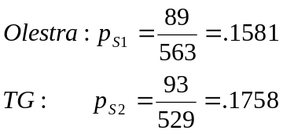

- Test to determine whether the proportion of subjects suffering gastrointestinal symptoms differ between the olestra and regular (TG) chip groups. The appropriate test statistic is:

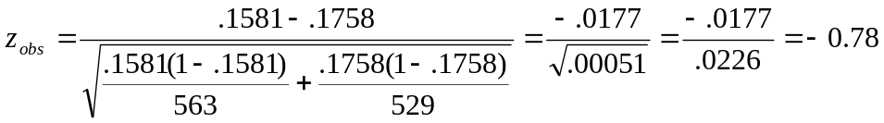

- Based on the test described above, if we choose to test the hypothesis of no olestra effect at α=0.05 significance level, the appropriate rejection region is:

Reject H₀ if z_{obs} ≥ 1.96 or if z_{obs} ≤ -1.96

- Based on this case study, should the manufacturer of Olestra be concerned that their product is associated with higher rates of gastrointestinal side effects than triglyceride based regular chips?

Certainly not. The proportions are not significantly different, and the sample proportion was actually lower (but again, not significantly) for the Olestra based chips.

- What is one major attribute of chips that has not been addressed in this study?

Taste

Source: Cheskin, L.J., R. Miday, N. Zorich, and T. Filloon (1998). “Gastrointestinal Symptoms Following Consumption of Olestra or Regular Triglyceride Potato Chips”, JAMA, 279:150-152.

Example: Human Resource Management Practices in Large & Small Firms

A study was conducted comparing Human Resource Management (HRM) practices among small and large companies. Among the items measured on a survey of n_{S}=79 small firms and n_{L}=21 large firms was whether or not the firm commonly used job tryouts as a common way of judging applicants. Of the small firms, X_{S} = 40 commonly use job tryouts, while X_{L} = 6 of the large firms use them. We wish to determine whether or not the proportions of small and large firms using job tryouts is the same.

- The sample proportions of small and large firms commonly using job tryouts are:
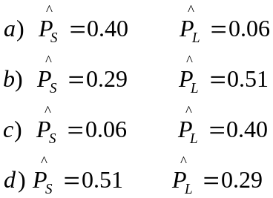

- While we have just (hopefully) seen that these sample proportions differ significantly, we would like to determine whether there is a difference in the underlying population proportions. That is, do these sample means differ by more than we would expect due to sampling variation?
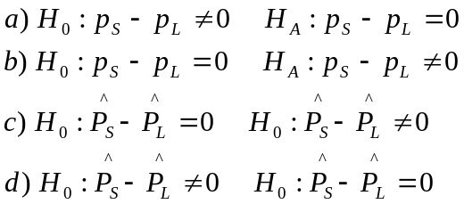
- Compute the appropriate test statistic:

- Z_{obs} = 1.83
- Z_{obs} = 4.40
- Z_{obs} = 14.67
- Z_{obs} = 3.14

- The appropriate rejection region (α=0.05) and p-value are:

a) RR: Z_{obs} > 1.645 p-value=.0336
b) RR: Z_{obs} > 1.96 p-value=.0336
c) RR: Z_{obs} > 1.96 p-value=.0672
d) RR: Z_{obs} > 1.645 p-value=.0672

- Can we conclude (based on this level of significance) that the true population proportions differ by size of firm?

- Yes
- No
- None of the above
- All of the above

- In the same article, they reported that 19 of the large firms and 70 of the small firms commonly used one-on-one interviews. Compute a 95% confidence interval for the difference in sample proportions between large and small firms that commonly use one-on-one interviews (p_{L}-p_{S}).
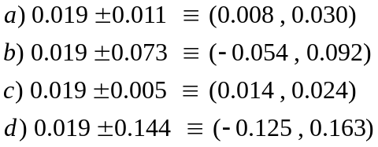

- Based on your confidence interval from 6), can we conclude (based on α=0.05) that the population proportions of firms that commonly conduct one-on-one interviews differ among large and small firms?

Source: Deshpande, S.P. and D.Y. Golhar (1994), “HRM Practices in Large and Small Manufacturing Firms: A Comparative Study”, Journal of Small Business Management, 49—56.

Comparing More Than 2 Populations – Independent Samples

Frequently, we have more than two groups to compare. Methods that appear quite difference from the 2 sample t and z tests can be used to compare more than 2 populations of interval or nominal measurements, Keep in mind that we are still conducting tests very similar to those in the previous section. Suppose there are c populations or treatments to be compared, we wish to test hypotheses of the following forms:

Interval Scale outcomes: Section 10.1

H₀: μ₁ = μ₂ = … = μ_{c} H_{A}: The c means are not all equal

Nominal Outcomes: (Section 11.1-2)

H_{A}: p₁ = p₂ = … = p_{c} H_{A}: The c proportions are not all equal

The test for interval scale outcomes is the F-test, based on the Analysis of Variance. The test for nominal outcomes is referred to as the Chi-square test for contingency tables. In each case, if we reject the null hypothesis and conclude that the means or proportions are not all equal, we will conduct post hoc comparisons to determine which pairs of populations or treatments differ.

The F-test for interval scale outcomes is theoretically based on the assumption that all k populations are normally distributed with common variance σ² (similar to the 2-sample t-test). Departures from normality have been shown to be less of a problem than unequal variances.

One-Way Analysis of Variance (Section 10.1)

Populations: c Groups, with mean μ_{j} and variance σ_{j}² for population j (j=1,...,c)

Samples: c samples of size n_{j} with mean 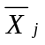 , variance S_{j}², for sample j (j=1,...,c)

Notation:

- X_{ij} – the i^{th} element from group j (The j being the more important subscript)
- n_{j} – the sample size for group j
- - the sample mean for group j : 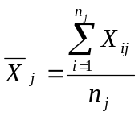
- S_{j}² – the sample variance for group j: 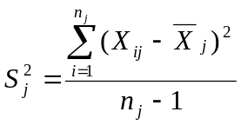
- n – overall sample size (across groups): 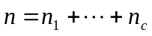
- 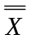 - overall sample mean 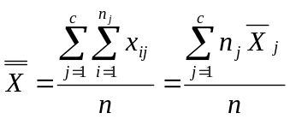

Total variation around overall mean (across all n observations):
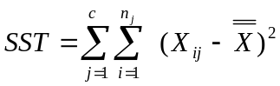

This total variation can be partitioned into two sources: Among and Within treatments.

Between Treatments: Sum of Squares for Treatments: (Page 422)
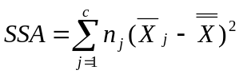

Within Treatments: Sum of Squares for Error: (Page 423)
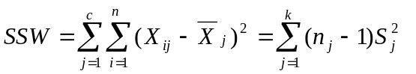

The Sum of Squares for Treatments has ν₁=c-1 degrees of freedom, while the Sum of Squares for Error has ν₂ = n-c degrees of freedom.

Mean Square for Treatments: 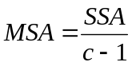

Mean Square for Error: 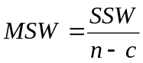

Testing for Differences Among Population Means:

- Null Hypothesis: 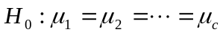

- Alternative Hypothesis: 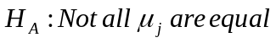

- Test Statistic: 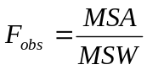

- Rejection Region: 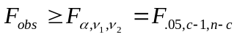

- P-value: Area in F-distribution to the right of F_{obs}

Large values of F_{obs} are consistent with the alternative hypothesis. Values near 1.0 are consistent with the null hypothesis.

Analysis of Variance (ANOVA) Table

Source of Degrees of Sum of Mean

Variation Freedom Squares Square F-Statistic
Treaments c-1 SSA MSA=SSA/(c-1) F_{obs}=MST/MSE
Error n-c SSW MSW=SSW/(n-c)
Total n-1 SST

Note: MSW is an extension of the pooled variance s_{p}² from two sample problems, and is an estimate of the observation variance σ².

Example: Impact of Attention on Product Attribute Performance Assessments

A study was conducted to determine whether amount of attention (as measured by the time subject is exposed to the advertisement) is related to importance ratings of a product attribute. In particular, subjects were asked to rate on a scale the importance of water resistance in a watch. People were exposed to the ad for either 60, 105, or 150 seconds. The means, standard deviations and sample sizes for each treatment group are given below (higher rating scores mean higher importance of water resistance). Source: MacKenzie, S.B. (1986), “The Role of Attention in Mediating the Effect of Advertising on Attribute Performance”, Journal of Consumer Research, 13:174-195

Statistic 60 seconds 105 seconds 150 seconds
Mean 4.3 6.8 7.1
Std Dev 1.8 1.7 1.5
Sample Size 11 10 9

The overall mean is: (11(4.3)+10(6.8)+9(7.1))/(11+10+9)=6.0

- Complete the degrees of freedom and sums of squares columns in the following Analysis of Variance (ANOVA) table:

Source df SS
Treatments ν₁ SST
Error ν₂ SSE
Total SS(Total)

SSA = 11(4.3-6.0)² + 10(6.8-6.0)² + 9(7.1-6.0)² = 31.8+6.4+10.9 = 49.1 ν₁=3-1=2
SSW = (11-1)(1.8)²+(10-1)(1.7)²+(9-1)(1.5)² = 32.4+26.0+18.0 = 76.4 ν₂ = 30-3=27
SST = SSA+SSW = 76.4+47.2 = 123.6

- The test statistic, rejection region, and conclusion for testing for differences in treatment means are (α=0.05):

MSA=49.1/2 = 24.55 MSW=76.4/27 = 2.83
Test Statistic: F_{obs} = 24.55/2.83 = 8.67
Rejection Region: F_{obs} ≥ F_{.05,2,27} = 3.35
Reject H₀, Conclude that means differ among the three exposure times.

Example: Corporate Social Responsibility and the Marketplace

A study was conducted to determine whether levels of corporate social responsibility (CSR) vary by industry type. That is, can we explain a reasonable fraction of the overall variation in CSR by taking into account the firm’s industry? If there are differences by industry, this might be interpreted as the existence of “industry forces” that affect what a firm’s CSR will be. For instance, consumer and service firms may be more aware of social issues and demonstrate higher levels of CSR than companies that deal less with the direct public (more removed from the retail marketplace).

A portion of the Analysis of Variance (ANOVA) table is given below. Complete the table by answering the following questions. Then complete the interpretive questions.
Analysis of Variance (ANOVA)
Source of Variation df SS MS F
Industry (Trts) 17 25.16 (Q3) (Q5)
Error (Q1) (Q2) (Q4) ---
Total 179 82.71 --- ---

- The degrees of freedom for error are:

- 196
- 10.5
- 162
- –162

- The error sum of squares (SSW) is:

- 107.87
- 3.29
- –57.55
- 57.55

- The treatment mean square (MSA) is:

- 25.16
- 1.48
- 427.72
- 8.16

- The error mean square (MSW) is:

- 57.55
- 9323.10
- 104.45
- 0.36

- The F-statistic used to test for industry effects (F_{obs}) is:

- 4.11
- 0.44
- 0.11
- 0.24

- The appropriate (approximate) rejection region and conclusion are (α=0.05):

a) RR: F_{obs} > 1.50 --- Conclude industry differences exist in mean CSR
b) RR: F_{obs} > 1.70 --- Conclude industry differences exist in mean CSR
c) RR: F_{obs} > 1.50 --- Cannot conclude industry differences exist in mean CSR
d) RR: F_{obs} > 1.70 --- Cannot conclude industry differences exist in mean CSR

- The p-value for this test is most precisely described as:

- greater than .10
- less than .05
- less than .01
- less than .001

- How many companies (firms) were in this sample?

- 17
- 162
- 179
- 180

- How many industries were represented?

- 17
- 18
- 162
- 179

Source: Cottrill, M.T., (1990), “Corporate Social Responsibility and the Marketplace”, Journal of Business Ethics, 9:723-729.

Example: Salary Progression By Industry

A recent study reported salary progressions during the 1980’s among k=8 industries. Results including industry means, standard deviations, and sample sizes are given in the included Excel worksheet. Also, calculations are provided to obtain the Analysis of Variance and multiple comparisons based on Tukey’s method.

- 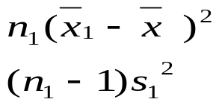Confirm the calculation of the following two quantities among pharmaceutical workers (feel free to do this for the other categories as well).

- We wish to test whether differences exist in mean salary progressions among the k=8 industries. If we let μ_{i} denote the (population) mean salary progression for industry i, then the appropriate null and alternative hypotheses are:
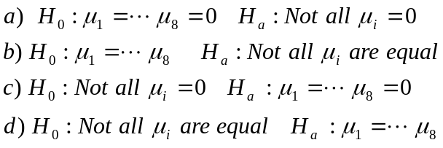
- The appropriate test statistic (TS) and rejection region (RR) are (use α=0.05):
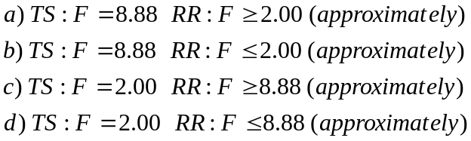
- What conclusion do we make, based on this test?

- Conclude no differences exist in mean salary progressions among the 8 industries
- Conclude that differences exist among the mean salary progressions among the 8 industries
- Conclude that all 8 industry mean salary progressions differ.

- We are at risk of (but aren’t necessarily) making a:

- Type I Error
- Type II Error
- All of the above
- None of the above

Source: Stroh, L.K. and J.M. Brett (1996) “The Dual-Earner Dad Penalty in Salary Progression”,Human Resources Management 35:181-201

Note: The last portion of the Spreadsheet will be covered in the next few pages.
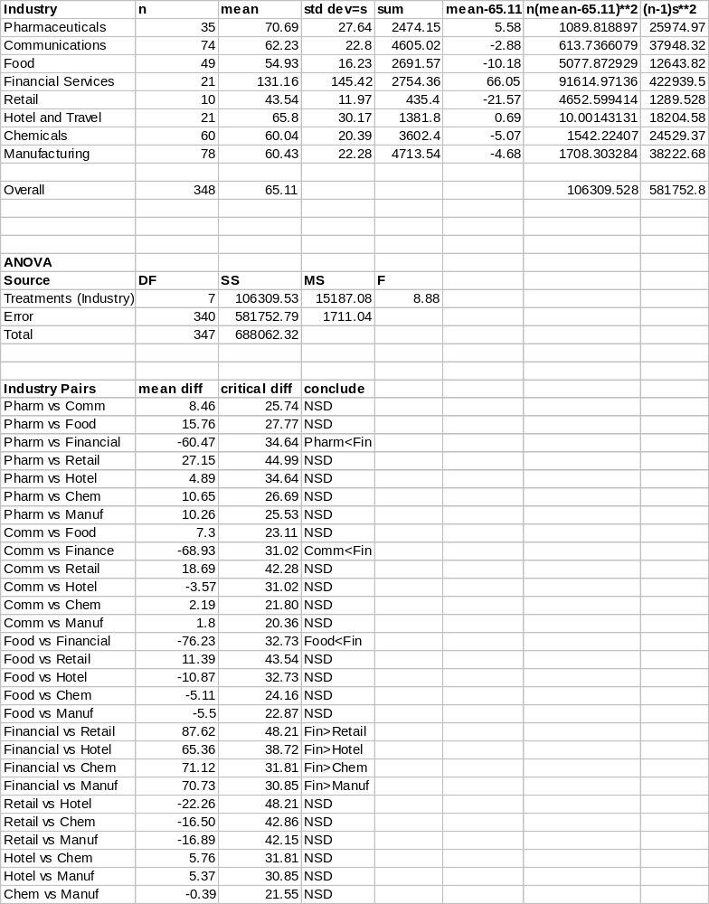

Multiple Comparisons (Section 10.1 & Supplement)

Assuming we have concluded that the means are not all equal, we wish to make comparisons among pairs of groups. There are 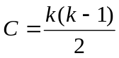 pairs of groups. We want to simultaneously compare all pairs of groups.

Problem: As the number of comparisons grows, so does the probability that we will make at least Type I error. (As the number of questions on a test increases, what happens to the probability that you make a perfect score).

Bonferroni’s Approach (Supplement)

Logic: Conduct each test at a very low type I error rate. Then, the combined, experimentwise error rate is bounded above by the sum of the error rates from the individual comparisons. That is, if we want to conduct 5 tests, and we conduct each at α=.01 error rate, the experimentwise error rate is α_{E} = 5(.01) = .05

Procedure:

- Obtain 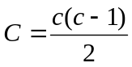, the total number of comparisons to be made.
- Obtain 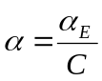 , where α_{E} is the experimentwise error rate (we will use 0.05)
- Obtain 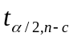the critical value from the t-distribution with n-c degrees of freedom
- Compute the critical differences: 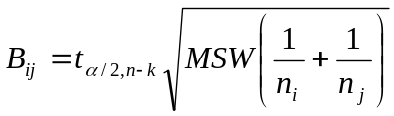
- Conclude that 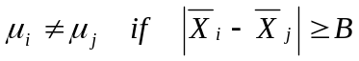 (You can also form simultaneous Confidence Intervals, and make conclusions based on whether confidence intervals contain 0.

Tukey-Kramer Approach:

Replace step 4 with: 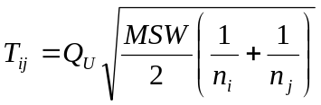 where Q_{U} values are given in Table E.9, indexed by c-1 on the top, and n-c on the side and α_{E}=0.05,0.01

Example: Impact of Attention on Product Attribute Performance Assessments (Continued)

For this problem:
c=3, n₁=11, n₂=10, n₃=9,

There are 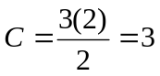comparisons

The comparisonwise error rate is 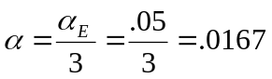

The critical t-value is: 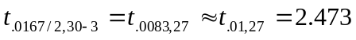

The critical differences for comparing groups i and j are:

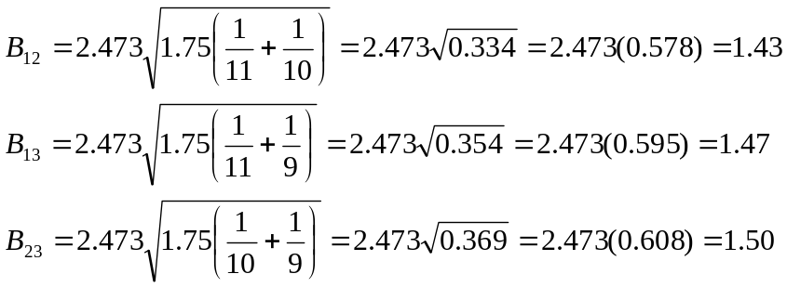

Results Table:

Treatments (i,j) 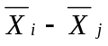 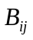 Conclusion
60 vs 105 (1,2) 4.3-6.8 = -2.5 1.43 μ₁−μ₂ < 0 (|-2.5|>1.43)
60 vs 150 (1,3) 4.3-7.1 = -2.8 1.47 μ₁−μ₃ < 0 (|-2.8|>1.47)
105 vs 150 (2,3) 6.8-7.1 = -0.3 1.50 μ₂−μ₃ = 0 (|-0.3|<1.50)

Often when the means are not significantly different, you will see NSD for the conclusion in such a table.

Chi-Squared Test for Contingency Tables (Section 11.1-2)

Goal: Test whether the population proportions differ among k populations or treatments (This method actually tests whether the two variables are independent).

Data: A cross-classification table of cell counts of individuals falling in intersections of levels of categorical variables.

Example: Recall the example of smoking status for college students by race:

 |  | Smoke
Race |  | Yes | No
 | White | 3807 | 6738
 | Hispanic | 261 | 757
 | Asian | 257 | 860
 | Black | 125 | 663

Step 1: Obtain row and column totals:

 |  | Smoke
Race |  | Yes | No | Total
 | White | 3807 | 6738 | 10545
 | Hispanic | 261 | 757 | 1018
 | Asian | 257 | 860 | 1117
 | Black | 125 | 663 | 788
 | Total | 4450 | 9018 | 13468

Step 2: Obtain the overall sample proportions who smoke and don’t smoke

Proportion smoking = 4450/13468 = .3304
Proportion not smoking = 9018/13468 = .6696

Step 3: Under the null hypothesis that smoking status is independent of race, the population proportions smoking are the same for all races. Apply the results from step 2 to all the row totals (these are called EXPECTED COUNTS).

Expected count of Whites who Smoke: .3304(10545) = 3484 Don’t: .6696(10545)=7061
Expected count of Hispanics who Smoke: .3304(1018) = 336 Don’t: .6696(1018)=682
Expected count of Asians who Smoke: .3304(1117) = 369 Don’t: .6696(1117)=748
Expected count of Blacks who Smoke: .3304(788) = 260 Don’t: .6696(788)=528

Table of Expected counts under the constraint that the proportions who smoke (and don’t) are the same for all races (note that all row and column totals):

 |  | Smoke
Race |  | Yes | No | Total
 | White | 3484 | 7061 | 10545
 | Hispanic | 336 | 682 | 1018
 | Asian | 369 | 748 | 1117
 | Black | 260 | 528 | 788
 | Total | 4450 | 9018 | 13468

Step 4: For each cell in table, obtain the following quantity:

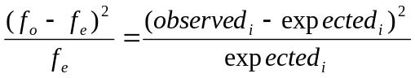

White Smokers: 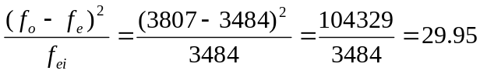

White Non-Smokers: 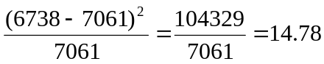

Repeat for all cells in table:

 |  | Smoke
Race |  | Yes | No | Total
 | White | 29.95 | 14.78
 | Hispanic | 16.74 | 8.25
 | Asian | 33.99 | 16.77
 | Black | 70.10 | 34.52
 | Total

Step 5: Sum the quantities from Step 4

Step 6: Obtain the critical value from the Chi-square distribution with
(r-1)(c-1) degrees of freedom, where r is the number of rows in the table (ignoring total), and c is the number of columns:

For this table: r=4 (races) and c=2 (smoking categories): 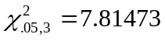

Step 7: Conclude that the distribution of outcomes differs by group if the statistic in Step 5, exceeds the critical value in Step 6.

225.10 > 7.81473 Conclude that the probability of smoking differs among races.

Chi-Squared test for more than two populations

- Null Hypothesis – H₀: Two variables are independent (p₁=...=p_{c} when there are c groups and 2 outcomes)

- Alternative Hypothesis – H_{A}: Two variables are dependent (Not all p_{i} are equal when there are c groups and 2 outcomes)

- Test Statistic - 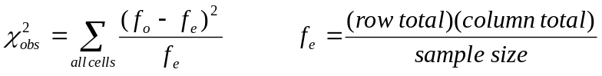

- Rejection Region - 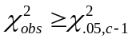

- P-Value – Area in chi-square distribution above the test statistic

Pairwise Comparisons (Marascuilo Procedure)

Critical Range: Conclude p_{j} ≠ p_{j’} if their sample means differ in absolute value than:

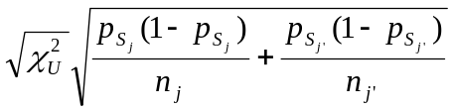

where 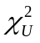 is the critical value from the test that all c proportions are equal.

Example: Smoking by ethnicity:

Group (j) | p_{sj} | n_{j}
White (1) | 3807/10545 = 0.3610 | 10545
Hispanic (2) | 261/1018 = 0.2564 | 1018
Asian (3) | 257/1117 = 0.2301 | 1117
Black (4) | 125/788 = 0.1586 | 788

For each comparison: =7.815, critical values and differences:

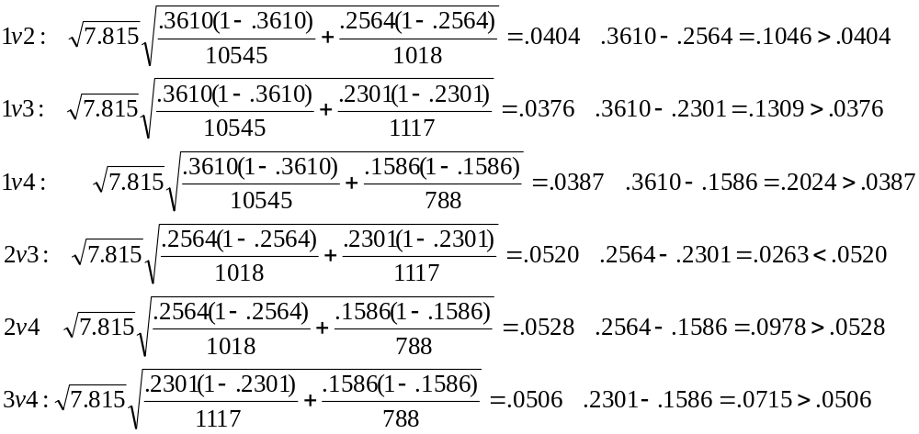

Conclude whites have higher rate than all other groups, blacks have lower rates than all other groups and that hispanics and asians are not significantly different.

