Basic Probability Examples
Chicago Passenger Licenses
A public passenger vehicle is a vehicle used for the transportation of passengers for hire by a public chauffeur. The list of public passenger vehicles includes licensed taxicabs (medallions), liveries, ambulances, medicars, charter-sightseeing buses, horse-drawn carriages, and pedicabs.
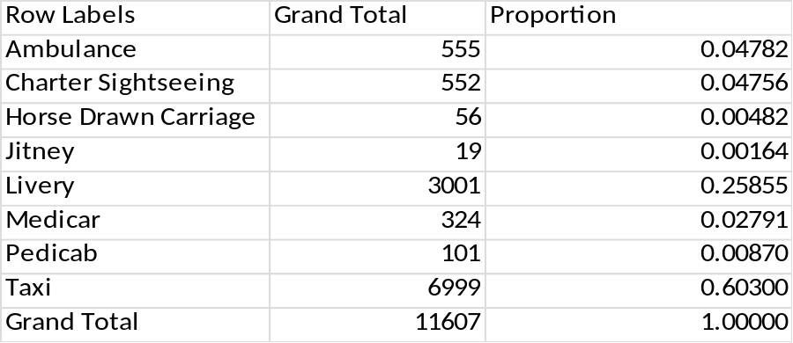
- A license is selected at random, what is the probability it is medically related (Ambulance or Medicar)
- A license is selected at random, what is the probability it is a Taxi or Livery
- A license is selected at random, what is the probability it is either a Charter Sightseeing, Horse Drawn Carriage, or Jitney
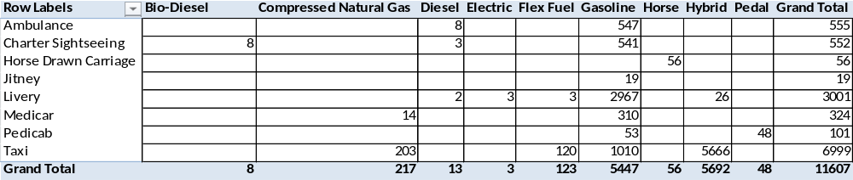
Vehicles classified by type and fuel. A license is selected at random, what is the probability:
- Taxi and Gasoline powered
- Taxi and hybrid
- Compressed Natural Gas given Medicar
- Pedal given Pedicab
- Pedicab given Pedal
- Ambulance given Gasoline
- Gasoline given Ambulance
- Taxi given hybrid

U.S. Currency Production – Fiscal Years 2003-2005
The following table gives the production (in 100,000s of notes) for U.S. Currency by fiscal year and denomination. In the following questions, assume you have a randomly selected currency note, and give the probability of each event.
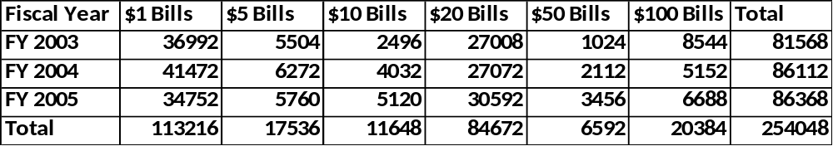
- Note was produced in FY 2003
- Note is a $50 bill
- Note was produced in FY 2003 & is a $50 bill
- Note is worth at least $20
- Note is worth at least $20 & produced after FY 2003
- Note was produced after FY 2003 given it is worth at least $20
- A random sample of 5 notes are taken from this period, give the probability that:
  - All 5 are $1 bills
  - 3 are $1 and 2 are $100
  - All 5 were produced in FY 2003
  - All three years appear in the sample
  - The total value is ≥ $400
LAX Passenger Data – 2006-2014
Assume a Los Angeles International Airport passenger from the following years has been selected at random. Give the following probabilities.
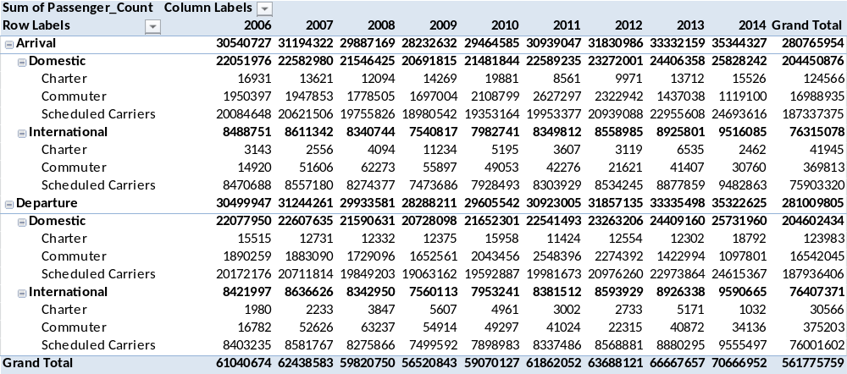
- Year was 2009.
- International & Arrival.
- International & Departure.
- International Flight.
- Scheduled Carrier & Domestic & Arrival
- Scheduled Carrier & International & Arrival
- Scheduled Carrier & Arrival
- Scheduled Carrier & Domestic & Departure
- Scheduled Carrier & International & Departure
- Scheduled Carrier & Departure
- Scheduled Carrier
- Departure given Scheduled Carrier
- Domestic Given Arrival
- Domestic Given Departure
- Arrival Given Domestic
- Departure Given Domestic
- Year (Each Year separately)
- Arrival given Year (Each Year separately)
- Arrival & Year (by multiplying 17 and 18 for Each Year)
- Year <= 2009 Given Arrival

New Orleans Restaurant Establishments
The following table gives frequencies of restaurant types in the City of New Orleans. For all parts, assume you have randomly selected a sample from the population, without replacement.
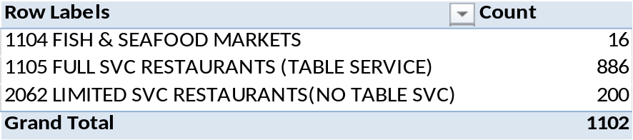
- 3 sampled, probability that 1 is of each type
- 3 sampled, all are full service
- 3 sampled, all are limited service
- 3 sampled, all are fish & seafood markets
- How many need to be sampled for the probability that all are Full service to be below ½.
- What is probability that it is Fish & Seafood given it is not full service
- What is probability that it is Limited Service given it is not full service

Chicago Department of Health Food Inspections
The Chicago Department of Health inspects all places where food is served (restaurants, schools, gas stations,…). Each location is given a Risk type, and after inspection, an inspection result (Fail, Pass with Conditions, or Pass). The following Table gives the counts for each combination, as well as marginal totals for the 95485 establishments. For all parts, assume you have taken a randomly selected establishment from this population, and obtain the following probabilities.
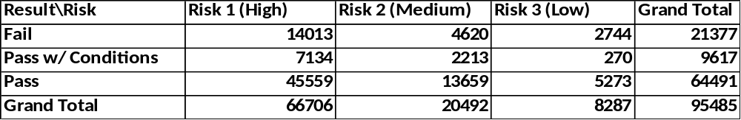
- High Risk
- Medium Risk
- Low risk
- Fail
- Pass w/ Conditions
- Pass
- Union of Fail and High Risk
- Pass w/ Conditions and/or Medium Risk
- Pass given High Risk
- Pass given Medium Risk
- Pass given Low Risk
- Pass & High Risk
- Pass & Medium Risk
- Pass & Low Risk
- Pass (summing 10:12)
- High Risk given Pass (Bayes’ Rule)
- Medium Risk given Pass (Bayes’ Rule)
- Low Risk given Pass (Bayes’ Rule)
- Fail given High Risk
- Pass w/ Conditions given High Risk
- Pass given High Risk
- Fail & High Risk
- Pass w/ Conditions & High Risk
- Pass & High Risk
- High Risk (summing 20:22)
- Fail given High Risk (Bayes’ Rule)
- Pass w/ Conditions given High Risk (Bayes’ Rule)
- Pass given High Risk (Bayes’ Rule)
Florida Lotto (Choose 6 Numbers from 1-53 without replacement)
Since October 24, 1999, the Florida Lotto has selected 6 numbers at random from 1:53, without replacement. The order of the numbers does not matter.
- How many potential sets of 6 numbers can be selected on a given drawing?
- How many odd numbers are there between 1 and 53? How many even numbers are there?
- How many ways can you obtain the following combinations of odd and even numbers on a given drawing? Also give the probability of each event.
  - 6 odd, 0 even
  - 5 odd, 1 even
  - 4 odd, 2 even
  - 3 odd, 3 even
  - 2 odd, 4 even
  - 1 odd, 5 even
  - 0 odd, 6 even
- The following table gives the observed counts of each number of odd digits among the winning tickets for the 1646 drawings between 10/24/1999 and 8/29/2015. Are they consistent with what you expect?
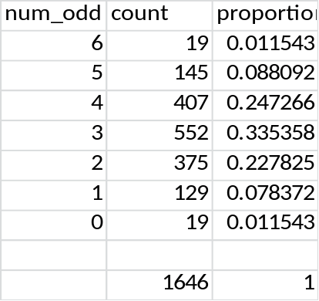
- A reporter once told me that a good strategy would to be to pick 3 odd numbers and 3 even numbers, since that event comes up the most. Does that seem reasonable?

